**MINISTRY OF EDUCATION AND TRAINING**

**FPT UNIVERSITY**

Capstone Project Document

**Laptop Reviews**

|  |  |
| --- | --- |
| **Group 1** | |
| **Group member** | Vo Thi Minh Chau – Team Leader – SE60931  Nguyen Van Hon – Team Member - 60390 (Dropped out)  Dinh Huu Toan – Team Member - SE60871  Nguyen Manh Khuong – Team Member - 60455 |
| **Supervisor** | Mr. Kieu Trong Khanh |
| **Ext. Supervisor** | N/A |
| **Capstone Project code** | LRA |

-Ho Chi Minh City, 05/2015-

*This page is intentionally left blank*

***ACKNOWLEDGEMENTS***

We wish to thank various people for their contribution to this project: Our teachers for their advice and participation in the final review, our friends for their valuable technical support.

Special thanks should be given to Mr. Kieu Trong Khanh, our research supervisor for his professional guidance and the useful, constructive recommendations throughout the course of this project.

# Table of Contents

List of Tables viii

List of Figures xi

Definitions, Acronyms, and Abbreviations xv

A. Introduction 1

1. Project Information 1

2. Introduction 1

3. Current Comparison websites in Vietnam 1

4. Problem Definition 1

5. Proposed Solution 2

5.1 Feature functions 2

5.2 Advantage and disadvantage 2

6. Functional Requirement 2

6.1 Parser Management 2

6.2 Train Machine 2

6.3 Account Management 2

6.4 Dictionary Management 2

6.5 Guests’ functions 3

6.6 Analyze comment 3

7. Role and Responsibility 3

B. Software Project Management Plan 4

1. Problem Definition 4

1.1 Name of this Capstone Project 4

1.2 Problem Abstract 4

1.3 Project Overview 4

2. Project organization 5

2.1 Software Process Model 5

2.2 Roles and responsibilities 8

2.3 Tools and Techniques 9

3. Project Management Plan 10

3.1 Software Development Life Cycle 10

3.2 Phase Detail 11

3.3 All Meeting Minutes 15

4. Coding Convention 15

C. Software Requirement Specification 16

1. User Requirement Specification 16

1.1 Guest Requirement 16

1.2 Member Requirement 16

1.3 Staff Requirement 16

1.4 Admin Requirement 16

1.5 System Requirement 16

2. System Requirement Specification 17

2.1 External Interface Requirement 17

2.2 System Overview Use Case 18

2.3 List of Use Case 19

3. Software System Attribute 102

3.1 Usability 102

3.2 Reliability 102

3.3 Availability 103

3.4 Security 103

3.5 Maintainability 103

3.6 Portability 103

3.7 Performance 103

4. Conceptual Diagram 103

Data Dictionary 104

D. Software Design Description 106

1. Design Overview 106

2. System Architectural Design 107

2.1 Web Architecture 107

3. Component Diagram 108

4. Detailed Description of Components 109

4.1 Class Diagram 109

4.2 Class Diagram Explanation 110

4.3 Sequence Diagram 114

5. User Interface Design 119

5.1 Component Interface 119

5.2 Web Application Design 121

6. Database Design 165

6.1 Web Application 165

7. Algorithms 170

7.1 Parse Data 170

7.2 Analyze Comment 171

7.3 String Comparison 173

7.4 Detect Duplicated Product 174

E. System Implementation & Test 176

1. Introduction 176

1.1 System Overview 176

1.2 Test Approach 176

2. Database Relationship Diagram 176

2.1 Physical Diagram 176

2.2 Data Dictionary 178

3. Performance Measures 183

3.1 Parser Performance 183

3.2 Analyzing Comment Algorithm Performance 183

4. Test Plan 183

4.1 Features to be tested 183

4.2 Features not to be tested 184

5. System Testing Test Case 185

5.1 Guest Test Case 188

5.2 System Test Case 190

5.3 Staff Test Case 191

F. Software User’s Manual 200

1. Installation Guide 200

1.1 Setting up environment at server side 200

1.2 Deployment at server side 200

1.3 Setting up the environment at client side 204

2. User Guide 204

2.1 Guest/Member Guide 204

2.2 Staff Guide 206

G. Appendix 220

# List of Tables

Table 1: Roles and Responsibility 3

Table 2: Hardware Requirement for Server 5

Table 3: Hardware Requirement for Mobile Application 5

Table 4: Compare Plan-driven and Agile development 7

Table 5: Roles and Responsibility Details 9

Table 6: Software Development Life Cycle Detail 11

Table 7: Phase 1: Outline Planning and Architectural Design 12

Table 8: Phase 2: Sprint Cycle – Parser Analysis 12

Table 9: Phase 2: Sprint Cycle – Training Machine Function 12

Table 10: Phase 2: Sprint Cycle – Dictionary Management 13

Table 11: Phase 2: Sprint Cycle – Parser Management 13

Table 12: Phase 2: Sprint Cycle – Main User’s Functions 14

Table 13: Phase 2: Sprint Cycle – User Account Management 14

Table 14: Phase 3: Project Closure 15

Table 15: <Admin> Create Account 21

Table 16: <Admin> Update Account 23

Table 17: <Admin> Activate/Deactivate Account 24

Table 18: <Staff> Merge Laptop 28

Table 19: <Staff> Split Laptop 31

Table 20: <Staff> Enable/Disable laptop 34

Table 21: <Staff> View Training Log File 36

Table 22: <Staff> Parse Specific Laptop 38

Table 23: <Staff> Run Parser 40

Table 24: <Staff> View Parsing Log File 41

Table 25: <Staff> Configure System 43

Table 26: <Staff> Search Word 45

Table 27: < Staff> Add Word 46

Table 28: <Staff> Edit Word 48

Table 29: <Staff> Import Excel File 51

Table 30: <Staff> Import Dictionary File 54

Table 31: <Staff> Process error product 59

Table 32: <Staff> Update Site 61

Table 33: <Staff> Activate/Deactivate Site 63

Table 34: <Staff> Parse Recommended Product 65

Table 35: <Staff> Edit Description 68

Table 36: <Staff> Upload Image 69

Table 37: <Staff> Activate/Deactivate Comment 71

Table 38: <Staff> Edit Comment 73

Table 39: <Staff> Deactivate Comment 75

Table 40: <Staff> Deny Report 76

Table 41: <Staff> Reanalyse Comment 78

Table 42: <Staff> Add sensitive Word 80

Table 43: <Member> Edit Profile 82

Table 44: <Member> Change Password 84

Table 45: <Member> Retrieve Password 86

Table 46: < Member > Log out 87

Table 47: <Guest> Login 89

Table 48: <Guest> Search Laptop 90

Table 49: <Guest> View laptop 92

Table 50: <Guest> Report Comment 93

Table 51: <System> Auto Parse Data 95

Table 52: <System> Create Log File 97

Table 53: <System> Auto Find Synonyms/Antonyms 98

Table 54: <System> Auto Search And Parse Laptop 100

Table 55: <System> Reanalyze Comment 101

Table 56: Entity Data dictionary - Describe content of all entities 105

Table 57: Component dictionary: describe component 108

Table 58: Class dictionary: describe class 110

Table 59: Web Service Interface 120

Table 60: Entity/Model description 120

Table 61: Exception Descriptio 120

Table 62: Entity Data Dictionary 167

Table 63: Attribute Data Dictionary 170

Table 64: Data Dictionary 178

Table 65: Attribute Data Dictionary 183

Table 66: Test cases summary 187

Table 67: Search Product by name Test Case 188

Table 68: View Detail Test Case 189

Table 69: Recommend Product Test Case 190

Table 70: Run Parser Test Case 190

Table 71: History compares Test Case 191

Table 72: Manage Recommended Product Test Case 192

Table 73: Create New Site Test Case 193

Table 74: Train Machine Test Case 195

Table 75: Update Word Test Case 197

Table 76: Import Excel File Test Case 198

Table 77: Import Dictionary File Test Case 199

Table 78: Search Product Steps 204

Table 79: Report comment 205

Table 80: Recommend Product 205

Table 81: Staff Login Steps 206

Table 82: Import Excel File Steps 207

Table 83: Import Dictionary File Steps 207

Table 84: Create New Site Steps – 1 208

Table 85: Create New Site Steps – 2 211

Table 86: Run Parser 212

Table 87: Manage Recommended Product 213

Table 88: Train Machine 214

Table 89: Manage Product - Step 1 215

Table 90: Manage Product - Step 2 216

Table 91: Manage Product – Edit Description 217

Table 92: Manage Product – Upload Image 218

Table 93: Manage Product – Edit Comment 219

# List of Figures

Figure 1: The Scrum Process 8

Figure 2: System Overview Use Case 18

Figure 3: <Admin> Overview Use Case 19

Figure 4: <Admin> Create Account 19

Figure 5: <Admin> Update Account 22

Figure 6: <Admin> Activate/Deactivate Account 23

Figure 7: <Staff> Overview Use Case 25

Figure 8: <Staff> Merge Laptop 26

Figure 9: <Staff> Update Parser 29

Figure 10: <Staff> Enable/Disable laptop 31

Figure 11: <Staff> View Training Log File 34

Figure 12: <Staff> Parse Specific Laptop 36

Figure 13: <Staff> Activate Parser 38

Figure 14: <Staff> View Parsing Log File 40

Figure 15: <Staff> Configure System 42

Figure 16: <Staff> Search Word 43

Figure 17: <Staff> Add word 45

Figure 18: <Staff> Edit Word 47

Figure 19: <Staff> Import Excel File 49

Figure 20: Valid Excel File 51

Figure 21: Invalid Excel File 51

Figure 22: <Staff> Import Dictionary File 52

Figure 23: Valid Synonym and Antonym Dictionary file 53

Figure 24: Valid Lingoes Dictionary file 54

Figure 25: <Staff> Create Site 54

Figure 26: <Staff> Update Site 59

Figure 27: <Staff> Activate/Deactivate Site 62

Figure 28: <Staff> Parse Recommended Laptop 63

Figure 29: <Staff> Edit Description 66

Figure 30: <Staff> Upload Image 68

Figure 31: <Staff> Activate/Deactivate comment 70

Figure 32: <Staff> Edit Comment 71

Figure 33: <Staff> Deactivate Comment 73

Figure 34: <Staff> Deny Report 75

Figure 35: <Staff> Reanalyse Comment 77

Figure 36: <Staff> Add sensitive Word 78

Figure 37: <Member> Overview Use Case 80

Figure 38: <Member> Edit Profile 81

Figure 39: <Member> Change Password 83

Figure 40: <Member> Retrieve Password 84

Figure 41: <Member> Log Out 86

Figure 42: <Guest> Overview Use Case 87

Figure 43: <Guest> Login 88

Figure 44: <Guest> Search laptop 89

Figure 45: <Guest> View Laptop 91

Figure 46: <Guest> Report comment 92

Figure 47: <System> Auto Parse Data 94

Figure 48: <System> Create Log File 96

Figure 49: <System> Auto Find Synonyms/Antonyms 97

Figure 50: <System> Auto Search And Parse Laptop 98

Figure 51: <System> Reanalyze Comment 100

Figure 52: <System> Cancel recommended product 101

Figure 53: Conceptual Diagram 104

Figure 54: MVC Architecture 107

Figure 55: Component Diagram 108

Figure 56: Class Diagram 109

Figure 57: Parse Specific Product Sequence Diagram 114

Figure 58: Import Excel File Sequence Diagram 115

Figure 59: Recommend Sequence Diagram 116

Figure 60: Add Word 116

Figure 61: Edit Word 117

Figure 62: Search Laptop 117

Figure 63: Create New Site Sequence Diagram 118

Figure 64: Configure System Sequence Diagram 118

Figure 65: Training Machine 119

Figure 66: Guest Home Page 121

Figure 67: Result Page 122

Figure 68: Register Page 123

Figure 69: Member Home Page 124

Figure 70: Admin/Staff Login Page 125

Figure 71: User List Page - 1 126

Figure 72: User List Page - 2 127

Figure 73: Create New User Page 128

Figure 74: System Configuration Page 129

Figure 75: <Staff> Dictionary Management 130

Figure 76: <Staff> Add new word 131

Figure 77: <Staff> Add new word 132

Figure 78: Import Excel Page 133

Figure 79: Result Page 134

Figure 80: Import Dictionary File 136

Figure 81: Product Management - All Product Page 138

Figure 82: Product Edit Page 140

Figure 83: Product Edit Page - Upload Image 141

Figure 84: Edit Product Page - Edit Description 142

Figure 85: Reported Comment Page 145

Figure 86: Edit Comment Page 147

Figure 87: Train Machine 148

Figure 88: Edit Alias Product 150

Figure 89: Recommended Product Page 151

Figure 90: Recommended Product Detail Page 152

Figure 91: Site Management Page 154

Figure 92: View Site 155

Figure 93: Create New Site - Step 1 156

Figure 94: Create New Site - Step 2 157

Figure 95: Create New Site - Step 3 158

Figure 96: Create New Site - Step 4 159

Figure 97: Create New Site - Step 5 160

Figure 98: Create New Site - Step 6 161

Figure 99: Create New Site – Preview Product’s Information 162

Figure 100: Manage Log File 163

Figure 101: Parser Specific Product Page 164

Figure 102: Run Parser 165

Figure 103: Entity Relationship Diagram 166

Figure 104: Physical Diagram 177

Figure 105: Analyze comment test result 183

Figure 106: Core Flow 185

Figure 107: Prepare deployment package 200

Figure 108: Deploy database – Step 1 201

Figure 109: Deploy database – Step 2 201

Figure 110: Deploy web application on server – Step 1 202

Figure 111: Deploy web application on server – Step 2 202

Figure 112: Deploy web application on server – Step 3 203

Figure 113: Search Product Page 204

Figure 114: Report comment 205

Figure 115: Recommend Product 205

Figure 116: Staff Login 206

Figure 117: Imported Excel File 207

Figure 118: Import Dictionary File 207

Figure 119: Create New Site Page – 1 208

Figure 120: Create New Site Page – 2 208

Figure 121: Create New Site Page – 3 209

Figure 122: Create New Site Page – 4 209

Figure 123: Create New Site Page – 5 209

Figure 124: Create New Site Page – 6 210

Figure 125: Create New Site Page – 7 210

Figure 126: Create New Site Page – 8 211

Figure 127: Run Parser 212

Figure 128: Manage Recommended Product – 1 212

Figure 129: Manage Recommended Product – 2 213

Figure 130: Confirm new laptop 214

Figure 131: Manage Product – Step 1 215

Figure 132: Manage Product – Step 2 216

Figure 133: Manage Product – Edit Description 217

Figure 134: Manage Product – Upload Image 218

Figure 135: Manage Product – Edit Comment 218

# Definitions, Acronyms, and Abbreviations

|  |  |  |
| --- | --- | --- |
| **No.** | **Abbreviation & Acronym** | **Definition** |
| 1 | LRA | Laptop Reviews |
| 2 | OS | Operation System |
| 3 | Admin | Administrator |
| 4 | API | Application Programming Interface |
| 5 | HTTP | Hyper Text Transfer Protocol |

# Introduction

## Project Information

* Project name: **Laptop Review**
* Project Code: **LRA**
* Product Type: **Website, Phone Application**
* Start Date: **May 12th, 2015**
* End Date: **August 21st, 2015**

## Introduction

Today, when people want to buy a new laptop, they usually search its information though technology websites. The information like laptop’s specifications, prices, outfit pictures are typically found, but lack of reviews from customer who bought that laptop. To solve that problem, we propose a solution which can help people to archive it. We will gather and classify the reviews from trusted websites so that customers can have the best advices and easily make decisions. How can we know whether the reviews are positive or negative? Our system will, therefore, help classify the reviews automatically, show them to our customers in an appropriate way.

## Current Comparison websites in Vietnam

Nowadays, there are many kinds of laptops that many people suffer difficulties in finding the best laptops for them. People often choose laptop based on what they see at the electronic supermarkets or reading reviews on some trusted pages, etc.

Below are some current habits:

* At electronic supermarkets: Here, people go to some well-known electronic supermarkets to collect information from the sellers or on manufacturers’ brochures and make decisions based on that information.
* Online: they can search on Google or another search engines for some well-known and trustworthy technology forums or websites, then they collect information of the laptops they want by reading the reviews. After that, they can make their final choice.

## Problem Definition

Below are the advantages and disadvantages of current habits:

* At electronic supermarkets:
* Advantages: Here, customers can see the laptops physically, gather information from sellers, and the quality can be trusted that can help them make decisions.
* Disadvantages: People tend to go to several electronic supermarkets to get as much information as they can. This will take time. Moreover, it’s hard for them to remember the information each supermarket provide exactly.
* Online:
* Advantages: Customers will have a wide range of reviews which are extremely helpful. Whether positive or negative, these reviews will guide customers in making a better purchasing decision.
* Disadvantages: It will take lots of time to search for trusted websites and read all the reviews, and some reviews may be useless or not relevant that can make customers confused.

According to the description above, we can realize that reviews are one of the most important factors for choosing laptop. Are the reviews relevant or not? Useful or nonsense? From the trusted website or not? Our system will help you with those problems.

## Proposed Solution

The system is intended for using by those with a smart phone or a laptop/computer with Internet connection. The system will have the following functions:

### **Feature functions**

On our system, general users can search for laptops’ specs and reviews. If the laptops that users want are not available on system, they can ask for notification through emails when the information is updated. To handle users’ requirements, the LRA can parse laptops’ specs and reviews daily or on requests. The system also allows staff to configure it, manually update dictionary which is used to classify the reviews, import new words from excel file and have the ability to automatically find the synonyms and antonyms of words/phrases in the dictionary or synchronize laptops’ name. Last but not lease, this system should help admins to manage all the accounts.

### Advantage and disadvantage

The advantages and disadvantages of the proposed solution:

* Advantages: Provide reviews with classification that help customers to make decision easier.
* Disadvantages:
  + If the source websites change their structures, the parse process may be failed.
  + There might be mistakes in classifying the reviews

## Functional Requirement

Function requirement of the system are listed as below:

### Parser Management

* Parse the reviews automatically and manually.

### Train Machine

* Train machine: Merge and Split duplicated items.

### Account Management

* Manage users.

### Dictionary Management

* Add new word.
* Import excel.
* Import dictionary.
* Automatically find synonyms and antonyms after adding new word.

### Guests’ functions

* Search laptops.
* Report comments.
* Recommend laptops.

### Analyze comment

* Analyze comment.

|  |  |  |  |  |
| --- | --- | --- | --- | --- |
| No | Full Name | Role | Position | Contact |
| 1 | Kieu Trong Khanh | Project Manager | Instructor | khanhkt@fpt.edu.vn |
| 2 | Vo Thi Minh Chau | Developer | Leader | chauvtmse60931@fpt.edu.vn |
| 3 | Nguyen Van Hon | Developer | Member | honnv60390@fpt.edu.vn |
| 4 | Dinh Huu Toan | Developer | Member | toandhse60871@fpt.edu.vn |
| 5 | Nguyen Manh Khuong | Developer | Member | khuongnm60455@fpt.edu.vn |

## Role and Responsibility

Table 1: Roles and Responsibility

# Software Project Management Plan

## Problem Definition

### Name of this Capstone Project

Laptop Reviews (LRA).

### Problem Abstract

Today, with the growth of the internet, when a customer want to buy a laptop, they can search for its specifications and other information through technology websites. But there are many information and reviews from experience users about a laptop, the customer must take a lot of times to read and appreciate or may be confused. Our system will help user to make a good decision when buy a laptop by gather reviews from trusted websites, classify and show them to users.

### Project Overview

#### Current Buying Habits

In Vietnam, people tend to choose laptops base on what they hear from sellers at electronic markets or what they read on some technical forums, websites. These activities have limitations. Sellers’ advices may be not accurate, some reviews may be non-sense and are not classified. Moreover, it will take lots of time for people to come to electronic markets to have laptops’ information or read reviews on many forums, websites. After searching on Google, we find this page: [www.buydig.com](http://www.buydig.com). They offer classified reviews for laptops but not all laptops. Therefore, customers will be upset when they can’t find what they need. Our solution will do a better job. We will gather and classify the reviews from trusted websites so that customers can make the best decision. Moreover, customers can claim for reviews for laptops which they can’t see on our system and get notification when those laptops’ information is updated.

#### The Proposed System

The system is intended for use by those with a smart phone or a laptop/computer with Internet connection. The system will have the following functions:

##### Web Application

* Admins can manage accounts.
* System can parse product, classify review and store to database daily or on requests.
* Staff can check feedback from user, manual update dictionary.
* Users can search laptop’s information, leave feedback

##### Mobile Application

* Users can search laptops, write comments or add favourite laptops.

#### Boundaries of the System

* The system can be used by every people with a smart phone or a laptop/computer with Internet connection.
* The language of the system is English.
* The complete product includes:
* The website, for staff and user.
* All the process document involved

#### Development Environment

##### Hardware requirements

**For Server**

|  |  |  |
| --- | --- | --- |
| Windows | Minimum Requirements | Recommended |
| Internet Connection | Cable, Wifi (4 Mbps) | Cable, Wifi (8 Mbps) |
| Operating System | XP, Vista, 7, 8 | XP, Vista, 7, 8 |
| Computer Processor | Intel® Core 2 Duo | Intel® Core(TM) i5 CPU , M 460 @ 2.53GHz |
| Computer Memory | 1GB RAM | 3GB or more |

Table 2: Hardware Requirement for Server

**For Mobile Application**

|  |  |  |
| --- | --- | --- |
| Android | Minimum Requirements | Recommended |
| Internet Connection | Wifi (4 Mbps) | Wifi (8 Mbps) |
| Operating System | 4.1 Jelly Bean | 4.3 Jelly Bean or later |
| Computer Processor | 1.0 GHz | 1.2 GHz or more |
| Computer Memory | 512 MB RAM | 1GB or more |

Table 3: Hardware Requirement for Mobile Application

##### Software requirements

* Microsoft Windows 8.1: operating system and platform for development.
* SQL Server 2008 Express R2: used to create and manage the database for system.
* StarUML: used to create models and diagrams.
* Skype: used for communication and meeting.
* Visual Studio 2013: used to implement website and web service.
* Github.com & TortoiseSVN: used for source control.

## Project organization

### Software Process Model

To determine the right process model for the software process, we answer ten guidelines questions (Sommerville, 2011).

| No. | Question | Answer | Plan-Driven | Agile |
| --- | --- | --- | --- | --- |
| 1 | Is it important to have a very detailed specification and design before moving to implementation? If so, you probably need to use a plan-driven approach. | We need a correct specification and design to code but a very detailed one is not necessary. | 0.5 | 0.5 |
| 2 | Is an incremental delivery strategy, where you deliver the software to customers and get rapid feedback from them, realistic? If so, consider using agile methods. | Yes. Our product need rapid feedback from customers so that we can modify to satisfy them. | 0 | 1 |
| 3 | How large is the system that is being developed? Agile methods are most effective when the system can be developed with a small co-located team who can communicate informally. This may not be possible for large systems that require larger development teams so a plan-driven approach may have to be used. | This system can be developed with a small team and we are at the same age so we can communicate informally. | 0 | 1 |
| 4 | What type of system is being developed? Systems that require a lot of analysis before implementation (e.g., real-time system with complex timing requirements) usually need a fairly detailed design to carry out this analysis. A plan-driven approach may be best in those circumstances. | This is an ecommerce system. We need some careful analysis but not too many. | 0.5 | 0.5 |
| 5 | What is the expected system lifetime? Long-lifetime systems may require more design documentation to communicate the original intentions of the system developers to the support team. However, supporters of agile methods rightly argue that documentation is frequently not kept up to date and it is not of much use for long-term system maintenance. | This system is expected to operate in 2 years. However, during that time, we will do some modifications to meet customers’ need. | 0.5 | 0.5 |
| 6 | What technologies are available to support system development? Agile methods often rely on good tools to keep track of an evolving design. If you are developing a system using an IDE that does not have good tools for program visualization and analysis, then more design documentation may be required. | We have a good tool to track changes. The IDE also support tracking phase. | 0.5 | 0.5 |
| 7 | How is the development team organized? If the development team is distributed or if part of the development is being outsourced, then you may need to develop design documents to communicate across the development teams. You may need to plan in advance what these are. | We all live in Ho Chi Minh City so that we can have meetings every day. | 0 | 1 |
| 8 | Are there cultural issues that may affect the system development? Traditional engineering organizations have a culture of plan-based development, as this is the norm in engineering. This usually requires extensive design documentation, rather than the informal knowledge used in agile processes. | We are all young people and we share common software development knowledge. Moreover, our own cultures are similar to each other. | 0 | 1 |
| 9 | How good are the designers and programmers in the development team? It is sometimes argued that agile methods require higher skill levels than plan-based approaches in which programmers simply translate a detailed design into code. If you have a team with relatively low skill levels, you may need to use the best people to develop the design, with others responsible for programming. | Although we are confident about software development skill, we are still student and we have no or little experience. | 1 | 0 |
| 10 | Is the system subject to external regulation? If a system has to be approved by an external regulator (e.g., the Federal Aviation Authority [FAA] approve software that is critical to the operation of an aircraft) then you will probably be required to produce detailed documentation as part of the system safety case. | No | 0 | 0 |
| Total | | | 3 | 6 |

Table 4: Compare Plan-driven and Agile development

After carefully considering the two approaches, we can see that agile methods are more suitable for our project. We decide to choose the Scrum approach which is a general agile method.

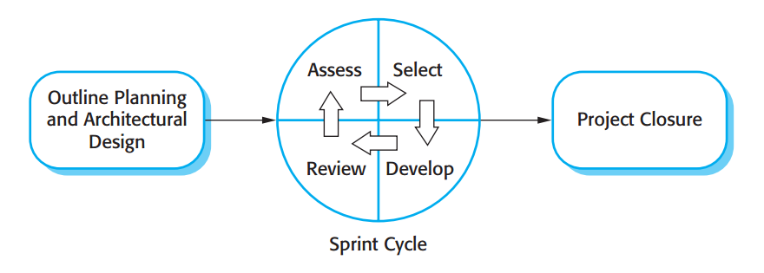

Figure 1: The Scrum Process

(Sommerville, Software Engineering, 9th Edition, 2011, Figure 3.8 page 73)

### Roles and responsibilities

|  |  |  |  |
| --- | --- | --- | --- |
| **No** | **Full name** | **Role in Group** | **Responsibilities** |
| **1** | Kieu Trong Khanh | Scrum Master | * Arrange daily meetings * Track the backlog of work to be done * Record decisions * Measure progress against the backlog * Communicates with customers and management outside of the team |
| **2** | Vo Thi Minh Chau | Scrum Team Member | * Design database * Clarify requirements * Prepare documents * GUI Design * Create test plan * Code * Test |
| **3** | Nguyen Van Hon | Scrum Team Member | * Design database * Clarify requirements * Prepare documents * GUI Design * Create test plan * Code * Test |
| **4** | Dinh Huu Toan | Scrum Team Member | * Design database * Clarify requirements * Prepare documents * GUI Design * Create test plan * Code * Test |
| **5** | Tran Manh Khuong | Scrum Team Member | * Design database * Clarify requirements * Prepare documents * GUI Design * Create test plan * Code * Test |

Table 5: Roles and Responsibility Details

### Tools and Techniques

- Front-end technologies: HTML5, CSS3, JavaScript, jQuery 1.10, AJAX, SignalR 2.0.

- Back-end: Website: ASP.NET MVC5 + Entity Framework 5.

- Web Server: Microsoft IIS 7.

- Database Management System: MS SQL Server 2008 Express R2.

- Android Developer Tools: Eclipse

## Project Management Plan

### Software Development Life Cycle

|  |  |  |  |  |  |
| --- | --- | --- | --- | --- | --- |
| **Phase**  **/Iteration** | **Description** | **Deliverables** | **Resource needed** | **Dependencies and Constrains** | **Risks** |
| **Outline Planning and Architectural Design** | - Study similar existing systems.  -Identify and clarify requirements for the system in general. | - Introduction of proposed system.  - Project task plan.  - Software requirement specification.  - Prototypes. | 20 man-days | N/A | - Missing  requirement  - Unclear  scope of  project  - Lack of  member share  of understand |
| **Sprint Cycle – Parser Analysis** | - Analyze websites to parse data.  - Choose a library for parsing HTML content. | - Websites which will be parsed date.  - Library for parsing HTML content. | 10 man-days | N/A | - Lack of experience. |
| **Sprint Cycle – Training Machine Function** | -Teach the system how to synchronize products’ names. | N/A | 20 man-days | Depends on “Data management”. | - Not have a clear understanding about business process. |
| **Sprint Cycle – Dictionary Management** | - Input data manually.  - Import data from excel files.  - Find synonyms and antonyms form dictionary websites. | - Dictionary management service. | 30 man-days | N/A | - Lack of experience.  - The dictionary is not variety. |
| **Sprint Cycle – Parser Management** | - Manage parser. | - Parser management system. | 20 man-days | Depend on “Sprint Cycle – Parser Analysis”. | - Lack of experience.  - Not have a clear understanding about business process. |
| **Sprint Cycle – Main User’s Functions** | - Parse data.  - Build algorithm to analyze comments then classify them into 3 groups: positive, negative and neutral.  - Member (staff and admin) can manage profile. | - Collected data.  - Classified comment system.  - Main user’s functions on web. | 60 man-days | Depend on “Sprint Cycle – Parser Analysis” and “Sprint Cycle - Dictionary management”. | - The implemented algorithm is not the best.  - Lack of test data.  - Lack of experience on analyzing sentence’s meaning. |
| **Sprint Cycle – User Account**  **Management** | - Manage user accounts in the system. | - Account management system. | 5 man-days | N/A | - Lack of experience.  - Not have a clear understanding about business process. |
| **Project Closure** | - Documentation. | - Installation guide.  - User manual. | 3 man-days | Depend on “Sprint Cycle” | - Lack of experience. |

Table 6: Software Development Life Cycle Detail

### Phase Detail

#### Phase 1: Outline Planning and Architectural Design

|  |  |  |
| --- | --- | --- |
| **Task** | **Description** | **Author** |
| **1. Identifying and studying existing systems** | - Find which systems currently provide similar service, their strengths and weakness. | ChauVTM, HonNV, ToanDH, KhuongNM |
| **2. Identifying and clarifying main functions.** | - Define which main functions system should provide. | ChauVTM |
| **3. Introduction.** | - Complete Introduction Report. | ToanDH, KhuongNM |
| **4. Project Management**  **Plan.** | - Prepare Project  - Management Plan. | ChauVTM |
| **5. Website Prototype.** | - Build a prototype of proposed system (Website). | ToanDH, HonNV |
| **6. Design Entity Relationship diagram** | - Design Entity Relationship diagram. | ChauVTM, HonNV, ToanDH, KhuongNM |

Table 7: Phase 1: Outline Planning and Architectural Design

#### Phase 2: Sprint Cycle

##### Parser Analysis

|  |  |  |
| --- | --- | --- |
| **Task** | **Description** | **Author** |
| **1. Assess** | - Determine the list of work to be done. | ChauVTM |
| **2. Select** | - Which feature this function should have and how to implement. | ChauVTM |
| **3. Develop** | - Analyze websites to parse data.  - Choose a library for parsing HTML content. | ChauVTM, HonNV, ToanDH, KhuongNM |
| **4. Review** | - Review and present to stakeholders. | ChauVTM, HonNV, ToanDH, KhuongNM |

Table 8: Phase 2: Sprint Cycle – Parser Analysis

##### Training Machine Function

|  |  |  |
| --- | --- | --- |
| **Task** | **Description** | **Author** |
| **1. Assess** | - Prepare product backlog  - Determine the list of work to be done. | ChauVTM |
| **2. Select** | - Which feature this function should have and how to implement. | ToanDH |
| **3. Develop** | - Add SRS, SDD.  - Compare many string comparison algorithms and choose the best one.  - Implement algorithm.  - Implement merging and splitting products’ names function.  - Create the interface for user.  - Test system behavior and performance.  - Test user behavior and performance. | ChauVTM, HonNV, ToanDH, KhuongNM |
| **4. Review** | - Review and present to stakeholders. | ChauVTM, HonNV, ToanDH, KhuongNM |

Table 9: Phase 2: Sprint Cycle – Training Machine Function

##### Dictionary Management

|  |  |  |
| --- | --- | --- |
| **Task** | **Description** | **Author** |
| **1. Assess** | - Prepare product backlog  - Determine the list of work to be done. | ChauVTM |
| **2. Select** | - Which feature this function should have and how to implement. | ChauVTM |
| **3. Develop** | - Add SRS, SDD.  - Build a function which let user input data by manually inputting and importing excel file.  - Build a function which let system find synonyms and antonyms of existed words in dictionary from dictionary websites automatically.  - Create the interface for user.  - Test system behavior and performance.  - Test user behavior and performance. | ChauVTM, HonNV, ToanDH, KhuongNM |
| **4. Review** | - Review and present to stakeholders. | ChauVTM, HonNV, ToanDH, KhuongNM |

Table 10: Phase 2: Sprint Cycle – Dictionary Management

##### Parser Management

|  |  |  |
| --- | --- | --- |
| **Task** | **Description** | **Author** |
| **1. Assess** | - Prepare product backlog  - Determine the list of work to be done. | ChauVTM |
| **2. Select** | - Which feature this function should have and how to implement. | ChauVTM |
| **3. Develop** | - Add SRS, SDD.  - Staff can add, edit or activate/deactivate websites to parse data.  - Test system behavior and performance.  - Test user behavior and  Performance. | ChauVTM, HonNV, ToanDH, KhuongNM |
| **4. Review** | - Review and present to stakeholders. | ChauVTM, HonNV, ToanDH, KhuongNM |

Table 11: Phase 2: Sprint Cycle – Parser Management

##### Main User’s Functions

|  |  |  |
| --- | --- | --- |
| **Task** | **Description** | **Author** |
| **1. Assess** | - Prepare product backlog  - Determine the list of work to be done. | ChauVTM |
| **2. Select** | - Which feature this function should have and how to implement. | ChauVTM |
| **3. Develop** | - Add SRS, SDD.  - Parse data.  - Build algorithm to analyze comments then classify them into 3 groups: positive, negative and neutral.  - Allow user search and view details of the product.  - Allow member manage their profile.  - Test system behavior and  Performance.  - Test user behavior and  Performance. | ChauVTM, HonNV, ToanDH, KhuongNM |
| **4. Review** | - Review and present to stakeholders. | ChauVTM, HonNV, ToanDH, KhuongNM |

Table 12: Phase 2: Sprint Cycle – Main User’s Functions

##### User Account Management

|  |  |  |
| --- | --- | --- |
| **Task** | **Description** | **Author** |
| **1. Assess** | - Prepare product backlog  - Determine the list of work to be done. | ChauVTM |
| **2. Select** | - Which feature this function should have and how to implement. | KhuongNM |
| **3. Develop** | - Add SRS, SDD.  - Staff can manage accounts in the system.  - Test system behavior and  Performance.  - Test user behavior and  Performance. | ChauVTM, HonNV, ToanDH, KhuongNM |
| **4. Review** | - Review and present to stakeholders. | ChauVTM, HonNV, ToanDH, KhuongNM |

Table 13: Phase 2: Sprint Cycle – User Account Management

#### Phase 3: Project Closure

|  |  |  |
| --- | --- | --- |
| **Task** | **Description** | **Author** |
| **1. Documentation** | - Complete Installation Guide, Manual Guide. | ChauVTM, HonNV, ToanDH, KhuongNM |
| **2. Assess** | - Assess the lessons learned from the project. | ChauVTM, HonNV, ToanDH, KhuongNM |

Table 14: Phase 3: Project Closure

### All Meeting Minutes

Refer to Meeting Minutes folder.

## Coding Convention

C#: Using to develop website.

Summary:

* Naming Convention:
  + For variable’s name, use camel case. Eg: minValue, maxValue…
  + For function name, class name, use pascal case. Eg: SearchProduct, ImportFile…
* Layout Convention:
  + Write only one statement/declaration per line.
  + Indent continuation one tab stop (four spaces).
  + Add at least one blank line between method definitions and property definitions.
  + Use parentheses to make clauses in an expression apparent.
* Language Guidelines:

Using C# Code Convention From:

<http://msdn.microsoft.com/en-us/library/vstudio/ff926074.aspx>

# Software Requirement Specification

## User Requirement Specification

### Guest Requirement

Guests is a person who doesn’t have access to the system. Guest can use some functions in the system. These are some functions guest can use:

Guests are normal users who don’t have access to the system. Guests can use almost functions but the systems functions. Here are things guests can do with our website:

* Search products.
* View products details with all information.
* Report unsuitable comment.
* Recommend not available products and ask for notification when they are available.

### Member Requirement

Member is an authoreized user of the system who has some functions relating their account, such as:

* Edit profile.
* Change password
* Retrieve password.

### Staff Requirement

Staff is a person whose work is maintaining the system. Staff will be able to do all Member’s functions and following additional these:

* Update dictionary manually or through importing Excel file and dictionary file.
* Modify parser.
* Train the system so that it can handle some tasks such as managing duplicated products.
* Configure the system
* Force parsing data.
* Manage products.
* Parse recommend product.
* Handle reported comment.

### Admin Requirement

Admin is the one who manage all accounts in the system. Beside the Member’s function, Admin can be able to:

* Create account.
* Edit account.
* Activate/Deactivate account.

### System Requirement

System is also an actor help run the website. System will handle these works:

* Auto parse the data
* Auto find synonyms and antonyms
* Parse recommended product if the result can be found automatically.

## System Requirement Specification

### External Interface Requirement

#### User Interface

* + The interface of the website should be clear, easy to understand that does not require much time to learn to use.
* The error, warning messages must be clear and should not contain technical words that may annoy users.

#### Hardware Interface

* The system will use the standard hardware and data communication resources that can be easily found on any normal computers.

#### Software Interface

* Web browsers such as Firefox, Chromes with Resolution (1024*768) or bigger that support JavaScript and HTML5.

#### Communication Protocol

* Website using HTTP protocol for communication between the web browser and the web server.
* Mobile app using HTTP protocol for communicating between app and web service.

### System Overview Use Case

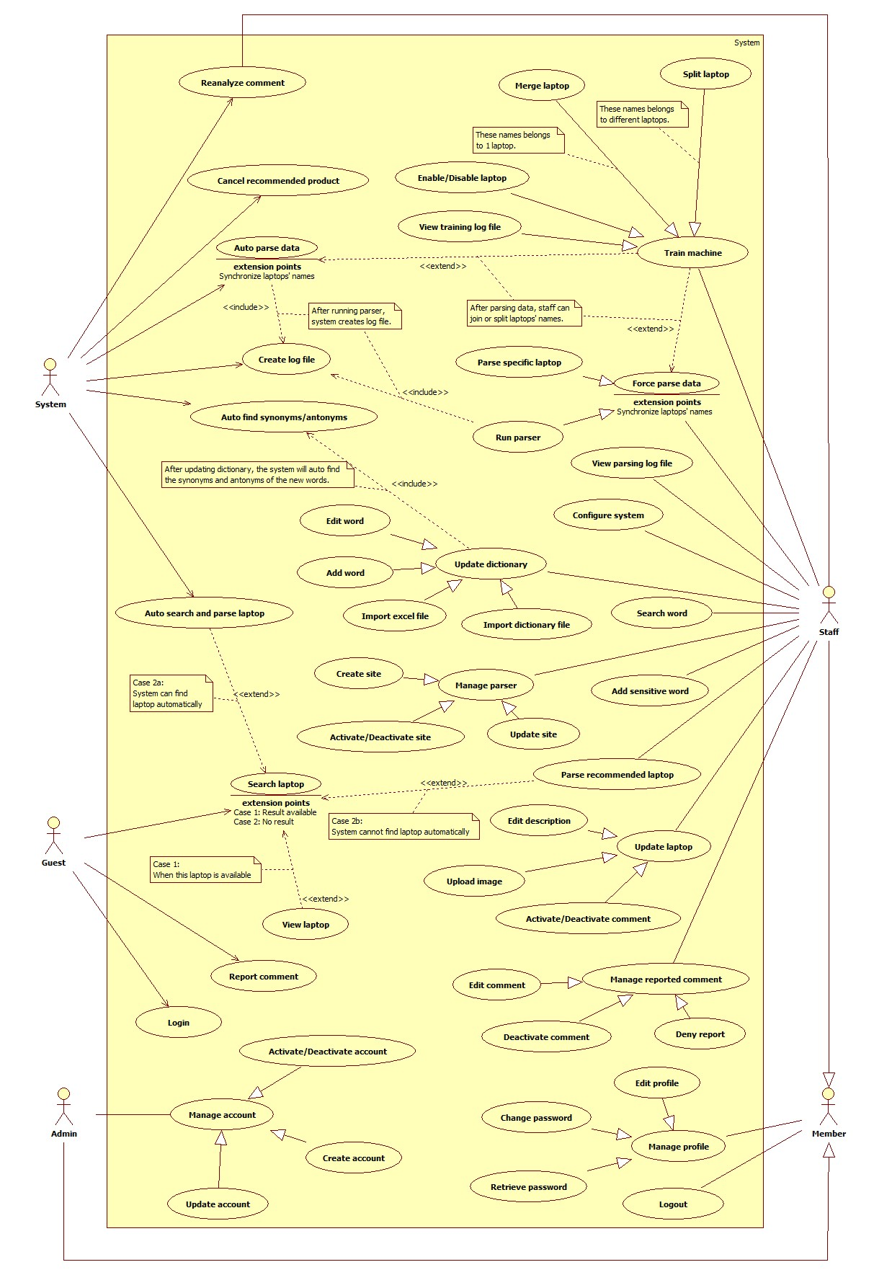

Figure 2: System Overview Use Case

### List of Use Case

#### <Admin> Overview Use Case

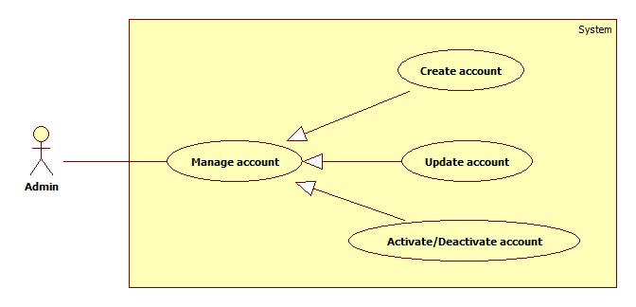

Figure 3: <Admin> Overview Use Case

##### <Admin> Create Account

Use Case Diagram



Figure 4: <Admin> Create Account

Use Case Specification

|  |  |  |  |
| --- | --- | --- | --- |
| **USE CASE – LRA001** | | | |
| **Use Case No.** | LRA001 | **Use Case Version** | 1.0 |
| **Use Case Name** | Create Account | | |
| **Author** | Nguyen Manh Khuong | | |
| **Date** | 28/05/2015 | **Priority** | Normal |
| **Actor:**   * Admin   **Summary:**   * This use case allows admin to create new account in the system.   **Goal:**   * New account will be added to the system.   **Triggers:**   * Admin goes to “Manager Account” page. * Admin choose “Create Account” command.   **Preconditions:**   * User must login the system with admin role.   **Post Conditions:**   * **Success:** New account will be added to the database. * **Fail:** Show error message on the current page.   **Main Success Scenario:**   |  |  |  | | --- | --- | --- | | Step | Actor Action | System Respone | | 1 | Admin goes to “Manager Account” page. | Navigate to “Manager Account” page, which contains:   * “Create Account” command. * A table with 4 columns:   + No.   + Username.   + Role.   + Action. * “No”: label. * “Username”: label. * “Role”: label. * “Edit”: command. * Activate/Deactivate: command | | 2 | Admin choose “Create Account” command. | Navigate to “Create Account” page, which contains:   * Username: free text input, min length: 2, max length: 35, required. * Name: free text input, min length: 2, max length: 35, required. * Email Address: regular expression: /\S+@@\S+\.\S+/, max length: 50, required. * Phone Number: free digits input, max length: 15. * Role: 2 values for admin to choose: “admin”, “staff”. Default value is “admin". * Password: free text input, min length: 2, max length: 35, required. * Confirm Password: free text input, min length: 2, max length: 35, required. * “Create”: command. | | 3 | Admin fills data to the form.  Admin choose “Create” command.  [Alternative 1,2,3,4,5,6] | Insert new account to the database and close the interface  [Exception 1] |   **Alternative Scenario:**   |  |  |  | | --- | --- | --- | | No | Actor Action | System Response | | 1 | “Username” is not in range [2-35]. | “Username” border colour is red. Show error message: “Please specify username”. | | 2 | “Username” has already existed. | Show error message: “This account had been existed. Please try again! ”. | | 3 | “Name” is not in range [2-35]. | “Name” border colour is red. Show error message: “Please specify account’s name”. | | 4 | Invalid email format. | “Email” border colour is red. Show error message: “Your email address must be in format of name@domain.com”. | | 5 | “Password” is not in range [2-35]. | “Password” border colour is red. Show error message: “Please enter at least 6 characters”. | | 6 | “Confirm Password” is not in range | “Confirm password” border colour is red. Show error message: “Please enter at least 6 characters”. | | 7 | “Confirm Password” is not similar “Password” | “Confirm password” border colour is red. Show error message: “Please enter the same value again”. |   **Exceptions:**   |  |  |  | | --- | --- | --- | | No | Actor Action | System Response | | 1 | Cannot create the account due to database connection. | Show error message: “Cannot create account. Try again later.” |   **Relationships:** N/A  **Business Rules:**   * Each created account must be in active state when insert to database. * New account name cannot be the same as existed account in database. * Password and Confirm Password must be similar. * Email format must be “name@domain.com”. | | | |

Table 15: <Admin> Create Account

##### <Admin> Update Account

Use Case Diagram



Figure 5: <Admin> Update Account

Use Case Specification

|  |  |  |  |
| --- | --- | --- | --- |
| **USE CASE – LRA002** | | | |
| **Use Case No.** | LRA002 | **Use Case Version** | 1.0 |
| **Use Case Name** | Update Account | | |
| **Author** | Nguyen Manh Khuong | | |
| **Date** | 28/05/2015 | **Priority** | Normal |
| **Actor:**   * Admin   **Summary:**   * This use case allows admin to update information for user accounts.   **Goal:**   * New account information will be updated to the database.   **Triggers:**   * Admin goes to “Manager Account” page. * Admin choose “Edit” command.   **Preconditions:**   * User must log in system with admin role.   **Post Conditions:**   * **Success:** New information will be updated to the database. * **Fail:** Show error message.   **Main Success Scenario:**   |  |  |  | | --- | --- | --- | | Step | Actor Action | System Response | | 1 | Admin goes to “Manager Account” page and choose “Edit” command. | Navigate to “Edit account” interface, which contains:   * Username: text, disabled. * Name: free text input, min length: 2, max length: 35, required. * Email Address: regular expression: /\S+@@\S+\.\S+/, max length: 50, required. * Phone Number: free text input, max length: 15. * “Save”: command. * “Cancel”: command. | | 3 | Admin updates “Name”, “Email”, “Phone Number”.  Click “Save” command.  [Alternative 1,2,3] | New information will be updated to the database and close the interface.  [Exception 1] |   **Alternative Scenario:**   |  |  |  | | --- | --- | --- | | No | Actor Action | System Response | | 1 | “Name” is not in range [2-35]. | “Name” border colour is red. Show error message: “Please specify account’s name”. | | 2 | Invalid email format. | “Email” border colour is red. Show error message: “Your email address must be in format of name@domain.com”. | | 3 | Admin click “Cancel” command | Close “Edit Account” interface. Back to “Account Management” page. |   **Exceptions:**   |  |  |  | | --- | --- | --- | | No | Actor Action | System Response | | 1 | Cannot update accountdue to database connection. | Show error message: “Cannot update account. Try again later.” |   **Relationships:** N/A  **Business Rules:**   * Cannot edit “Account Name”. * Email format must be “name@domain.com”. | | | |

Table 16: <Admin> Update Account

##### a<Admin> Activate/Deactivate Account

Use Case Diagram

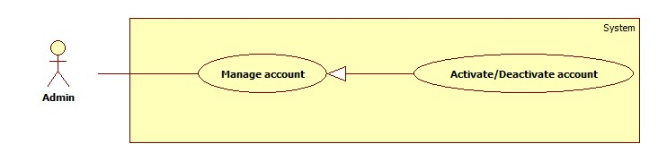

Figure 6: <Admin> Activate/Deactivate Account

Use Case Specification

|  |  |  |  |
| --- | --- | --- | --- |
| **USE CASE – LRA003** | | | |
| **Use Case No.** | LRA003 | **Use Case Version** | 1.0 |
| **Use Case Name** | Activate/Deactivate Account | | |
| **Author** | Nguyen Manh Khuong | | |
| **Date** | 28/05/2015 | **Priority** | Normal |
| **Actor:**   * Admin   **Summary:**   * This user case allows admin to activate/deactivate a user account.   **Goal:**   * Deactivated accounts will be activated or activated accounts will be deactivated.   **Triggers:**   * Admin goes to “Manager Account” page. * Admin choose “Activate/Deactivate” command.   **Preconditions:**   * User must log in the system with admin role.   **Post Conditions:**   * **Success:** The selected account will be activated/deactived. * **Fail:** Database connection is not available. Show error message   **Main Success Scenario:**   |  |  |  | | --- | --- | --- | | Step | Actor Action | System Response | | 1 | Admin goes to “Manager Account” page and choose “Activate/Deactivate” command. | The account will be activating/deactivating and button name change to “Activate” or “Deactivate”  [Exception 1,2] |   **Alternative Scenario:** N/A  **Exceptions:**   |  |  |  | | --- | --- | --- | | No | Actor Action | System Response | | 1 | Cannot activate the account Due to database connection. | Show error message: “Cannot active the account. Try again later.” | | 2 | Cannot deactivate the account Due to database connection. | Show error message: “Cannot deactivate the account. Try again later.” |   **Relationships:** N/A  **Business Rules:**   * Admins can’t activate/deactivate account of themselves or other admins. | | | |

Table 17: <Admin> Activate/Deactivate Account

#### <Staff > Overview Use Case

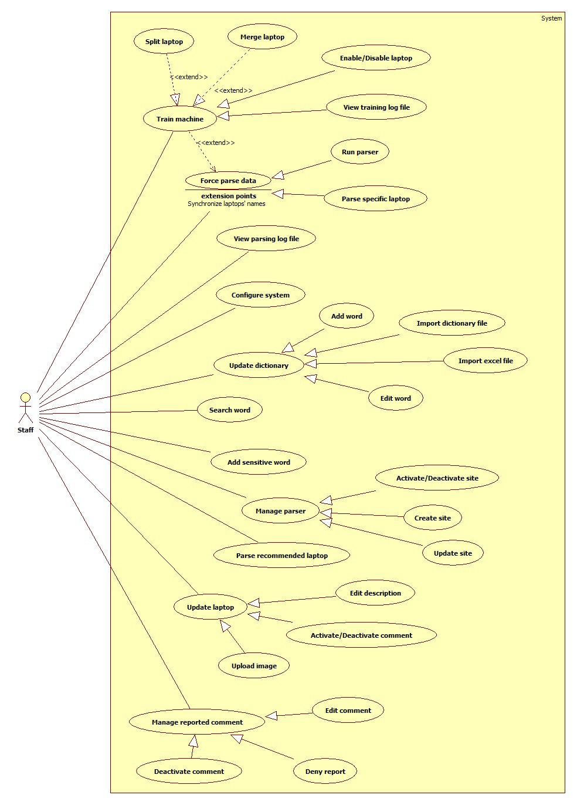

Figure 7: <Staff> Overview Use Case

##### <Staff> Merge Laptop

Use Case Diagram

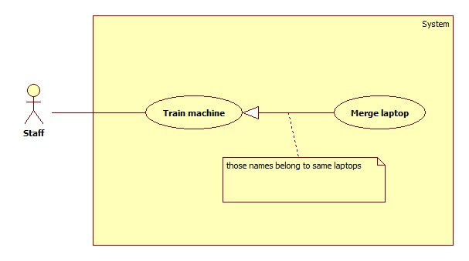

Figure 8: <Staff> Merge Laptop

Use Case Specification

|  |  |  |  |
| --- | --- | --- | --- |
| **USE CASE – LRA004** | | | |
| **Use Case No.** | LRA004 | **Use Case Version** | 1.0 |
| **Use Case Name** | Merge Laptop | | |
| **Author** | Dinh Huu Toan | | |
| **Date** | 05/06/2015 | **Priority** | High |
| **Actor:**   * Staff.   **Summary:**   * This use case allows staff to merge duplicated laptops   **Goal:**   * Duplicated laptops are merged together with main laptop chosen by staff.   **Triggers:**   * Staffs send command to merge duplicated laptops   **Preconditions:**   * User has logged in with staff role. * System has detected duplicated laptops after parsing.   **Post Conditions:**   * **Success**: Selected duplicated laptops are merged and added. * **Fail:** Show messages to indicate sufficient problems.   **Main Success Scenario:**   |  |  |  | | --- | --- | --- | | Step | Actor Action | System Response | | 1 | Staff goes to Training Machine page  [Alternative 1] | Show “Training Machine” page which includes:   * Total duplicated products: text * Disabled duplicated products: link to Disabled duplicated products page * Search: free text input, length 1 – 200 * “Show log file”: submenu, link to Show log file page * Table contains duplicated products which are grouped base on matching percent of their names. Table includes:   + Selected duplicated products: check 2 or more duplicated products, required  + Product Name: text  + Website: text  + Main: select one from many options, required  + Action: commands for staff to handle duplicated products, includes:   * Merge: command to merge selected products * Split: command to split selected products * Disable: command to disable selected products | | 2 | Staff selects some products in duplicated products group, choose Main product then send command to Merge products  [Alternative 2,3] | * System shows message to require staff’s confirmation for Merge process includes:   + Confirmation messages: text  + Process: command to process the request  + Cancel: command to cancel the request | | 3 | Staff sends Process command  [Alternative 4] | * System reload current page. Selected products are merged. Selected products information is saved.[Exception 1] |   **Alternative Scenario:**   |  |  |  | | --- | --- | --- | | No | Actor Action | System Response | | 1 | There is no duplicated product that need to handle | * Show message to indicate that there is no duplicated products | | 2 | Staff does not choose main product or selected main product does not belong to selected products or staff choose product that is already selected as main product | * Show message to notify invalid main product | | 3 | Staff selects only one product and set it as main product then send Merge command | * Show message to notify that Merge cannot be handle with only one product and ask for Split command instead [Alternative 5,6] | | 4 | Staff send command to cancel merge proccess | * Nothing happens | | 5 | Staff send command to process Split | * System saves selected product | | 6 | Staff send command to cancel Split process | * Nothing happens |   **Exceptions:**   |  |  |  | | --- | --- | --- | | No | Exception | System Response | | 1 |  | * Merged products information cannot be added. * Show message to notify the error |   **Relationships:**   * Split Laptop   **Business Rules:**   * After merging, comments and images of duplicated products will be added to main product. If description of duplicated product is better than main product, then description of main product will be replaced by description of duplicated product. * After merging, processed products will be removed from list duplicated products. * Merge can only be done with 2 or more duplicated products. * If staff select only one product and send Merge command, system will ask for Split command instead of Merge. * Staff must choose main product before processing Merge. * System will automatically goes to “Show Disabled Duplicated Products” page after 5 seconds if there is no duplicated product | | | |

Table 18: <Staff> Merge Laptop

##### <Staff> Split Laptop

**Use case Diagram**

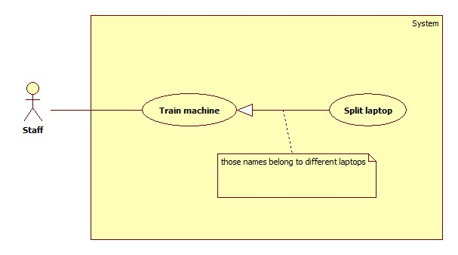

Figure 9: <Staff> Update Parser

|  |  |  |  |
| --- | --- | --- | --- |
| **USE CASE – LRA005** | | | |
| **Use Case No.** | LRA005 | **Use Case Version** | 1.0 |
| **Use Case Name** | Split Laptop | | |
| **Author** | Dinh Huu Toan | | |
| **Date** | 05/06/2015 | **Priority** | High |
| **Actor:**   * Staff.   **Summary:**   * This use case allows staff to split duplicated laptops from duplicated group   **Goal:**   * Duplicated laptops are split and save as new laptop.   **Triggers:**   * Staffs send command to split duplicated laptops   **Preconditions:**   * User has logged in with staff role. * System has detected duplicated laptops after parsing   **Post Conditions:**   * **Success**: Selected duplicated laptops are split and added as new laptops. * **Fail**: Show messages to indicate sufficient problems.   **Main Success Scenario:**   |  |  |  | | --- | --- | --- | | Step | Actor Action | System Response | | 1 | Staff goes to Training machine page  [Alternative 1] | Show “Training Machine” page which includes:   * Total duplicated products: text * Disabled duplicated products: link to Disabled duplicated products page * Search: free text input, length 1 – 200 * “Show log file”: submenu, link to Show log file page * Table contains duplicated products which are grouped base on matching percent of their names. Table includes:   + Selected duplicated products: check 2 or more duplicated products, required  + Product Name: text  + Website: text  + Main: select one from many options, required  + Action: commands for staff to handle duplicated products, includes:   * Merge: command to merge selected products * Split: command to split selected products * Disable: command to disable selected products | | 2 | Staff selects some products and send Split command  [Alternative 2] | * System shows message to require staff’s confirmation for Split process includes:   + Confirmation messages: text  + Process: command to process the request  + Cancel: command to cancel the request | | 3 | Staff sends command to process request  [Alternative 3] | * System reload current page. Selected products are split and added with its comments, description and images[Exception 1] |   **Alternative Scenario:**   |  |  |  | | --- | --- | --- | | No | Actor Action | System Response | | 1 | There is no duplicated product that need to handle | * Show message to indicate that there is no duplicated products | | 2 | Staff does not choose products to split or they choose product that is already main product | * Show message to require staff selection | | 3 | Staff sends command to cancel request | * Nothing happens |   **Exceptions:**   |  |  |  | | --- | --- | --- | | No | Exception | System Response | | 1 |  | * Split products information cannot be added. * Show message to notify the error |   **Relationships:** N/A  **Business Rules:**   * After splitting, processed products will be removed from list duplicated products * System will automatically goes to “Show Disabled Duplicated Products” page after 5 seconds if there is no duplicated product * Staff must choose at least one product before processing Split | | | |

Table 19: <Staff> Split Laptop

##### <Staff> Enable/Disable Laptop

**Use Case Diagram**

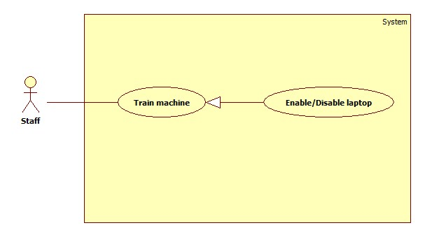

Figure 10: <Staff> Enable/Disable laptop

**Use case Specification**

|  |  |  |  |
| --- | --- | --- | --- |
| **USE CASE – LRA006** | | | |
| **Use Case No.** | LRA006 | **Use Case Version** | 1.0 |
| **Use Case Name** | Enable/Disable laptop | | |
| **Author** | Dinh Huu Toan | | |
| **Date** | 05/06/2015 | **Priority** | High |
| **Actor:**   * Staff.   **Summary:**   * This use case allows staff to enable/disable laptops   **Goal:**   * Laptops are enabled/disabled   **Triggers:**   * Staff sends command to Disable/Enable laptop   **Preconditions:**   * User has logged in with staff role. * System has detected duplicated laptops after parsing   **Post Conditions:**   * **Success**: Laptop is disabled/enabled successfully * **Fail**: Show messages to indicate sufficient problems.   **Main Success Scenario:**   |  |  |  | | --- | --- | --- | | Step | Actor Action | System Response | | 1 | Staff clicks “Training Machine” sub menu.  [Alternative 1] | Show “Training Machine” page which includes:   * Total duplicated products: text * Disabled duplicated products: link to Disabled duplicated products page * Search: free text input, length 1 – 200 * “Show log file”: submenu, link to Show log file page * Table contains duplicated products which are grouped base on matching percent of their names. Table includes:   + Selected duplicated products: check 2 or more duplicated products, required  + Product Name: text  + Website: text  + Main: select one from many options, required  + Action: commands for staff to handle duplicated products, includes:   * Merge: command to merge selected products * Split: command to split selected products * Disable: command to disable selected products | | 2 | Staff sends command to disable selected product  [Alternative 2] | * System shows message to require staff’s confirmation for disable process includes:   + Confirmation messages: text  + Process: command to process the request  + Cancel: command to cancel the request | | 3 | Staff sends command to process request | * Selected product is disabled.[Exception 1] |   **Alternative Scenario:**  **Alternative 1:**   |  |  |  | | --- | --- | --- | | Step | Actor Action | System Response | | 1 | There is no duplicated product that need to handle | * Show message to indicate that there is no duplicated products |   **Alternative 2:**   |  |  |  | | --- | --- | --- | | Step | Actor Action | System Response | | 1 | Staff goes to disabled duplicated products page | * Go to disabled duplicated products page. This pages include: * Number of total disabled duplicated products: text * Train machine: link to train machine page * Search: free text input, length 1 - 200 * Table contains disabled duplicated products which are grouped base on matching percent of their names. Table includes:   + Name: text  + Website: text  + Action: commands for staff to handle duplicated products, includes:   * Enable: command to enable a product | | 2 | Staff click “Enable” button of one product | * System shows message to require staff’s confirmation for enable process includes:   + Confirmation messages: text  + Process: command to process the request  + Cancel: command to cancel the request | | 3 | Staff send command to process request [Alternative 3] | * Product is enabled [Exception 2] |   **Alternative 3:**   |  |  |  | | --- | --- | --- | | Step | Actor Action | System Response | | 1 | Staff sends command to cancel request | * Nothing happens |   **Exceptions:**   |  |  |  | | --- | --- | --- | | No | Exception | System Response | | 1 |  | * Selected product cannot be Disabled * Show message to notify the error | | 2 |  | * Selected product cannot be Enabled * Show message to notify the error |   **Relationships**: N/A  **Business Rules:**   * If disabled product is main product which is the product that has been saved in the system, the system will check for number of members in that duplicated product list for appropriate action:   + If there are only 2 members in that group and the first one is main product, the other one will be split  + If there are more than 2 members in that group, the second product will be chosen as main product. All of its information will be saved. | | | |

Table 20: <Staff> Enable/Disable laptop

##### <Staff> View Training Log File

**Use Case Diagram**

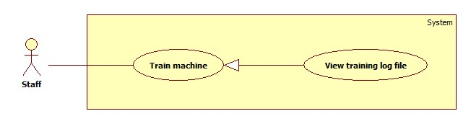

Figure 11: <Staff> View Training Log File

**Use Case Specification**

|  |  |  |  |
| --- | --- | --- | --- |
| **USE CASE – LRA007** | | | |
| **Use Case No.** | LRA007 | **Use Case Version** | 1.0 |
| **Use Case Name** | View Training Log File | | |
| **Author** | Dinh Huu Toan | | |
| **Date** | 06/06/2015 | **Priority** | High |
| **Actor:**   * Staff.   **Summary:**   * This use case allows staff to view training log file   **Goal:**   * Training log file appear with appropriate information   **Triggers:**   * Staff sends command to show log file   **Preconditions:**   * User has logged in with staff role.   **Post Conditions:**   * **Success**: Training log file appear with appropriate information * **Fail:** N/A   **Main Success Scenario:**   |  |  |  | | --- | --- | --- | | Step | Actor Action | System Response | | 1 | Staff clicks “Training Machine” sub menu.  [Alternative 1] | Show “Training Machine” page which includes:   * Total duplicated products: text * Disabled duplicated products: link to Disabled duplicated products page * Search: free text input, length 1 – 200 * “Show log file”: submenu, link to Show log file page * Table contains duplicated products which are grouped base on matching percent of their names. Table includes:   + Selected duplicated products: check 2 or more duplicated products, required  + Product Name: text  + Website: text  + Main: select one from many options, required  + Action: commands for staff to handle duplicated products, includes:   * Merge: command to merge selected products * Split: command to split selected products * Disable: command to disable selected products | | 3 | Staff send command to show products log file | * Navigate to “Show Products Log File” with table includes:   + Product index: text  + Product Image: image  + Product Name: text  + Action Type: text  + Updated Date: text [Alternative 1] |   **Alternative Scenario:**   |  |  |  | | --- | --- | --- | | No | Actor Action | System Response | | 1 | Staff send command to show log products file but there is no handled product | * Show message to notify that there is no product in log file |   **Exceptions:** N/A  **Relationships:**   * Merge Laptop * Split Laptop   **Business Rules:**   * Main products’ names are appeared in bold * If there is no product in log file, system will automatically go to Train Machine page after 5 seconds | | | |

Table 21: <Staff> View Training Log File

##### <Staff> Parse Specific Laptop

Use Case Diagram

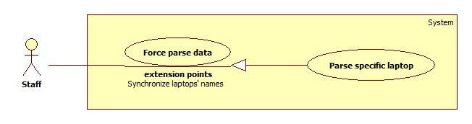

Figure 12: <Staff> Parse Specific Laptop

Use Case Specification

|  |  |  |  |
| --- | --- | --- | --- |
| **USE CASE – LRA008** | | | |
| **Use Case No.** | LRA008 | **Use Case Version** | 1.0 |
| **Use Case Name** | Parse Specific Laptop | | |
| **Author** | Vo Thi Minh Chau | | |
| **Date** | 30/05/2015 | **Priority** | High |
| **Actor:**   * Staff.   **Summary:**   * This use case allows staff to parse a specific laptop.   **Goal:**   * This laptop will be inserted or updated successfully.   **Triggers:**   * Staff sends command to parse a specific laptop.   **Preconditions:**   * User has logged in with staff role.   **Post Conditions:**   * **Success**: This laptop will be inserted or updated successfully. Show success message. * **Fail:** Show error message.   **Main Success Scenario:**   |  |  |  | | --- | --- | --- | | Step | Actor Action | System Response | | 1 | - Staff goes to “Run Parser” page. | - Show “Run Parser” page which includes 2 tabs: “Parse a specific product” tab (chosen default) and “Parse all product” tab.  - The “Parse a specific product” tab contains:  + “Url of the product”: free text input, required.  + “Parse Product”: command. | | 2 | - Staff inputs url of laptop which will be parsed to “Url of the product”, then sends “Parse Product” command. | - If this product was not existed, the system will parse and insert new product. Otherwise, it will be updated. [Alternative 1]  - Show success message. |   **Alternative Scenario:**   |  |  |  | | --- | --- | --- | | Step | Actor Action | System Response | | 1 | - Staff sends “Yes” command. | - If this url does not belong to existed sites in the system, show message to ask whether the staff wants to create new site.  - The system redirect to “Create New Site” Page (refer use case LRA). |   **Exceptions:**   |  |  |  | | --- | --- | --- | | Step | Actor Action | System Response | | 1 | - Error while parsing product. | - Show error message. |   **Relationships:** N/A  **Business Rules:**   * With each existed product, only the new valid comments will be parsed.   + New comments are comments which be written after the last comment’s date of this product.   + Valid comments are comments which are satisfied these following rules:     - Have at least 5 words.     - Do not include sensitive words.     - Have >70% correct spelling words. * If this product’s is similar to another existed product, it will be saved to xml file. | | | |

Table 22: <Staff> Parse Specific Laptop

##### <Staff> Run Parser

Use Case Diagram

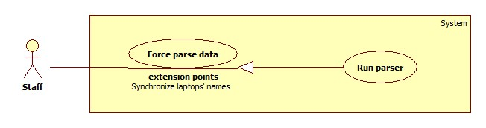

Figure 13: <Staff> Activate Parser

Use Case Specification

|  |  |  |  |
| --- | --- | --- | --- |
| **USE CASE – LRA009** | | | |
| **Use Case No.** | LRA009 | **Use Case Version** | 1.0 |
| **Use Case Name** | Run Parser | | |
| **Author** | Vo Thi Minh Chau | | |
| **Date** | 02/06/2015 | **Priority** | High |
| **Actor:**   * Staff.   **Summary:**   * This use case allows staff to run parser.   **Goal:**   * The parser will be run.   **Triggers:**   * Staff sends command to run parser.   **Preconditions:**   * User has logged in with staff role.   **Post Conditions:**   * **Success**: Parser will be run. Show list of parsed products and success message. * **Fail:** Show error message.   **Main Success Scenario:**   |  |  |  | | --- | --- | --- | | Step | Actor Action | System Response | | 1 | - Staff goes to “Run Parser” page. | - Show “Run Parser” page which includes 2 tabs: “Parse a specific product” tab (chosen default) and “Parse all product” tab.  - The “Parse a specific product” tab contains:  + “Url of the product”: free text input  + “Parse Product”: command | | 2 | - Staff clicks “Parse all product”.  [Alternative 1] | - Show “Parse all product” tab with a “Run Parser” command. | | 3 | - Staff sends “Run Parser” command.  [Alternative 2, 3] | - Show a page that contains:  + “Stop Parser”: command  + “Skip”: command  + Status of progess: progress bar with a text  + A table with 3 columns: No, Product which is being parsed and Status  - Get list of url which will be parsed from the existed sites.  - Parse data [Exception 1].  - Analyze comments.  - Insert data to system.  - Generate log file. |   **Alternative Scenario:**  [Alternative 1]   |  |  |  | | --- | --- | --- | | Step | Actor Action | System Response | | 1 | - Staff inputs url of laptop which will be parsed to “Url of the product”, then send “Parse Product” command. | - Refer use case LRA008. |   [Alternative 2]   |  |  |  | | --- | --- | --- | | Step | Actor Action | System Response | | 1 | - Staff sends “Skip” command. | - Skip all rest urls of this parsing site, then continue to parse data from next site. |   [Alternative 3]   |  |  |  | | --- | --- | --- | | Step | Actor Action | System Response | | 1 | - Staff sends “Stop Parser” command. | - Stop the parser and show message. |   **Exceptions:**   |  |  |  | | --- | --- | --- | | Step | Actor Action | System Response | | 1 | - Error while parsing data. | - Show error message. |   **Relationships:** N/A  **Business Rules:**  - The system will parse all existed active sites.  - The system will parse the n-first products and all existed product of this site. (n is configured by staff brefore)  - With each existed product, only the new valid comments will be parsed (define of new valid comments: refer use case LRA008).  - If this product’s is similar to another existed product, it will be saved to xml file.  - While parsing progress, the table will be updated with the being parsed url. If this url is parsed successfully, its status will be the “tick” icon. Otherwise, the “x” icon will be shown.  - The progress bar is specified for each site. When finishing parsing each site, the progress bar is reset.  - When staff sends “Skip” command, the progress bar will be reset.  - If the last site is skipped of the staff sends “Stop Parser” command, the progess bar is set to 100%.  - When the progress finishes, a notification with the number of duplicated product will be shown. | | | |

Table 23: <Staff> Run Parser

##### <Staff> View Parsing Log File

**Use Case Diagram**

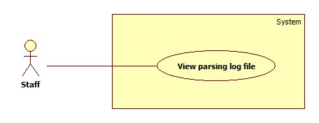

Figure 14: <Staff> View Parsing Log File

|  |  |  |  |
| --- | --- | --- | --- |
| **USE CASE – LRA010** | | | |
| **Use Case No.** | LRA0010 | **Use Case Version** | 1.0 |
| **Use Case Name** | Configure system | | |
| **Author** | Vo Thi Minh Chau | | |
| **Date** | 02/06/2015 | **Priority** | High |
| **Actor:**   * Staff.   **Summary:**   * This use case allows staff to view parsing log files.   **Goal:**   * Staff can view log files.   **Triggers:**   * Staff sends command to view log file.   **Preconditions:**   * User must log in the system with staff role.   **Post Conditions:**   * **Success:** Log file will be shown. * **Fail:** Log file cannot be shown.   **Main Success Scenario:**   |  |  |  | | --- | --- | --- | | Step | Actor Action | System Response | | 1 | - Staff goes to “Log File” page. | Show “Log File” page which contains:  - A table with 4 columns:  + No  + Created Time  + Action | | 2 | Staff sends “View” command. | This log file will be shown. [Exception 1] |   **Alternative Scenario:** N/A  **Exceptions:**   |  |  |  | | --- | --- | --- | | No | Actor Action | System Response | | 1 | Connection to database error. | Show error message. |   **Relationships:** N/A  **Business Rules:**   * List of all log file is sorted by created date descending. | | | |

Table 24: <Staff> View Parsing Log File

##### <Staff> Configure System

Use Case Diagram

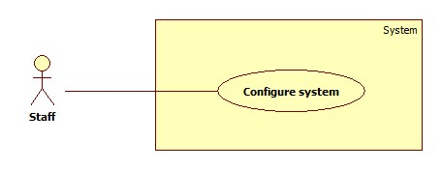

Figure 15: <Staff> Configure System

Use Case Specification

|  |  |  |  |
| --- | --- | --- | --- |
| **USE CASE – LRA011** | | | |
| **Use Case No.** | LRA0011 | **Use Case Version** | 1.0 |
| **Use Case Name** | Configure system | | |
| **Author** | Vo Thi Minh Chau | | |
| **Date** | 02/06/2015 | **Priority** | High |
| **Actor:**   * Staff.   **Summary:**   * This use case allows staff to configure the system.   **Goal:**   * System parameters will be updated.   **Triggers:**   * Staff sends command to save the configuration.   **Preconditions:**   * User must log in the system with staff role.   **Post Conditions:**   * **Success:** New parameter will be saved to configuration file. * **Fail:** Nothing is saved to configuration file.   **Main Success Scenario:**   |  |  |  | | --- | --- | --- | | Step | Actor Action | System Response | | 1 | - Staff goes to “System Configuration” page. | Show “System Configuration” page which contains:  - “Daily reanalyzing time”: time input, required.  - “Daily parsing time”: time input, required.  - “Number of product”: free text input, required, max length: 2  - “Limited day”: free text input, required, max length: 2  - “Save”: command | | 2 | - Staff changes system parameters.  - Staff sends “Save” command. | - Save data to configuration file [Exception 1].  - Show success message. |   **Alternative Scenario:** N/A  **Exceptions:**   |  |  |  | | --- | --- | --- | | No | Actor Action | System Response | | 1 |  | - Cannot open configuration file.  - Show error message. |   **Relationships:** N/A  **Business Rules:**   * “Daily reanalyzing time” means the time the system reanalyses all comments automatically. * “Daily parsing time” means the time the system runs parser automatically. * “Number of product” means the number of product of each site which will be parsed automatically. * “Number of product” and “Limited day” must be under 100. | | | |

Table 25: <Staff> Configure System

##### <Staff> Search Word

Use Case Diagram

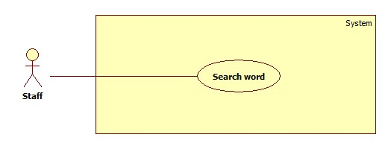

Figure 16: <Staff> Search Word

Use Case Specification

|  |  |  |  |
| --- | --- | --- | --- |
| **USE CASE – LRA012** | | | |
| **Use Case No.** | LRA0012 | **Use Case Version** | 2.0 |
| **Use Case Name** | Search Word | | |
| **Author** | Dinh Huu Toan | | |
| **Date** | 03/06/2015 | **Priority** | High |
| **Actor:**   * Staff   **Summary:**   * This use case helps staff to search for available word in dictionary   **Goal:**   * Show appropriate word to staff.   **Triggers:**   * Staff send command to search   **Preconditions:**   * User should login to the system under Staff role.   **Post Conditions:**   * **Success:** Show list of appropriate words * **Fail:** N/A.   **Main Success Scenario:**   |  |  |  | | --- | --- | --- | | Step | Actor Action | System Response | | 1 | Staff goes to dictionary management page | Show “Dictionary Management” page with following information:   * Search, free text input, length 1 -20 * Add new: command to add new word * Word: link to definition of word * Definition of first word of list of words: text * Edit word: command to show edit word form | | 2 | Input search string into search free text input. | Show result with following information:   * Edit command * List of appropriate results * Definition of selected word includes:   + Word: text  + Word type: text  + Word class: text  + Synonyms: text  + Antonyms: text  [Alternative 1] |   **Alternative Scenario:**   |  |  |  | | --- | --- | --- | | No | Actor Action | System Response | | 1 | System cannot find word match search string. | Show a message to notify no suitable word |   **Exceptions:** N/A  **Relationships:** N/A  **Business Rules:**   * The list is sorted by alphabetical order. * System will automatically show definition of first word in the list of word after searching * System will automatically search for synonyms and antonyms of words in the first time those words are selected | | | |

Table 26: <Staff> Search Word

##### <Staff> Add Word

Use Case Diagram

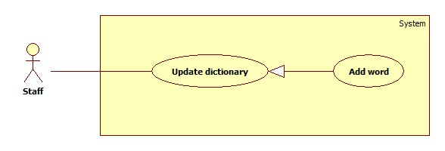

Figure 17: <Staff> Add word

Use Case Specification

|  |  |  |  |
| --- | --- | --- | --- |
| **USE CASE – LRA013** | | | |
| **Use Case No.** | LRA0013 | **Use Case Version** | 2.0 |
| **Use Case Name** | Add word | | |
| **Author** | Dinh Huu Toan | | |
| **Date** | 03/06/2015 | **Priority** | High |
| **Actor:**   * Staff   **Summary:**   * This use case help staff to add new word to dictionary   **Goal:**   * New word is added to dictionary   **Triggers:**   * Staff sends command to add new word   **Preconditions:**   * User should login to the system under Staff role.   **Post Conditions:**   * **Success:** New word is added to dictionary. * **Fail:** Show an error message.   **Main Success Scenario:**   |  |  |  | | --- | --- | --- | | Step | Actor Action | System Response | | 1 | Staff goes to dictionary management page | Show “Dictionary Management” page with following information:   * Search, free text input, length 1 -20 * Add new: command to add new word * Word: link to definition of word * Definition of first word of list of words: text * Edit word: command to show edit word form | | 2 | Staff send command to add new word | System show add new word information:   * Word: free text input, length 1 -20, required [Alternative 1,2] * Type: select one in 5 options: Pros/Cons/Neutral/Negative/Totally Pros * Class: select on in 5 option: Noun/Verb/Adverb/Adjective/Others * Synonyms: free text input * Antonyms: free text input * “Add New Word” command * “Reset” command | | 3 | Staff fills in all fields and sends “Add New Word” command[Alternative 2] | New word is added to the dictionary. Show success message [Exception 1] |   **Alternative Scenario:**   |  |  |  | | --- | --- | --- | | No | Actor Action | System Response | | 1 | Inputted word is already in dictionary | System will automatically change Add form to Edit form [Reference to Use case LRA014] | | 2 | Staff does not input word | Show message to require staffs to input word | | 2 | Staff send “Reset” command | All inputted fields are reset |   **Exceptions:**   |  |  |  | | --- | --- | --- | | No | Actor Action | System Response | | 1 |  | - New word cannot be added  - Show message to notify error |   **Relationships:** Edit Word  **Business Rules:**   * After successfully add new word, system will show that word definition field for staff to check again. * If staffs input word which is already in database, system will automatically go to edit form of that word * When inputting antonyms or synonyms of word, system will show suggestion words. Each synonym/antonym is separated by “,” * If staff does not input new word, system will disable add command * Default option of Type is “Pros”, default option of Class is “Adjective” | | | |

Table 27: < Staff> Add Word

##### <Staff> Edit Word

Use Case Diagram

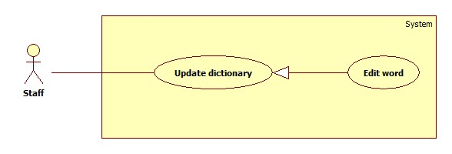

Figure 18: <Staff> Edit Word

Use Case Specification

|  |  |  |  |
| --- | --- | --- | --- |
| **USE CASE – LRA014** | | | |
| **Use Case No.** | LRA0014 | **Use Case Version** | 2.0 |
| **Use Case Name** | Edit word | | |
| **Author** | Dinh Huu Toan | | |
| **Date** | 03/06/2015 | **Priority** | High |
| **Actor:**   * Staff   **Summary:**   * This use case help staff to edit word in dictionary.   **Goal:**   * Selected word is edited.   **Triggers:**   * Staff sends command to edit word   **Preconditions:**   * User should login to the system under Staff role. * That word should be available in the dictionary.   **Post Conditions:**   * **Success:** Edited information will be saved. * **Fail:** Show an error message.   **Main Success Scenario:**   |  |  |  | | --- | --- | --- | | Step | Actor Action | System Response | | 1 | Staff goes to dictionary management page | Show “Dictionary Management” page with following information:   * Search, free text input, length 1 -20 * Add new: command to add new word * Word: link to definition of word * Definition of first word of list of words: text * Edit word: command to show edit word form | | 2 | Input search string into search free text input. | Show result with following information:   * Edit command * List of appropriate results * Definition of selected word includes:   + Word: text  + Word type: text  + Word class: text  + Synonyms: text  + Antonyms: text  [Alternative 1] | | 3 | Staff send command to edit word | System show edit word information:   * Word: text * Type: select one in 5 options: Pros/Cons/Neutral/Negative/Totally Pros * Class: select on in 5 option: Noun/Verb/Adverb/Adjective/Others * Synonyms: free text input * Antonyms: free text input * “Save” command * “Reset” command | | 4 | Staff sends command to save new information  [Alternative 1] | * New information of word is saved |   **Alternative Scenario:**   |  |  |  | | --- | --- | --- | | No | Actor Action | System Response | | 1 | Staff send command to reset input fields | All inputted fields are cleared. |   **Exceptions:**   |  |  |  | | --- | --- | --- | | No | Actor Action | System Response | | 1 |  | - New information of word cannot be added  - Show message to notify error |   **Relationships:** Search Word  **Business Rules:**   * After successfully edit word, system will show that word definition field for staff to check again. * System will show available synonyms and antonyms of selected words. Staff can add new or delete synonyms/antonyms | | | |

**Table 28: <Staff> Edit Word**

##### <Staff> Import Excel File

Use Case Diagram

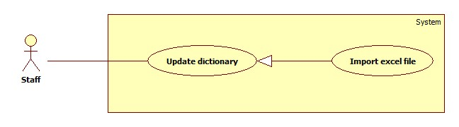

Figure 19: <Staff> Import Excel File

Use Case Specification

|  |  |  |  |
| --- | --- | --- | --- |
| **USE CASE – LRA0015** | | | |
| **Use Case No.** | LRA0015 | **Use Case Version** | 1.0 |
| **Use Case Name** | Import Excel File | | |
| **Author** | Nguyen Manh Khuong | | |
| **Date** | 30/05/2015 | **Priority** | Normal |
| **Actor:**   * Staff.   **Summary:**   * This use case allows staff to import new words into the system by using an excel file.   **Goal:**   * Add new words into the system data.   **Triggers:**   * Staff goes to “Manage Dictionary” page. * Staff click “Import Excel File” command.   **Preconditions:**   * User must log in the system with Staff role.   **Post Conditions:**   * **Success:** New words will be inserted into the system data. * **Fail:** Show an error message.   **Main Success Scenario:**   |  |  |  | | --- | --- | --- | | Step | Actor Action | System Response | | 1 | Staff goes to “Manage Dictionary” page and choose “Import Excel File” command. | Show “Import Excel File” page which contains:   * “Select file”: command. * “Import”: command. | | 2 | Choose “Choose file” command. | Show “Open” dialog box. | | 3 | Select a file and choose “Open” command. | Show “Import Excel File” page which contains that filename next to “Choose file” command. | | 4 | Send “Submit” command.  [Alternative 1],  [Alternative 2],  [Alternative 3] | Read excel file, filter and add words are contained in file to a list.  Show list of new words in table with 3 columns:   * “Select”: allow to choose or not. * “Word”: free text input. * “Type”: a list of values for staff to choose, include: Pros, Cons, Neutral or Negative. * “Save to Database”: command. | | 5 | Staff selects which word will be save to the system and sends “Save” command. | Save selected word(s) to the system. Find synonyms and antonyms of each word. Show synonyms and antonyms in tables. Each table has 2 tabs, each tabs has 2 columns:   * “Select”: allow to choose or not. * “Word”: free text input.   [Exception 1] | | 6 | Staff selects which synonyms and antonyms will be save to the system and sends “Save” command. | Save selected word(s) to the system. Find synonyms and antonyms of each word.  [Exception 1] |   **Alternative Scenario:**   |  |  |  | | --- | --- | --- | | No | Actor Action | System Response | | 1 | No file is chosen | Show message: “Please upload a file!” | | 2 | Extension of the chosen file is not supported. | Show message: “Please upload an Excel file! (.xlsx or xls)” | | 3 | Excel file is incorrect structure. | Show message: “Excel file is not valid format!” |   **Exceptions:**   |  |  |  | | --- | --- | --- | | No | Actor Action | System Response | | 1 | Connection to database error. | Show error message: “Cannot save to database! Please try again later.” |   **Relationships:** Dictionary Management  **Business Rules:**   * Words already existed in database will be removed from list. * Misspelled words will be indicated by red color in text input field. * Correct spelling words will be unchangeable and checked “Selected” as default. * File extension is Microsoft Office Excel (.xlsx or .xls) * File must have at least 1 row data. * File structure must be formatted as below: * Valid file format example:   Figure 20: Valid Excel File   * Invalid file format example:     Figure 21: Invalid Excel File | | | |

Table 29: <Staff> Import Excel File

##### <Staff> Import Dictionary File

Use Case Diagram

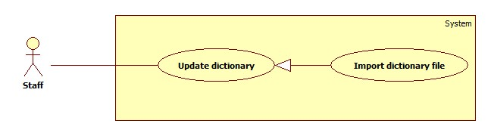

Figure 22: <Staff> Import Dictionary File

Use Case Specification

|  |  |  |  |
| --- | --- | --- | --- |
| **USE CASE – LRA0016** | | | |
| **Use Case No.** | LRA0016 | **Use Case Version** | 1.0 |
| **Use Case Name** | Import Excel File | | |
| **Author** | Nguyen Manh Khuong | | |
| **Date** | 30/05/2015 | **Priority** | Normal |
| **Actor:**   * Staff.   **Summary:**   * This use case allows staff to import new dictionary word(s) into the system by using a text file (*.txt).   **Goal:**   * Add new dictionary word(s) into the system data.   **Triggers:**   * Staff goes to “Manage Dictionary” page. * Staff click “Import Dictionary File” command.   **Preconditions:**   * User must log in the system with Staff role.   **Post Conditions:**   * **Success:** New words will be inserted into the system data. * **Fail:** Show an error message.   **Main Success Scenario:**   |  |  |  | | --- | --- | --- | | Step | Actor Action | System Response | | 1 | Staff goes to “Manage Dictionary” page and choose “Import Dictionary File” command. | Show “Import Dictionary File” page which contains:   * “Select file”: command. * “Dictionary type” have 2 option :   + “Lingoes Dictionary”.   + “Synonym and Antonym Dictionary”. * “Import”: command. | | 2 | Choose “Choose file” command. | Show “Open” dialog box. | | 3 | Staff select a file, select type of dictionary and choose “Import” command.  [Alternative 1],  [Alternative 2],  [Alternative 3] | Show message number of word(s) is added to the system.  [Exception 1] |   **Alternative Scenario:**   |  |  |  | | --- | --- | --- | | No | Actor Action | System Response | | 1 | No file is chosen | Show message: “Please upload a file!” | | 2 | Extension of the chosen file is not supported. | Show message: “Please upload a text file! (.txt)” | | 3 | Text file is incorrect structure. | Show message: “Text file is not valid format!” |   **Exceptions:**   |  |  |  | | --- | --- | --- | | No | Actor Action | System Response | | 1 | Connection to database error. | Show error message: “Cannot save to database! Please try again later.” |   **Relationships:** Dictionary Management  **Business Rules:**   * Words already existed in database will be ignored. * Misspelled words will be indicated by red color in text input field. * Correct spelling words will be unchangeable and checked “Selected” value. * File extension is text file(.txt) * Valid Synonym and Antonym Dictionary file example:     Figure 23: Valid Synonym and Antonym Dictionary file   * Valid Lingoes Dictionary file example:     Figure 24: Valid Lingoes Dictionary file | | | |

Table 30: <Staff> Import Dictionary File

##### <Staff> Create Site

**Use Case Diagram**

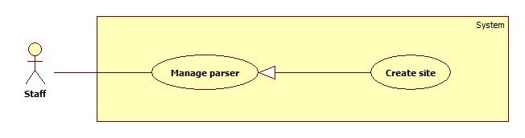

Figure 25: <Staff> Create Site

**Use Case Specification**

|  |  |  |  |
| --- | --- | --- | --- |
| **USE CASE – LRA017** | | | |
| **Use Case No.** | LRA017 | **Use Case Version** | 1.0 |
| **Use Case Name** | Create Site | | |
| **Author** | Vo Thi Minh Chau | | |
| **Date** | 02/06/2015 | **Priority** | High |
| **Actor:**   * Staff.   **Summary:**   * This use case allows staff to create new site for parser.   **Goal:**   * New site will be created.   **Triggers:**   * Staff sends command to create new site.   **Preconditions:**   * User has logged in with Staff role.   **Post Conditions:**   * **Success**: New site is added to the system. Show success message. * **Fail:** Show error message.   **Main Success Scenario:**   |  |  |  | | --- | --- | --- | | Step | Actor Action | Sstem Response | | 2 | Staff goes to “Create New Site” page. | Show “Create New Site” page which includes:   * “Url of site”: free text input. * “View”: command. | | 3 | Staff inputs url and sends “View” command.  [Alternative 1] | Show wizard to create a new site which includes:   * Status bar with 6 steps – 1st step is chosen. * “Xpath of Product's Name”: free text input. * “Next”: command. * Staff’s selected page: “Preview” area | | 4 | At steps 1: “Product’s name”, staff clicks the mouse at the area which include product’s name in “Preview” area.  [Alternative 2] | “Xpath of Product’s name” will be filled with the xpath string, required. | | 5 | Staff sends “Next” command. | Show wizard to create a new site which includes:   * Status bar with 6 steps – 2nd step is chosen. * “Xpath of Brand”: free text input. * “NA”: command. * “Next”: command. * “Previous”: command. * Staff’s selected page: “Preview” area | | 6 | At steps 2: “Product’s brand”, staff clicks the mouse at the area which include product’s brand in “Preview” area.  [Alternative 3, 4, 5] | “Xpath of Brand” will be filled with the xpath string. | | 7 | Staff sends “Next” command. | Show wizard to create a new site which includes:   * Status bar with 6 steps – 3rd step is chosen. * Xpath of Description: free text input. * “NA”: command * Next: command. * “Previous”: command. * Staff’s selected page: “Preview” area | | 8 | At step 3: “Description”, staff clicks the mouse at the area which include image information in “Preview” area.  [Alternative 6, 7, 8] | “Xpath of Description” will be filled with the xpath string, required. | | 9 | Staff sends “Next” command. | Show wizard to create a new site which includes:   * Status bar with 6 steps – 4th step is chosen. * “Xpath of Image”: free text input. * “NA”: command. * “Next”: command. * “Previous”: command * Staff’s selected page: “Preview” area | | 10 | At step 4: “Image”, staff click the mouse at the area which includes product’s description in “Preview” area.  [Alternative 9, 10, 11] | “Xpath of Image” will be filled with the xpath string. | | 11 | Staff sends “Next” command. | Show wizard to create a new site which includes:   * Status bar with 6 steps – 5th step is chosen. * Xpath of Commented Date: free text input. * Xpath of Date’s Format: free text input. * “Next”: command. * “Previous”: command. * Staff’s selected page: “Preview” area | | 12 | At step 5: “Commented date”, staff click the mouse at the area which include commented date in “Preview” area.  [Alternative 12, 13] | “Xpath of Commented Date” will be filled with the xpath string, required. | | 13 | Staff sends “Next” command. | Show wizard to create a new site which includes:   * Status bar with 6 steps – last step is chosen. * “Xpath of Comment’s Content”: free text input. * “Next”: command. * “Previous”: command. * Staff’s selected page: “Preview” area   [Alternative 4] | | 14 | At step 6: “Comment’s content”, staff click the mouse at the area which include comment’s content in “Preview” area.  [Alternative 14, 15] | “Xpath of Comment’s Content” will be filled with the xpath string, required. | | 15 | Staff sends “Finish” command. | Get data from the inputted url based on the chosen XPaths.  System shows:  - Title “Preview Product’s Information”.  - The name, brand, description, image, the commented date and content of the first comment of this products.  - “Create New Site”: command.  - “Close”: command. | | 16 | Staff sends “Create New Site” command.  [Alternative 16] | Save this site and show message.  [Exception 1]. |   **Alternative Scenario:**   |  |  |  | | --- | --- | --- | | No | Actor Action | System Response | | 1 | “Url of product” is blank and staff sends “View” command. | Show message error: “Please input url of product which will be parsed”. | | 2 | “Xpath of product’s name” is blank and staff sends “Next” command. | Show message error: “Please select name of product which will be parsed”. | | 3 | “Xpath of brand” is blank and staff sends “Next” command. | Show message error: “Please select brand of product which will be parsed”. | | 4 | Staff sends “NA” command. | Fill “NA” to “Xpath of description” free text input. | | 5 | Staff sends “Previous” command | Show the 1st step with the content of “Xpath of product’s name” filled. | | 6 | “Xpath of description” is blank and staff sends “Next” command. | Show message error: “Please select description of product which will be parsed”. | | 7 | Staff sends “NA” command. | Fill “NA” to “Xpath of description” free text input. | | 8 | Staff sends “Previous” command. | Show the 2nd step with the content of “Xpath of brand” filled. | | 9 | “Xpath of image” is blank and staff sends “Next” command. | Show message error: “Please select image of product which will be parsed”. | | 10 | Staff sends “NA” command. | Fill “NA” to “Xpath of image” free text input. | | 11 | Staff sends “Previous” command. | Show the 3rd step with the content of “Xpath of description” filled. | | 12 | “Xpath of commented date” is blank and staff sends “Next” command. | Show message error: “Please select commented date which will be parsed”. | | 13 | Staff sends “Previous” command. | Show the 4th step with the content of “Xpath of image” filled. | | 14 | “Xpath of comment’s content” is blank and staff sends “Finish” command. | Show message error: “Please select comment’s content which will be parsed”. | | 15 | Staff sends “Previous” command. | Show the 5th step with the content of “Xpath of commented date” filled. | | 16 | Staff sends “Close” command. | Show the last step with the content of “Xpath of image” filled. |   **Exceptions:**   |  |  |  | | --- | --- | --- | | No | Actor Action | System Response | | 1 | - Fail to update to database. | - Display error message “Cannot connect to the database. Please try again!” |   **Relationships:** N/A  **Business Rules:**   * The data display structure of that page should be for a specified product. * When staff sends “Finish” command after finishing all steps, the system will parse data from the selected url and get name, brand, description, image, the commented date and content of the first comment to show. * At the 5th step, if the inputted format is wrong or the format is blank, the system will find the correct date’s format automatically. | | | |

Table 31: <Staff> Process error product

##### <Staff> Update Site

**Use Case Diagram**

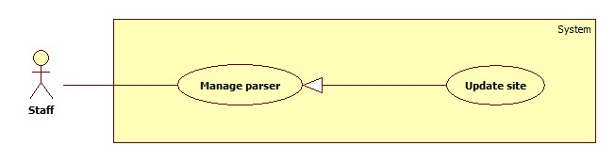

Figure 26: <Staff> Update Site

**Use Case Specification**

|  |  |  |  |
| --- | --- | --- | --- |
| **USE CASE – LRA0018** | | | |
| **Use Case No.** | LRA0018 | **Use Case Version** | 1.0 |
| **Use Case Name** | Update Site | | |
| **Author** | Vo Thi Minh Chau | | |
| **Date** | 02/06/2015 | **Priority** | High |
| **Actor:**   * Staff   **Summary:**   * This use case allows staff to update site in parser.   **Goal:**   * Site will be updated.   **Triggers:**   * Staff sends command to update this site.   **Preconditions:**   * User must log in the system with staff role.   **Post Conditions:**  **Success**: Site will be updated.   * **Fail:** Site cannot be updated.   **Main Success Scenario:**   |  |  |  | | --- | --- | --- | | Step | Actor Action | System Response | | 1 | - Staff goes to “Site Management” page. | - Show “Site Management” page which contains:  + A table with 3 columns:   * No * Domain * Action (with 2 commands: “Activate/Deactivate” and “Edit”) | | 2 | - Staff sends “Edit” command [Alternative 1] | - Show detail of this site which contains:  + “Domain”: text  + “Name's Xpath”: free text input, required  + “Brand’s Xpath”: free text input  + “Description's Xpath”: free text input  + “Image’s Xpath”: free text input  + “Date's Xpath”: free text input, required  + “Date’s Format”: free text input  + “Content’s Xpath”: free text input, required  + “Go to the parser wizard to edit this site”: hyperlink  + “Save”: command  + “Cancel”: command | | 3 | - Staff inputs site’s detail.  - Staff sends “Save” command [Alternative 1] [Alternative 2]. | - Update site’s detail [Exception 1]. |   **Alternative Scenario:**  [Alternative1]   |  |  |  | | --- | --- | --- | | Step | Actor Action | System Response | | 1 | - Staff clicks hyperlink. | - Redirect to “Create New Site” page (refer user case LRA017). |   [Alternative 2]   |  |  |  | | --- | --- | --- | | Step | Actor Action | System Response | | 1 | - Staff sends “Cancel” command. | - Return the “Site Management” page. |   **Exceptions:**   |  |  |  | | --- | --- | --- | | Step | Actor Action | System Response | | 1 | - Fail to update to database. | - Display error message “Cannot connect to the database. Please try again!” |   **Relationships:** N/A  **Business Rules:**   * When the site’s detail is shown, all detail will be loaded in suitable free text input. * When redirecting to “Create New Site” page, the first product’s url which belongs to this site will be loaded to “Url of this site” free text input. | | | |

Table 32: <Staff> Update Site

##### <Staff> Activate/Deactivate Site

**Use Case Diagram**

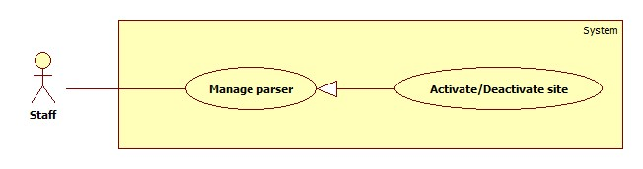

Figure 27: <Staff> Activate/Deactivate Site

**Use Case Specification**

|  |  |  |  |
| --- | --- | --- | --- |
| **USE CASE – LRA0019** | | | |
| **Use Case No.** | LRA0019 | **Use Case Version** | 1.0 |
| **Use Case Name** | Activate/Deactivate Site | | |
| **Author** | Vo Thi Minh Chau | | |
| **Date** | 02/06/2015 | **Priority** | High |
| **Actor:**   * Staff   **Summary:**   * This use case allows staff to activate/deactivate site in parser.   **Goal:**   * Site will be activated/deactivated.   **Triggers:**   * Staff sends command to activate/deactivate site.   **Preconditions:**   * User must log in the system with staff role.   **Post Conditions:**  **Success**: Site will be activated/deactivated.   * **Fail:** Status of site cannot be updated.   **Main Success Scenario:**   |  |  |  | | --- | --- | --- | | Step | Actor Action | System Response | | 1 | - Staff goes to “Site Management” page. | - Show “Site Management” page which contains:  + A table with 3 columns:   * No * Domain * Action (with 2 commands: “Activate/Deactivate” and “Edit”) | | 2 | - Staff sends “Activate/Deactivate” command [Alternative 1] | - Activate/Deactivate this site [Exception 1]. |   **Alternative Scenario:**  [Alternative1]   |  |  |  | | --- | --- | --- | | Step | Actor Action | System Response | | 1 | - Staff sends “Edit” command. | - Show detail of this site (refer user case LRA018). |   **Exceptions:**   |  |  |  | | --- | --- | --- | | Step | Actor Action | System Response | | 1 | - Fail to update to database. | - Display error message “Cannot connect to the database. Please try again!” |   **Relationships:** N/A  **Business Rules:**   * When deactivating a site, this site will not be parsed data in the next parser running times. | | | |

Table 33: <Staff> Activate/Deactivate Site

##### <Staff> Parse Recommended Laptop

**Use Case Diagram**

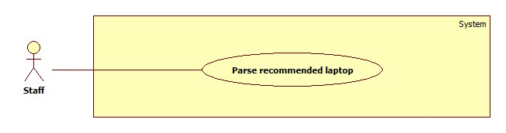

Figure 28: <Staff> Parse Recommended Laptop

**Use Case Specification**

|  |  |  |  |
| --- | --- | --- | --- |
| **USE CASE – LRA020** | | | |
| **Use Case No.** | LRA020 | **Use Case Version** | 1.0 |
| **Use Case Name** | Parse recommended laptop | | |
| **Author** | Vo Thi Minh Chau | | |
| **Date** | 02/06/2015 | **Priority** | High |
| **Actor:**   * Staff   **Summary:**   * This use case allows staff to parse recommended laptop.   **Goal:**   * Recommended laptop will be parsed.   **Triggers:**   * Staff sends command to parse product.   **Preconditions:**   * User must log in the system with staff role.   **Post Conditions:**   * **Success**: Recommended laptop will be parsed. * **Fail:** Recommended laptop cannot be parsed.   **Main Success Scenario:**   |  |  |  | | --- | --- | --- | | Step | Actor Action | System Response | | 1 | - Staff goes to “Recommended Product” page. | - Show “Recommended Product” page which contains:  + A table with 4 columns:   * No * Product’s Name * Sent Date * Status | | 2 | - Staff clicks a product’s name. | - Show detail of this comment which includes:  + “Product’s Name”: text  + “Guest’s Email”: text  + “Sent Time”: text  + “Status”: text  + “Url which will be parse”: free text input  + “Parse Product”: command  + “OK”: command  [Alternative 1] | | 3 | - Staff inputs url of this product then sends “Parse product” command. | - Parse this product and send notification mail to guest [Alternative 2] [Exception 1, 2]. |   **Alternative Scenario:**  [Alternative 1]   |  |  |  | | --- | --- | --- | | Step | Actor Action | System Response | | 1 |  | If status of this product is “Sent”:  - Show detail of this comment which includes:  + “Product’s Name”: text  + “Guest’s Email”: text  + “Sent Time”: text  + “Status”: text  + “OK”: command | | 2 | - Staff sends “OK” command. | - Return the “Recommended Product” page. |   [Alternative 2]   |  |  |  | | --- | --- | --- | | Step | Actor Action | System Response | | 1 |  | - If this url does not belong to any existed site, redirect to “Create New Site” page (refer use case LRA017).  - After creating new site, parse this product and sent notification mail to guest [Exception 1, 2] |   **Exceptions:**   |  |  |  | | --- | --- | --- | | No | Actor Action | System Response | | 1 | - Fail to update to database. | - Display error message “Cannot connect to the database. Please try again!” | | 2 | - Notification mail cannot be sent. | - Set the status “Added”. |   **Relationships:** N/A  **Business Rules:**   * List of all recommended product is sorted by sent date descending and only the products which are in limited time are shown. * The row of product which has not been seen is bold. After viewing detail of this, the row becomes normal style. * Each recommended product has 4 types of status:   + Pending: if this cannot be found automatically and is waiting for handling.   + Added: if this was be added to system but cannot be sent email to guests.   + Sent: if this was be added to system and be sent email to guests successfully.   + Cancel: if this is out of date for handling. | | | |

Table 34: <Staff> Parse Recommended Product

##### <Staff> Edit Description

**Use case diagram**

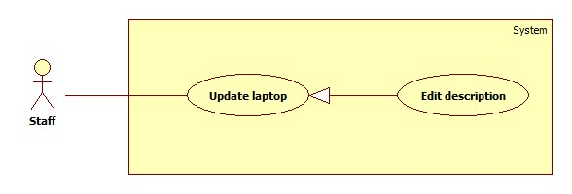

Figure 29: <Staff> Edit Description

**Use case Specification**

|  |  |  |  |
| --- | --- | --- | --- |
| **USE CASE – LRA021** | | | |
| **Use Case No.** | LRA021 | **Use Case Version** | 1.0 |
| **Use Case Name** | Edit Description | | |
| **Author** | Dinh Huu Toan | | |
| **Date** | 05/06/2015 | **Priority** | High |
| **Actor:**   * Staff   **Summary:**   * This use case allows staffs to edit description of a laptop   **Goal:**   * New description of selected laptop is updated   **Triggers:**   * Staffs go to Product Detail page and send “Edit” command in that page.   **Preconditions:**   * User must log in the system with staff role. * Edited product must be available   **Post Conditions:**   * **Success**: : New description of laptop is saved and load on Product Detail page * **Fail:** Cannot saved description to database. Show error message   **Main Success Scenario:**   |  |  |  | | --- | --- | --- | | Step | Actor Action | System Response | | 1 | From staff page, staffs send “Product Management” command and then send “All products” command | Show a table contains all products with following information:   * No: text * Product Id: text * Product Name: a link to product detail page * Updated Time: text | | 2 | Staffs send “Product Detail” command of a product | Show a Product Detail page with following information:   * Images of product: Image [Alternative 2] * Description of product: text * Comments of product: text * Deactivate/Activate Product command * Edit Description command * Deactivate/Activate comments command | | 3 | Staffs send “Edit Description” command | A form appears with following information:   * Type: free text input * Screen size: free text input * Screen resolution: free text input * Bundled OS: dropdown list, 4 options: Windows, Mac, Linux, Other * Processor Speed: free text input * System Ram: number format input * Maximum battery life: free text input * Weight: number format input only * Released: Date time input * Save command * Cancel command | | 4 | Staffs input all information and send “Save” command  [Alternative 1] | New description is saved. Load new description to page  [Exception 1] |   **Alternative Scenario:**   |  |  |  | | --- | --- | --- | | No | Actor Action | System Response | | 1 | Staff send “Cancel” command | Nothing happens | | 2 |  | If that product does not have any image, show:   * Upload Images command * Select images command |   **Exceptions:**   |  |  |  | | --- | --- | --- | | NO | Exception | System Response | | 1 |  | * Cannot save new description * Show message to notify error |   **Relationships:** N/A  **Business Rules:**   * Staff can only input number to RAM and Weight. | | | |

**Table 35: <Staff> Edit Description**

##### <Staff> Upload Image

**Use case Diagram**

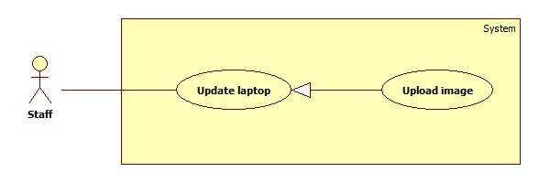

Figure 30: <Staff> Upload Image

**Use case Specification**

|  |  |  |  |
| --- | --- | --- | --- |
| **USE CASE – LRA022** | | | |
| **Use Case No.** | LRA022 | **Use Case Version** | 1.0 |
| **Use Case Name** | Upload image | | |
| **Author** | Dinh Huu Toan | | |
| **Date** | 05/06/2015 | **Priority** | High |
| **Actor:**   * Staff   **Summary:**   * This use case allows staff to upload images.   **Goal:**   * Uploaded images are saved and loaded to Product Detail page.   **Triggers:**   * Staffs access “Product Detail” page, choose images and send “Submit” command.   **Preconditions:**   * User must log in the system with staff role. * Staff can only upload images to products that don’t have images.   **Post Conditions:**   * **Success**: Images are uploaded and showed on Product Detail page. * **Fail:** Cannot save images. Show error messages   **Main Success Scenario:**   |  |  |  | | --- | --- | --- | | Step | Actor Action | System Response | | 1 | From staff page, staffs send “Product Management” command and then send “No Image” command | Show a table contains all no-image-products with following information:   * No: text * Product Id: text * Product Name: link to product detail page * Updated Time: text | | 2 | Staffs send “Product Detail” command of a product | Show a Product Detail page with following information:   * Select images command * Upload image command * Description of product: text * Comments of product: text * Deactivate/Activate Product command * Deactivate/Activate comment command * Edit Description command | | 3 | Staffs send “Select images” command | Show a form for staff to select images from their computer | | 4 | Staffs choose some images | Selected images are loaded on page for reviewing  Show “Submit” command | | 5 | Staff send “Submit” command | Images are saved and loaded to page |   **Alternative Scenario:** N/A  **Exceptions:**   |  |  |  | | --- | --- | --- | | No | Exceptions | System Response | | 1 |  | * Images cannot be saved * Show message to notify error |   **Relationships:** N/A  **Business Rules:**   * Only no-image products can be uploaded images to reduce the chance that staff will upload non-relevant images to products that already have images * Staff can upload image format file only | | | |

Table 36: <Staff> Upload Image

##### <Staff> Activate/Deactivate Comment

**Use case Diagram**

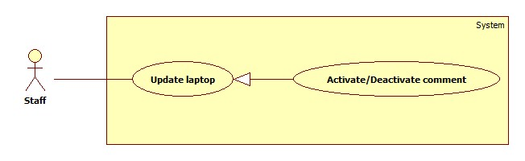

System

**Staff**

**Manager product**

**Import hardware file**

**Save correct hardware**

**Process duplicate hardware**

<<extend>>

<<extend>>

Figure 31: <Staff> Activate/Deactivate comment

**Use case Specification**

|  |  |  |  |
| --- | --- | --- | --- |
| **USE CASE – LRA023** | | | |
| **Use Case No.** | LRA023 | **Use Case Version** | 1.0 |
| **Use Case Name** | Activate/Deactivate comment | | |
| **Author** | Dinh Huu Toan | | |
| **Date** | 03/06/2015 | **Priority** | High |
| **Actor:**   * Staff   **Summary:**   * This use case allows staff to Activate/Deactivate comment   **Goal:**   * Selected comment is activated/deactivate   **Triggers:**   * Staff sends activate/deactivate comment command in Product Detail page   **Preconditions:**   * User must log in the system with staff role.   **Post Conditions:**   * **Success**: selected comment is activated/deactivated * **Fail:** selected comment cannot be activated/deactivated. Show error message   **Main Success Scenario:**   |  |  |  | | --- | --- | --- | | Step | Actor Action | System Response | | 1 | From staff page, staffs send “Product Management” command and then send “All Products” command | Show a table contains all products with following information:   * No: text * Product Id: text * Product Name: link to product detail page * Updated Time: text | | 2 | Staffs send “Product Detail” command of a product | Show a Product Detail page with following information:   * Images of product: Image [Alternative 1] * Description of product: text * Comments of product: text * Deactivate/Activate Product command * Edit Description command * Deactivate/Activate comments command | | 3 | Staffs sends “Deactivate comment” command [Alternative 2] | Comment is deactivated [Exception 1] |   **Alternative Scenario:**   |  |  |  | | --- | --- | --- | | No | Actor Action | System Response | | 1 |  | If that product does not have any image, show:   * Upload Images command * Select images command | | 2 | Staff sends “Activate comment” command | Comment is activated [Exception 1] |   **Exceptions:**   |  |  |  | | --- | --- | --- | | No | Exception | System Response | | 1 |  | * Comment cannot be activated/deactivated * Show message to notify error |   **Relationships:** N/A  **Business Rules:**   * After being deactivated, the command next to deactivated comment will be “Activated”. * After being activated, the command next to activated comment will be “Deactivated”. | | | |

**Table 37: <Staff> Activate/Deactivate Comment**

##### <Staff> Edit Comment

**Use Case Diagram**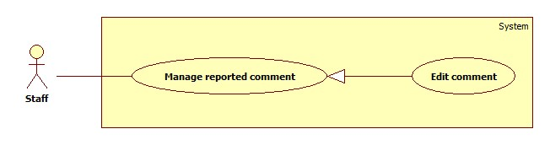

Figure 32: <Staff> Edit Comment

**Use Case Specification**

|  |  |  |  |
| --- | --- | --- | --- |
| **USE CASE – LRA0024** | | | |
| **Use Case No.** | LRA0024 | **Use Case Version** | 1.0 |
| **Use Case Name** | Edit comment | | |
| **Author** | Vo Thi Minh Chau | | |
| **Date** | 02/06/2015 | **Priority** | High |
| **Actor:**   * Staff   **Summary:**   * This use case allows staff to edit reported comment.   **Goal:**   * Comment will be updated.   **Triggers:**   * Staff sends command to edit comment.   **Preconditions:**   * User must log in the system with staff role.   **Post Conditions:**   * **Success**: Comment will be updated successfully. * **Fail:** Comment cannot be update.   **Main Success Scenario:**   |  |  |  | | --- | --- | --- | | Step | Actor Action | System Response | | 1 | - Staff goes to “Product Management” page. | - Show the “Product Management” page which includes 4 tabs:  + All products  + No image  + No description  + Reported comments (chosen default)  - The “Parse a specific product” tab contains:  + A table with 4 columns:   * No * Comment * Date * Action (with 3 commands: “Edit”, “Deny” and “Deactivate”) | | 2 | - Staff sends “Edit” command. | - Show detail of this comment which includes:  + “Content”: free text input  + “Type”: a list of value, includes: Positive, Neutral, Negative and Undefined.  + A hyperlink to this product’s detail page.  + “Save”: command  + “Cancel”: command | | 3 | - Staff edits this comment.  - Staff sends “Save” command.  [Alternative 1] | - Save new detail of this comment [Exception 1]. |   **Alternative Scenario:**  [Alternative 1]   |  |  |  | | --- | --- | --- | | Step | Actor Action | System Response | | 1 | - Staff sends “Cancel” command. | - Return the “Product Management” page. |   **Exceptions:**   |  |  |  | | --- | --- | --- | | Step | Actor Action | System Response | | 1 | - Fail to update to database. | - Display error message “Cannot connect to the database. Please try again!” |   **Relationships:** N/A  **Business Rules:**   * When the comment’s detail is shown, the current type of this comment will be loaded at “Type”. * After editing comment, this comment will be removed from list of reported comment and the table will be reloaded. | | | |

Table 38: <Staff> Edit Comment

##### <Staff> Deactivate Comment

**Use Case Diagram**

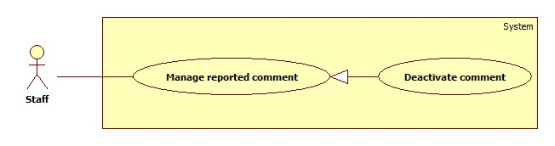

Figure 33: <Staff> Deactivate Comment

**Use Case Specification**

|  |  |  |  |
| --- | --- | --- | --- |
| **USE CASE – LRA0025** | | | |
| **Use Case No.** | LRA0025 | **Use Case Version** | 1.0 |
| **Use Case Name** | Deactivate comment | | |
| **Author** | Vo Thi Minh Chau | | |
| **Date** | 02/06/2015 | **Priority** | High |
| **Actor:**   * Staff   **Summary:**   * This use case allows staff to deactivate comment.   **Goal:**   * Comment will be deactivated.   **Triggers:**   * Staff sends command to deactivate this comment.   **Preconditions:**   * User must log in the system with staff role.   **Post Conditions:**   * **Success**: Comment will be updated successfully. * **Fail:** Comment cannot be updated.   **Main Success Scenario:**   |  |  |  | | --- | --- | --- | | Step | Actor Action | System Response | | 1 | - Staff goes to “Product Management” page. | - Show the “Product Management” page which includes 4 tabs:  + All products  + No image  + No description  + Reported comments (chosen default)  - The “Parse a specific product” tab contains:  + A table with 4 columns:   * No * Comment * Date * Action (with 3 commands: “Edit”, “Deny” and “Deactivate”) | | 2 | - Staff sends “Deactivate” command. | - Deactivate this comment [Exception 1]. |   **Alternative Scenario:** N/A  **Exceptions:**   |  |  |  | | --- | --- | --- | | Step | Actor Action | System Response | | 1 | - Fail to update to database. | - Display error message “Cannot connect to the database. Please try again!” |   **Relationships:** N/A  **Business Rules:**   * After deactivating comment, this comment will be removed from list of reported comment and the table will be reloaded. * When the comment is deactivated, it will not be shown in product’s detail page. | | | |

Table 39: <Staff> Deactivate Comment

##### <Staff> Deny Report

**Use Case Diagram**

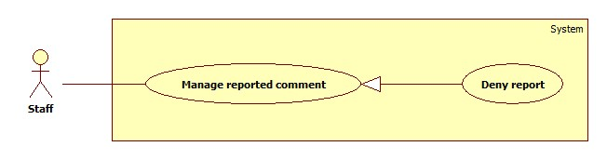

Figure 34: <Staff> Deny Report

**Use Case Specification**

|  |  |  |  |
| --- | --- | --- | --- |
| **USE CASE – LRA0026** | | | |
| **Use Case No.** | LRA0026 | **Use Case Version** | 1.0 |
| **Use Case Name** | Deny report | | |
| **Author** | Vo Thi Minh Chau | | |
| **Date** | 02/06/2015 | **Priority** | High |
| **Actor:**   * Staff   **Summary:**   * This use case allows staff to deny report.   **Goal:**   * This report will be denied.   **Triggers:**   * Staff sends command to deny this comment.   **Preconditions:**   * User must log in the system with staff role.   **Post Conditions:**   * **Success**: This report will be updated successfully. * **Fail:** Comment cannot be updated.   **Main Success Scenario:**   |  |  |  | | --- | --- | --- | | Step | Actor Action | System Response | | 1 | - Staff goes to “Product Management” page. | - Show the “Product Management” page which includes 4 tabs:  + All products  + No image  + No description  + Reported comments (chosen default)  - The “Parse a specific product” tab contains:  + A table with 4 columns:   * No * Comment * Date * Action (with 3 commands: “Edit”, “Deny” and “Deactivate”) | | 2 | - Staff sends “Deny” command. | - Deactivate this comment [Exception 1]. |   **Alternative Scenario:** N/A  **Exceptions:**   |  |  |  | | --- | --- | --- | | Step | Actor Action | System Response | | 1 | - Fail to update to database. | - Display error message “Cannot connect to the database. Please try again!” |   **Relationships:** N/A  **Business Rules:**   * After denying comment, this comment will be removed from list of reported comment and the table will be reloaded. | | | |

Table 40: <Staff> Deny Report

##### <Staff> Reanalyse Comment

**Use case diagram**

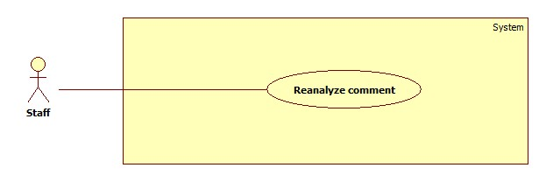

Figure 35: <Staff> Reanalyse Comment

**Use case Specification**

|  |  |  |  |
| --- | --- | --- | --- |
| **USE CASE – LRA027** | | | |
| **Use Case No.** | LRA0027 | **Use Case Version** | 1.0 |
| **Use Case Name** | Reanalyse Comment | | |
| **Author** | Dinh Huu Toan | | |
| **Date** | 23/05/2015 | **Priority** | High |
| **Actor:**   * Staff   **Summary:**   * This use case allows staffs to reanalyse comment   **Goal:**   * Comments are reanalysed.   **Triggers:**   * Staffs send “Reanalyse” command   **Preconditions:**   * User must log in the system with staff role.   **Post Conditions:**   * **Success**: Comments are reanalysed successfully. * **Fail:** Show error message and require staff try one more time.   **Main Success Scenario:**   |  |  |  | | --- | --- | --- | | Step | Actor Action | System Response | | 1 | Staffs send “Dictionary” command | Show “Dictionary Management” command  Show “Import Excel File” command  Show “Import Dictionary File” command  Show “Reanalyse” command | | 2 | Staffs send “Reanalyse” command | * Show a sign indicates that system is reanalysing comments. * After successfully re-analysing comments, show message to indicate the success [Exception 1] |   **Alternative Scenario:N/A**  **Exceptions:**   |  |  |  | | --- | --- | --- | | No | Exception | System Response | | 1 |  | * Comments cannot be reanalysed * Show message to notify error |   **Relationships:** N/A.  **Business Rules:**   * Analysing comments takes much time, system will show an animation to indicate that the command is processing. | | | |

**Table 41: <Staff> Reanalyse Comment**

##### <Staff> Add sensitive Word

**Use Case Diagram**

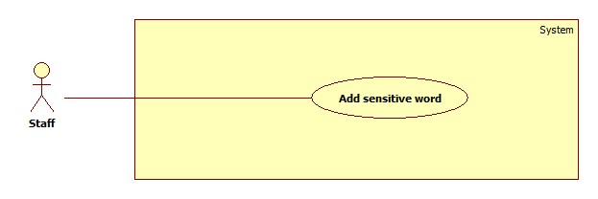

Figure 36: <Staff> Add sensitive Word

**Use Case Specification**

|  |  |  |  |
| --- | --- | --- | --- |
| **USE CASE – LRA028** | | | |
| **Use Case No.** | LRA0028 | **Use Case Version** | 1.0 |
| **Use Case Name** | Add sensitive word | | |
| **Author** | Dinh Huu Toan | | |
| **Date** | 23/05/2015 | **Priority** | High |
| **Actor:**   * Staff   **Summary:**   * This use case allows staffs to add sensitive word   **Goal:**   * Sensitive word is added.   **Triggers:**   * Staffs select sensitive word and send “Add sensitive word” command   **Preconditions:**   * User must log in the system with staff role.   **Post Conditions:**   * **Success**: Sensitive word is successfully added. * **Fail:** Show error message and require staff try one more time.   **Main Success Scenario:**   |  |  |  | | --- | --- | --- | | Step | Actor Action | System Response | | 1 | From staff page, staffs send “Product Management” command and then send “All products” command  [Alternative 1] | Show a table contains all products with following information:   * No: text * Product Id: text * Product Name: link to product detail page * Updated Time: text | | 2 | Staffs send “Product Detail” command of a product | Show a Product Detail page with following information:   * Images of product * Description of product * Table contains comments of product * Deactivate/Activate Product command * Edit Description command | | 3 | Staffs select sensitive word and send “Add sensitive word” command | Sensitive word is added. Show message to notify that sensitive word is added. [Exception 1] |   **Alternative Scenario:**  **Alternative 1:**   |  |  |  | | --- | --- | --- | | Step | Actor Action | System Response | | 1 | From staff page, staffs send “Product Management” command and then send “Reported comment” command | Show “Reported Comment” part with these information:   * No: text * Comment: text * Date: text * Action: actions help handle reported comment. Include: Edit command, Deny command , Deactivate command | | 3 | Staffs select sensitive word and send “Add sensitive word” command | Sensitive word is added. Show message to notify that sensitive word is added. [Exception 1] |   **Exceptions:**   |  |  |  | | --- | --- | --- | | No | Exception | System Response | | 1 |  | * Comments cannot be reanalysed * Show message: “Sorry, we cannot add sensitive word right now! Please try again later! Thank you!” |   **Relationships:** N/A.  **Business Rules:**   * When staff process add sensitive word command in [Alternative 1], after adding sensitive word, the comment contains that word is disappeared. * After adding sensitive word in [Main Success Scenario], the comment contains that word is deactivated. | | | |

Table 42: <Staff> Add sensitive Word

#### <Member> Overview Use Case

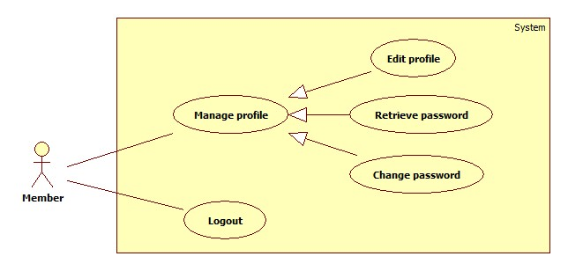

Figure 37: <Member> Overview Use Case

##### <Member> Edit Profile

Use Case Diagram

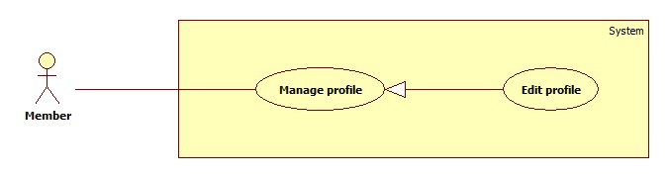

Figure 38: <Member> Edit Profile

Use Case Specification

|  |  |  |  |
| --- | --- | --- | --- |
| **USE CASE - LRA0029** | | | |
| **Use Case No.** | LRA0029 | **Use Case Version** | 1.0 |
| **Use Case Name** | Edit Profile | | |
| **Author** | Nguyen Manh Khuong | | |
| **Date** | 28/05/2015 | **Priority** | Normal |
| **Actor:**   * Member.   **Summary:**   * This use case allows member to edit profile.   **Goal:**   * Profile of user will be changed.   **Triggers:**   * Member choose “Edit Profile” command.   **Preconditions:**   * User has logged in system as member role. * Product is not found when member search.   **Post Conditions:**   * **Success**: Recommended product’s detail was sent successfully. Show successful message. * **Fail:** Database connection is not available. Show error message.   **Main Success Scenario:**   |  |  |  | | --- | --- | --- | | Step | Actor Action | System Response | | 1 | Member selected “Manager Profile” command. | Navigate to “Manager Profile” interface, which contains:   * “Name”: label. * “Email”: label. * “Mobile phone”: label. * “Password”: label. * “Change password”: command. * “Edit Profile”: command. | | 2 | Member selected “Edit Profile” command. | Navigate to “Edit Profile” interface, which contains:   * Name: textbox. * Email: regular expression: /^[_a-z0-9-]+(\.[_a-z0-9-]+)*@@[a-z0-9-]+(\.[a-z0-9-]+)*(\.[a-z]{2,4})$/ required. * “Mobile Phone”: textbox. * Password: textbox, min length: 5, max length: 100. * “Save”: command. | |  | Member change data to the form and choose “Save” command.  [Alternative 1,2,3,4] | Show success message: “Edit profile successfully”, close the interface.  Return “Manage profile” interface.  [Exception 1] |   **Alternative Scenario:**   |  |  |  | | --- | --- | --- | | No | Actor Action | System Response | | 1 | “Password” is not in range  [5,100]. | “Password” textbox border color is red. | | 2 | “Password” is a blank | Show error message: “Please enter password!” | | 3 | “Password” is wrong. | Show error message:”Wrong password.” | | 4 | Invalid email format. | Show error message: “Email is must valid format!” |   **Exceptions:**   |  |  |  | | --- | --- | --- | | No | Actor Action | System Response | | 1 | Cannot edit profile due to database connection. | Show error message: “Cannot edit profile. Try again later.” |   **Relationships:** N/A  **Business Rules:**   * Password must match current password. * User must be logged in the system. | | | |

Table 43: <Member> Edit Profile

##### <Member> Change Password

Use Case Diagram

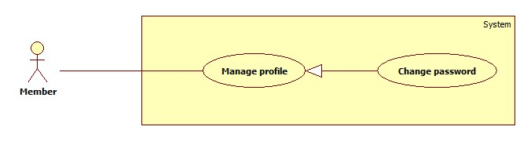

Figure 39: <Member> Change Password

Use Case Specification

|  |  |  |  |
| --- | --- | --- | --- |
| **USE CASE - LRA0030** | | | |
| **Use Case No.** | LRA0030 | **Use Case Version** | 1.0 |
| **Use Case Name** | Change Password | | |
| **Author** | Nguyen Manh Khuong | | |
| **Date** | 28/05/2015 | **Priority** | Normal |
| **Actor:**   * Member.   **Summary:**   * This use case allows member to change password.   **Goal:**   * Member change password successfully.   **Triggers:**   * Member login to the system. * Member click on “Change password” command.   **Preconditions:**   * User must log in the system with member role.   **Post Conditions:**   * **Success**: New password will be updated in database. * **Fail:** Show error message.   **Main Success Scenario:**   |  |  |  | | --- | --- | --- | | Step | Actor Action | System Response | | 1 | Member clicks “Change password” command. | Show “Change password ” page with includes:   * Old password: textbox, password box, min length: 6, max length: 20, required. * New password: textbox, password box, min length: 6, max length: 20, required. * Re-enter new password: textbox, password box, min length: 6, max length: 20, required. * Save change: button. * Clear: button. | |  | Member clicks “Save change” button  [Alternative 1,2,3,4,5,6,7] | Show successful message and return to home page. [Exception 1] |   **Alternative Scenario:**   |  |  |  | | --- | --- | --- | | No | Actor Action | System Response | | 1 | Member clicks “Clear” button. | Clear all input fields. | | 2 | Length of password is not in range. | Show error message: “Password length must be 6-20 characters!” | | 3 | “Old password” is wrong. | Show error message: ”Wrong password.” | | 4 | “Old password” is a blank. | Show error message: ”Please enter old password” | | 5 | “New password” is a blank. | Show error message:” Please enter new password” | | 6 | “Re-enter new password” is a blank. | Show error message: ”Please re-enter new password” | | 7 | “New password” and “Re-enter new password” is not similar. | Show error message: “New password and Re-enter new password is must be similar”. |   **Exceptions:**   |  |  |  | | --- | --- | --- | | No | Actor Action | System Response | | 1 | Cannot change password due to database connection. | Show error message: “Cannot change password. Try again later.” |   **Relationships:** N/A  **Business Rules:**   * User must be logged in the system. | | | |

Table 44: <Member> Change Password

##### <Member> Retrieve Password

Use Case Diagram

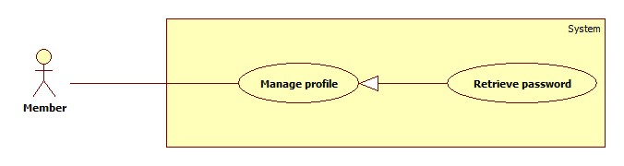

Figure 40: <Member> Retrieve Password

Use Case Specification

|  |  |  |  |
| --- | --- | --- | --- |
| **USE CASE – LRA0031** | | | |
| **Use Case No.** | LRA0031 | **Use Case Version** | 1.0 |
| **Use Case Name** | Retrieve Password | | |
| **Author** | Nguyen Manh Khuong | | |
| **Date** | 28/05/2015 | **Priority** | High |
| **Actor:**   * Member.   **Summary:**   * This use case allows Member to retrive password.   **Goal:**   * Password will be send to member’s email.   **Triggers:**   * Member cannot log in to the system. * Member clicks on “Retrieve Password” command.   **Preconditions:**   * N/A   **Post Conditions:**   * **Success**: The password will be send to member’s email. * **Fail:** Show error message.   **Main Success Scenario:**   |  |  |  | | --- | --- | --- | | Step | Actor Action | System Response | | 1 | Member clicks on “Retrieve Password” command | Navigate to “Retrieve Password” interface, which contains:   * “Email”: textbox. * “Send”: command. | | 2 | Member change data to the form and choose “Send” command.  [Alternative 1,2,3] | Show success message and close the interface. [Exception 1] |   **Alternative Scenario:**   |  |  |  | | --- | --- | --- | | No | Actor Action | System Response | | 1 | “Email” is a blank | Show error message: “Please enter email!” | | 2 | “Email” is wrong. | Show error message: “The email address is not existed in the system.” | | 3 | Invalid email format. | Show error message: “Email is must valid format!” |   **Exceptions:**   |  |  |  | | --- | --- | --- | | No | Actor Action | System Response | | 1 | Cannot retrieve password due to database connection. | Show error message: “Cannot retrieve password. Try again later.” |   **Relationships:** N/A  **Business Rules:**   * Email must match member’s email. | | | |

Table 45: <Member> Retrieve Password

##### <Member> Log out

Use Case Diagram

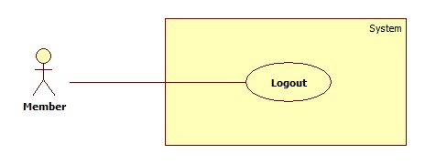

Figure 41: <Member> Log Out

Use Case Specification

|  |  |  |  |
| --- | --- | --- | --- |
| **USE CASE – LRA0032** | | | |
| **Use Case No.** | LRA0032 | **Use Case Version** | 1.0 |
| **Use Case Name** | Log Out | | |
| **Author** | Nguyen Manh Khuong | | |
| **Date** | 30/05/2015 | **Priority** | Normal |
| **Actor:**   * Member.   **Summary:**   * This use case allows Member to log out of the system.   **Goal:**   * Member logs out of the system. Member’s current session is destroyed.   **Triggers:**   * Member clicks “Log out” command.   **Preconditions:**   * Member has logged in to the system.   **Post Conditions:**   * **Success**: Member’s current session is destroyed. Redirect to homepage. * **Fail:** Show error message.   **Main Success Scenario:**   |  |  |  | | --- | --- | --- | | Step | Actor Action | System Response | | 1 | Member clicks “Log out” command. | Show message “Do you want to log out?”   * Yes: command * No: command | | 2 | Member clicks “Yes” command.  [Alternative 1] | Destroy Member’s session. Redirect to homepage.  [Exception 1] |   **Alternative Scenario:**   |  |  |  | | --- | --- | --- | | No | Actor Action | System Response | | 1 | Member clicks “No” command. | Do nothing. |   **Exceptions:**   |  |  |  | | --- | --- | --- | | No | Actor Action | System Response | | 1 | Fail to destroy Member’s session | Redirect to error page. |   **Relationships:** N/a  **Business Rules:**   * User must be logged in the system. * User role will be changed to guest. | | | |

Table 46: < Member > Log out

#### <Guest> Overview Use Case

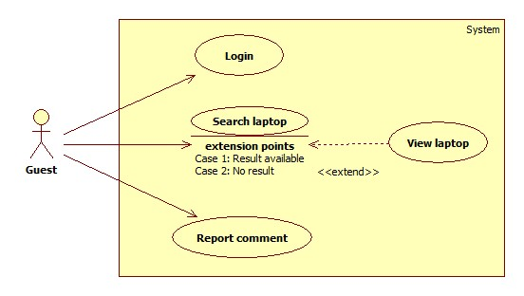

Figure 42: <Guest> Overview Use Case

##### <Guest> Login

Use Case Diagram

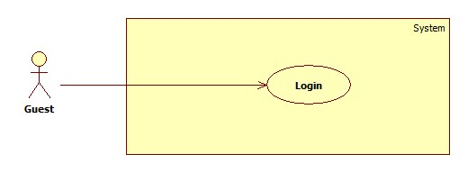

Figure 43: <Guest> Login

Use Case Specification

|  |  |  |  |
| --- | --- | --- | --- |
| **USE CASE – LRA034** | | | |
| **Use Case No.** | LRA034 | **Use Case Version** | 1.0 |
| **Use Case Name** | Login | | |
| **Author** | Dinh Huu Toan | | |
| **Date** | 06/06/2015 | **Priority** | Normal |
| **Actor:**   * Guest.   **Summary:**   * This use case allows guest to login.   **Goal:**   * Allow authentication and authorization of the system.   **Triggers:**   * Guest input username and password, then send “Login” command   **Preconditions:**   * Database has a registered account.   **Post Conditions:**   * **Success:** Guest is authorized, redirect to corresponding page. * **Fail:** System will show error on current page.   **Main Success Scenario:**   |  |  |  | | --- | --- | --- | | Step | Actor Action | System Response | | 1 | Guest send command to go to login page | Login form includes:   * Username, free text input, 6 – 35 characters [Required] * Password, password input, 6 – 35 characters [Required] * “Keep me signed in” checkbox * Login command | | 2 | Guess enters required information, then send “Login” command | Guest is logged in  [Exception 1,2, 3] |   **Alternative Scenario:** N/A  **Exceptions:**   |  |  |  | | --- | --- | --- | | No | Actor Action | System Response | | 1 | Guest input wrong username or password | Show error message “Invalid username or password. Please try again!” | | 2 | Guest input wrong username/password format | Show error message “Please enter at least 6 characters.” | | 3 | Guest does not fill in username/password field | Show error message “This field is required” |   **Relationships:** N/A  **Business Rules:**   * Guest cannot sign up. All account is provided by admin * Only active account can log in. | | | |

Table 47: <Guest> Login

##### <Guest> Search Laptop

Use Case Diagram

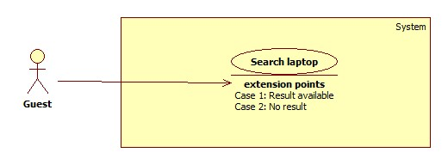

Figure 44: <Guest> Search laptop

|  |  |  |  |
| --- | --- | --- | --- |
| **USE CASE – LRA035** | | | |
| **Use Case No.** | LRA035 | **Use Case Version** | 1.0 |
| **Use Case Name** | Search laptop | | |
| **Author** | Dinh Huu Toan | | |
| **Date** | 30/05/2015 | **Priority** | High |
| **Actor:**   * Guest.   **Summary:**   * This use case allows guest to search for specific laptops by their names   **Goal:**   * Appropriate laptops are shown   **Triggers:**   * Guest input name of laptop and then send “Search” command   **Preconditions:** N/A  **Post Conditions:**   * **Success:** appropriate laptops are shown * **Fail:** System will show error on current page.   **Main Success Scenario:**   |  |  |  | | --- | --- | --- | | Step | Actor Action | System Response | | 1 | From home page, guest input laptop name into search free text input and send “Search” command | Appropriate laptops are shown with information include:   * Laptops’ names: text * Laptops’ avatars: text * Laptops’ positive comment percent: text * Sort command   [Alternative 1] |   **Alternative Scenario:**  **Alternative 1:**   |  |  |  | | --- | --- | --- | | Step | Actor Action | System Response | | 1 | Guest cannot find their wanted laptop | Navigate to No result page with following information:   * Message: text * Email: text, email format, required * Send command * Cancel command | | 2 | Guest input their email and send “Send” command  [Alternative 2] | Show message to indicate that the processing is done successfully |   **Alternative 2**:   |  |  |  | | --- | --- | --- | | Step | Actor Action | System Response | | 1 | Guest send “Cancel” command | Navigate to home page |   **Exceptions:**   |  |  |  | | --- | --- | --- | | No | Actor Action | System Response | | 1 | Cannot find laptop due to system error | Show error message |   **Relationships:** N/A.  **Business Rules:**   * After inputting email and send “Send” command or send “Cancel” command, guest will be navigated to home page | | | |

Table 48: <Guest> Search Laptop

##### <Guest> View Laptop

**Use case Diagram**

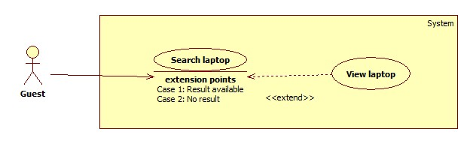

Figure 45: <Guest> View Laptop

**Use case Specification**

|  |  |  |  |
| --- | --- | --- | --- |
| **USE CASE – LRA036** | | | |
| **Use Case No.** | LRA036 | **Use Case Version** | 1.0 |
| **Use Case Name** | View laptop | | |
| **Author** | Dinh Huu Toan | | |
| **Date** | 06/06/2015 | **Priority** | High |
| **Actor:**   * Guest.   **Summary:**   * This use case allows guest to search and view laptop information.   **Goal:**   * A page detail of products will be shown to guest.   **Triggers:**   * Guests send View detail command   **Preconditions:**   * Laptop that guests want to view must be available in system   **Post Conditions:**   * **Success**: Appropriate information is shown * **Fail:** Show an error message.   **Main Success Scenario:**   |  |  |  | | --- | --- | --- | | Step | Actor Action | System Response | | 1 | Guests send View detail command | Navigate to Detail page with following information:   * Laptop name: text * Laptop images: image * Laptop description: text * Comment: text * Command to report insufficient comments   [Exception 1] |   **Alternative Scenario:** N/A  **Exceptions:**   |  |  |  | | --- | --- | --- | | Step | Actor Action | System Response | | 1 | System cannot handle guests request due to system problem | Show error message |   **Relationships:** Search  **Business Rules:**   * Comments are classified and shown to guests in 3 groups: Positive, Negative and Neutral | | | |

Table 49: <Guest> View laptop

##### <Guest> Report Comment

**Use case Diagram**

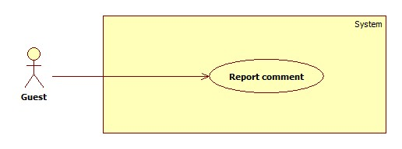

Figure 46: <Guest> Report comment

**Use case Specification**

|  |  |  |  |
| --- | --- | --- | --- |
| **USE CASE – LRA036** | | | |
| **Use Case No.** | LRA037 | **Use Case Version** | 1.0 |
| **Use Case Name** | Report comment | | |
| **Author** | Dinh Huu Toan | | |
| **Date** | 06/06/2015 | **Priority** | High |
| **Actor:**   * Guest.   **Summary:**   * This use case allows guest to report unsuitable comments   **Goal:**   * System archives reported comments   **Triggers:**   * Guests send “Reported comment” command   **Preconditions:** N/A  **Post Conditions:**   * **Success**: reported comments are saved to system * **Fail:** Show an error message.   **Main Success Scenario:**   |  |  |  | | --- | --- | --- | | Step | Actor Action | System Response | | 1 | In view laptop detail page, staff sends command to report comment | Reported comments are highlighted and saved to system  [Exception 1] |   **Alternative Scenario:** N/A  **Exceptions:**   |  |  |  | | --- | --- | --- | | Step | Actor Action | System Response | | 1 | System cannot handle guests request due to system problem | Show error message |   **Relationships:** View Detail  **Business Rules:**   * If this comment was denied by staff before, it cannot be continued reported. * If this comment was reported before, increase its the report times and report’s date is still the first date when it was reported. | | | |

**Table 50: <Guest> Report Comment**

#### <System> Overview Use Case

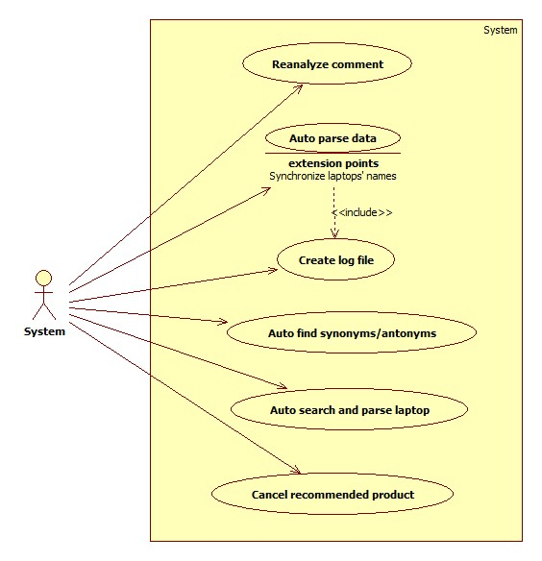

##### <System> Auto Parse Data

**Use Case Diagram**

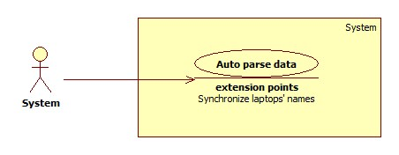

Figure 47: <System> Auto Parse Data

**Use Case Specification**

|  |  |  |  |
| --- | --- | --- | --- |
| **USE CASE – LRA037** | | | |
| **Use Case No.** | LRA037 | **Use Case Version** | 1.0 |
| **Use Case Name** | Auto parse data | | |
| **Author** | Vo Thi Minh Chau | | |
| **Date** | 03/06/2015 | **Priority** | High |
| **Actor:**   * System.   **Summary:**   * System can parse data automatically from many websites at specified time.   **Goal:**   * Log file is generated.   **Triggers:**   * The time hits configured time.   **Preconditions:**   * Daily parsing time has been configured.   **Post Conditions:**   * **Success:** Log file is generated. * **Fail:** Log file cannot be generated.   **Main Success Scenario:**   |  |  |  | | --- | --- | --- | | Step | Actor Action | System Response | | 1 | Server checks the current time. If it hits configured time, parse process starts. | - Get list of url which will be parsed from the existed sites.  - Parse data [Exception 1].  - Analyze comments.  - Insert data to system.  - Generate log file. |   **Alternative Scenario:** N/A  **Exceptions:**   |  |  |  | | --- | --- | --- | | No | Actor Action | System Response | | 1 | - Error while parsing data. | - Generate log file. |   **Relationships:** N/A  **Business Rules:**  - The system will parse all existed active sites.  - The system will parse the n-first products and all existed product of this site. (n is configured by staff before)  - With each existed product, only the new valid comments will be parsed (define of new valid comments: refer use case LRA008).  - If this product’s is similar to another existed product, it will be save to xml file. | | | |

Table 51: <System> Auto Parse Data

##### <System> Create Log File

**Use Case Diagram**

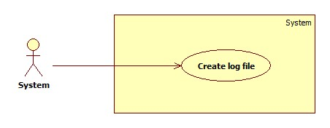

Figure 48: <System> Create Log File

**Use Case Specification**

|  |  |  |  |
| --- | --- | --- | --- |
| **USE CASE – LRA038** | | | |
| **Use Case No.** | LRA038 | **Use Case Version** | 1.0 |
| **Use Case Name** | Create Log File | | |
| **Author** | Vo Thi Minh Chau | | |
| **Date** | 03/06/2015 | **Priority** | High |
| **Actor:**   * System.   **Summary:**   * System can parse data automatically from many websites at specified time.   **Goal:**   * Get data from many websites.   **Triggers:**   * The time hits configured time.   **Preconditions:**   * N/A   **Post Conditions:**   * **Success:** New data is inserted to database. Log file is generated. * **Fail:** Nothing is changed in the database. Log file is generated.   **Main Success Scenario:**   |  |  |  | | --- | --- | --- | | Step | Actor Action | System Response | | 1 | Server checks the current time. If it hits configured time, parse process starts. | - Generate log file. |   **Alternative Scenario:** N/A  **Exceptions:** N/A  **Relationships:** N/A  **Business Rules:**   * Format of log file | | | |

Table 52: <System> Create Log File

##### <System> Auto Find Synonyms/Antonyms

**Use Case Diagram**

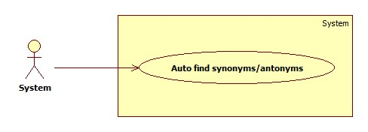

Figure 49: <System> Auto Find Synonyms/Antonyms

**Use Case Specification**

|  |  |  |  |
| --- | --- | --- | --- |
| **USE CASE – LRA039** | | | |
| **Use Case No.** | LRA039 | **Use Case Version** | 1.0 |
| **Use Case Name** | Auto find synonyms/Antonyms | | |
| **Author** | Vo Thi Minh Chau | | |
| **Date** | 03/06/2015 | **Priority** | High |
| **Actor:**   * System.   **Summary**   * System searches synonyms and antonyms of new word and inserts to database.   **Goal:**   * Synonyms and antonyms are inserted.   **Triggers:**   * New word is inserted.   **Preconditions:**   * N/A   **Post Conditions:**   * **Success:** Synonyms and antonyms are inserted. * **Fail:** Synonyms and antonyms cannot be inserted.   **Main Success Scenario:**   |  |  |  | | --- | --- | --- | | Step | Actor Action | System Response | | 1 | Server checks when new word is inserted. | - Search synonyms and antonyms of this word and insert to database [Alternative 1] [Exception 1]. |   **Alternative Scenario:**  [Alternative 1]   |  |  |  | | --- | --- | --- | | No | Actor Action | System Response | | 1 |  | - If the system cannot find any synonym or antonym, do nothing. |   **Exceptions:**   |  |  |  | | --- | --- | --- | | No | Actor Action | System Response | | 1 | - Fail to update to database. | - Display error message “Cannot connect to the database. Please try again!” |   **Relationships:** N/A  **Business Rules:**   * Synonyms and antonyms are found in Lingoes dictionary and parsed from <http://www.thesaurus.com/> | | | |

Table 53: <System> Auto Find Synonyms/Antonyms

##### <System> Auto Search And Parse Laptop

**Use Case Diagram**

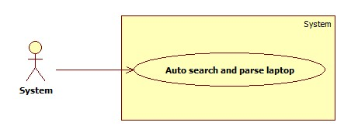

Figure 50: <System> Auto Search And Parse Laptop

**Use Case Specification**

|  |  |  |  |
| --- | --- | --- | --- |
| **USE CASE – LRA040** | | | |
| **Use Case No.** | LRA040 | **Use Case Version** | 1.0 |
| **Use Case Name** | Auto parse data | | |
| **Author** | Vo Thi Minh Chau | | |
| **Date** | 03/06/2015 | **Priority** | High |
| **Actor:**   * System.   **Summary:**   * System searches recommended product and parses it.   **Goal:**   * Recommended product will be parsed.   **Triggers:**   * Guest recommends new product.   **Preconditions:**   * N/A   **Post Conditions:**   * **Success:** Recommended product will be parsed and system sends notification mail to guest. * **Fail:** Recommended product cannot be found.   **Main Success Scenario:**   |  |  |  | | --- | --- | --- | | Step | Actor Action | System Response | | 1 | Server checks when guest recommends new product. | - Search recommended product.  - Get url of this product and parse it [Alternative 1].  - Send notification mail to guest [Exception 1]. |   **Alternative Scenario:**  [Alternative 1]   |  |  |  | | --- | --- | --- | | Step | Actor Action | System Response | | 1 |  | - If the system cannot find the recommended product, set its status “Pending”. |   **Exceptions:**   |  |  |  | | --- | --- | --- | | No | Actor Action | System Response | | 1 | - Notification mail cannot be sent. | - Set the status “Added”. |   **Relationships:** N/A  **Business Rules:**   * The solution for searching and parsing product automatically:   + Get list of all site in system ordered by number of reports ascending.   + For each site, use Google to search whether this product is existed in this site. Get 10-first results from Google.   + Try to parse from these above url. When finding and parsing 1 product successfully, add this product to system and send notification mail to guests. * Setting status for this recommended product:   + Pending: if this cannot be found automatically and is waiting for handling.   + Added: if this was be added to system but cannot be sent email to guests.   + Sent: if this was be added to system and be sent email to guests successfully | | | |

Table 54: <System> Auto Search And Parse Laptop

##### <System> Reanalyze Comment

**Use Case Diagram**

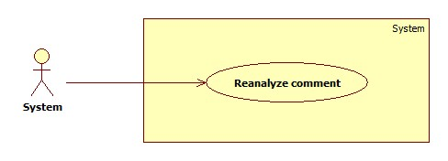

Figure 51: <System> Reanalyze Comment

Use Case Specification

|  |  |  |  |
| --- | --- | --- | --- |
| **USE CASE – LRA041** | | | |
| **Use Case No.** | LRA041 | **Use Case Version** | 1.0 |
| **Use Case Name** | Reanalyze comment | | |
| **Author** | Vo Thi Minh Chau | | |
| **Date** | 03/06/2015 | **Priority** | High |
| **Actor:**   * System.   **Summary:**   * System can reanaylyze comments automatically from many websites at specified time.   **Goal:**   * Reanalyze all comments.   **Triggers:**   * The time hits configured time.   **Preconditions:**   * Daily analyzing time has been configured.   **Post Conditions:**   * **Success:** All comments are reanalyzed. * **Fail:** All comments cannot be reanalyzed.   **Main Success Scenario:**   |  |  |  | | --- | --- | --- | | Step | Actor Action | System Response | | 1 | Server checks the current time. If it hits configured time, reanalyzing process starts. | - Analyze comments. |   **Alternative Scenario:** N/A  **Exceptions:** N/A  **Relationships:** N/A  **Business Rules:**   * Analysing comments takes much time, system will show an animation to indicate that the command is processing. | | | |

Table 55: <System> Reanalyze Comment

##### <System> Cancel recommended product

**Use Case Diagram**

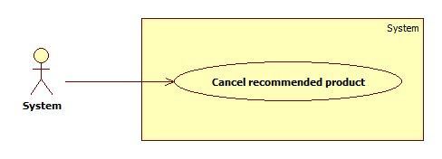

Figure 52: <System> Cancel recommended product

Use Case Specification

|  |  |  |  |
| --- | --- | --- | --- |
| **USE CASE – LRA042** | | | |
| **Use Case No.** | LRA042 | **Use Case Version** | 1.0 |
| **Use Case Name** | Cancel recommended product | | |
| **Author** | Vo Thi Minh Chau | | |
| **Date** | 03/06/2015 | **Priority** | High |
| **Actor:**   * System.   **Summary:**   * System can cancel out of date recommended products at specified time.   **Goal:**   * Cancel out of date recommended products.   **Triggers:**   * The time hits configured time.   **Preconditions:**   * Limited day has been configured.   **Post Conditions:**   * **Success:** Out of date recommended products are cancelled. * **Fail:** Out of date recommended products cannot be cancelled.   **Main Success Scenario:**   |  |  |  | | --- | --- | --- | | Step | Actor Action | System Response | | 1 | Server checks the current time. If it hits 12:00 AM, cancelling process starts. | - Cancel all out of date recommended products. |   **Alternative Scenario:** N/A  **Exceptions:** N/A  **Relationships:** N/A  **Business Rules:**   * Out of date recommended products are products which have the time from it recommended to now longer than limited day. * When this product is cancelled, it will not be shown in “Recommended product” page. | | | |

## Software System Attribute

### Usability

#### Graphic User Interface

* All the texts, labels and should be written in English.

#### Usability

* Admin, staff should need less than one week of training to be productive with the system.
* Guest and member can use the system easily without training.

#### Installation

* The system must be easy to deploy. Customer can deploy successfully and learn to configure, maintain the system within one day of training.
* The attached manual guide must be clear. User can read and do themselves without developer’s help.

### Reliability

* The product should be updated every day.
* The parser should be updated every day.
* If the product is already existed, system will notify for user.
* The system can analyze almost comments, classify them base on dictionary with above 80% accuracy.

### Availability

* N/A.

### Security

* Privacy: Each role of user has a specific permission to interact with system.
* System always checks authorization and authentication before doing anything.
* Only admin can grant permission to staff.

### Maintainability

* Dictionary data is easy to change and update.

### Portability

* The web application can be used anywhere, where has Internet Connection, by Smart phones or PC.

### Performance

* Server responses in 3 seconds for normal progresses, in 10 seconds for complex progresses.
* The page resources are lightly to reduce loading time.

## Conceptual Diagram

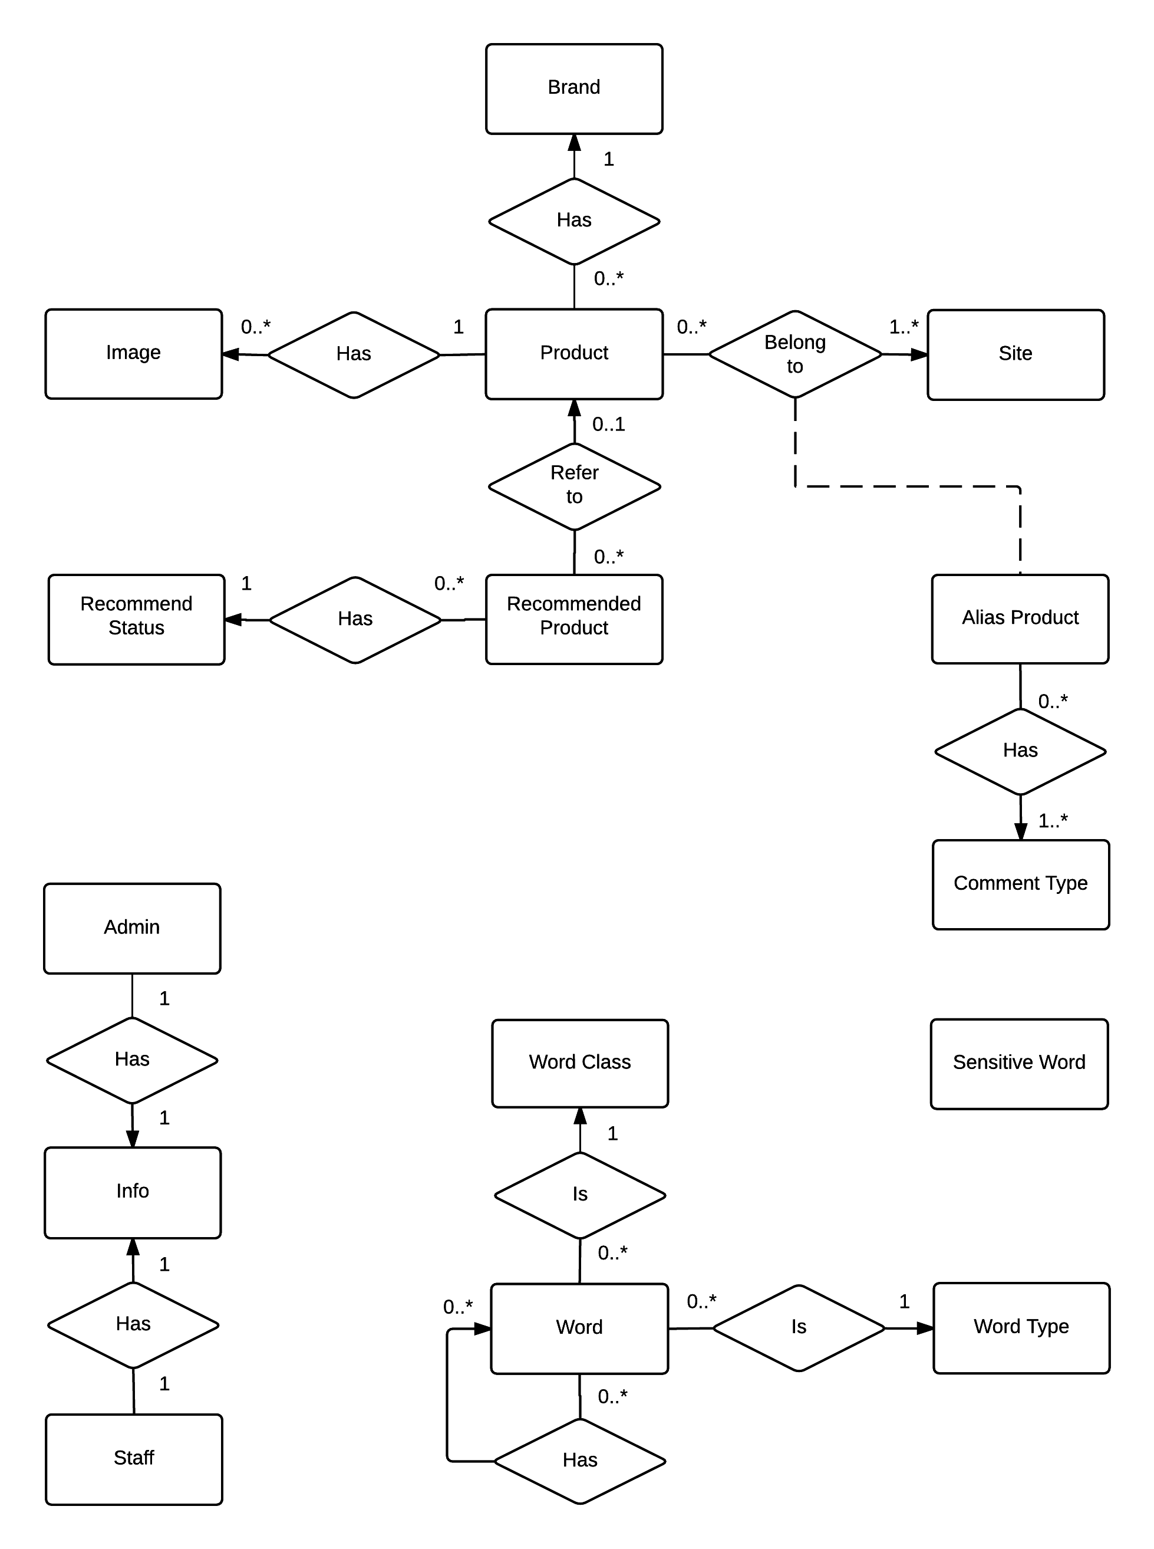

Figure 53: Conceptual Diagram

### Data Dictionary

|  |  |
| --- | --- |
| **Entity Data dictionary: describe content of all entities** | |
| **Entity Name** | **Description** |
| Image | Describe all image link that product is included. |
| Product | Describe all products in the system. |
| Recommend Product | Describe the product that user recommend for system. |
| Recommend Status | Describe the status of user recommend. |
| Brand | Describe all brands the products are belonged. |
| Alias Product | Describe all alias products in the system. |
| Comment Type | Describe all types of comments. |
| Site | Describe all site parse data. |
| Word | Describe all words |
| Word Type | Describe all types of words in Dictionary. |
| Word Class | Describe all classes of words in Dictionary |
| Staff | Describe all information of staff. |
| Admin | Describe all information of admin. |
| Info | Describe all information of user. |

Table 56: Entity Data dictionary - Describe content of all entities

# Software Design Description

## Design Overview

* This document describes the technical and user interface design LRA System using web. It includes the architectural design, the detailed design of common functions and business functions and the design of database model.
* The architectural design describes the overall architecture of the system and the architecture of each main component and subsystem.
* The detailed design describes static and dynamic structure for each component and functions. It includes class diagrams, class explanations and sequence diagrams for each use cases.
* The database design describes the relationships between entities and details of each entities.
* Document overview:
* Section 2: gives an overall description of the system architecture design.
* Section 3: gives component diagrams that describe the connection and integration of the system.
* Section 4: gives the detail design description which includes class diagram, class explanation, and sequence diagram to details the application functions.
* Section 5: describe an ERD with logical diagram.

## System Architectural Design

### Web Architecture

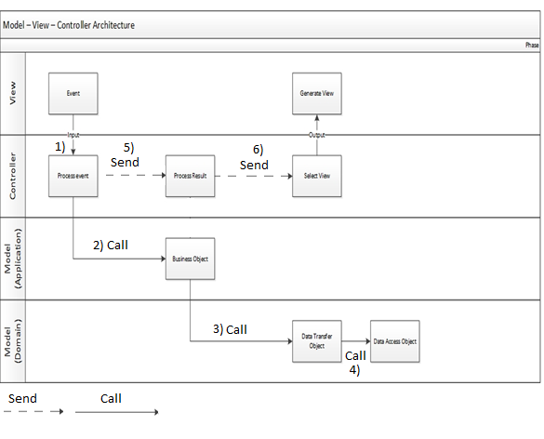

Figure 54: MVC Architecture

* **Model** is the part of the application that handles the logic for the application data. Often model objects retrieve data (and store data) from a database.
* **View** is the parts of the application that handles the display of the data. Most often the views are created from the model data.
* **Controller** is the part of the application that handles user interaction. Typically controllers read data from a view, control user input, and send input data to the model.

## Component Diagram

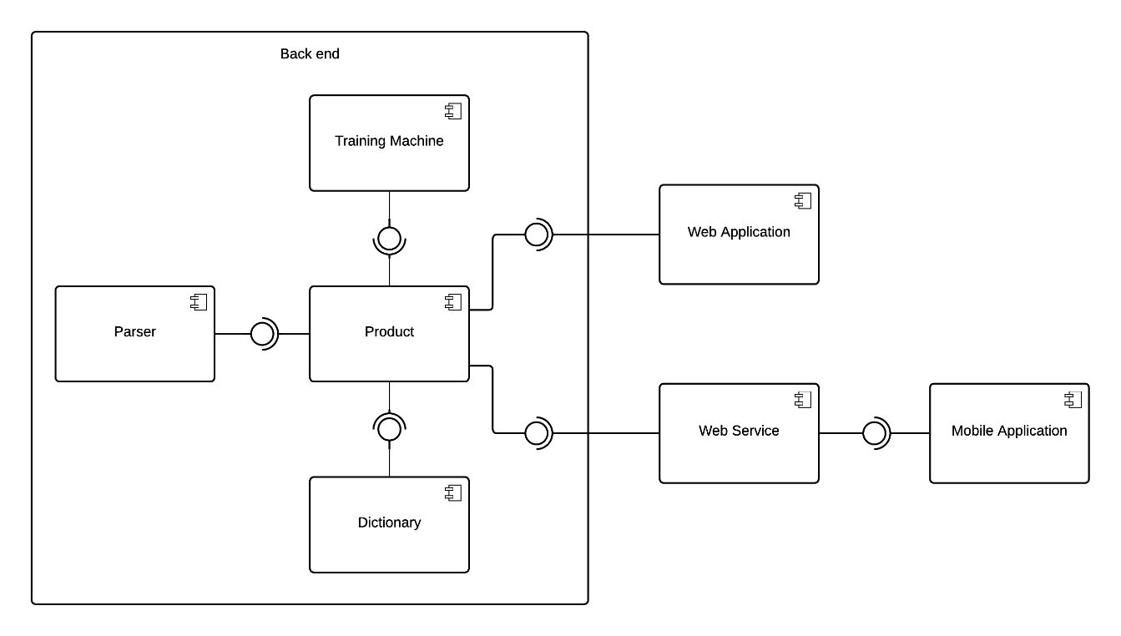

Figure 55: Component Diagram

**Data Dictionary**

|  |  |
| --- | --- |
| **Component dictionary: describe component** | |
| **Component Name** | **Description** |
| Product | Business logic processing for searching product function |
| Dictionary | Business logic processing for analysing comment function |
| Parser | Business logic processing for parsing function. |
| Training Machine | Business logic processing for training machine function. |
| Web Application | Provide all functions on web for user. |
| Web Service | Provide business logic for mobile application. |
| Mobile Application | Provide all functions on mobile for user. |

Table 57: Component dictionary: describe component

## Detailed Description of Components

### Class Diagram

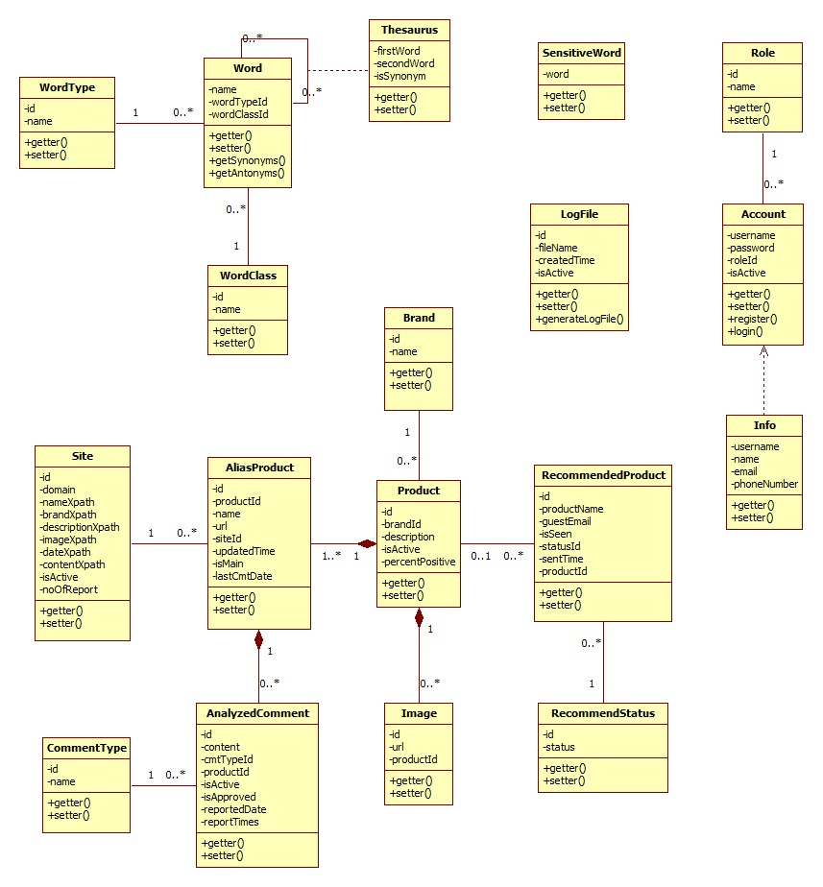

Figure 56: Class Diagram

**Data Dictionary**

|  |  |
| --- | --- |
| **Class dictionary: describe class** | |
| **Class Name** | **Description** |
|  |  |
|  |  |
|  |  |
|  |  |
|  |  |
|  |  |
|  |  |
|  |  |
|  |  |
|  |  |
|  |  |
|  |  |
|  |  |
|  |  |
|  |  |
|  |  |
|  |  |
|  |  |

Table 58: Class dictionary: describe class

### Class Diagram Explanation

#### Site

Attribute

|  |  |  |  |
| --- | --- | --- | --- |
| **Attribute** | **Type** | **Visibility** | **Description** |
| id | integer | Public | Unique identifier of each site |
| url | string | Public | Link to the site |
| nameXpath | string | Public | Xpath that defines product’s name location in the website |
| brandXpath | string | Public | Xpath that defines product’s brand location in the website |
| descriptionXpath | string | Public | Xpath that defines product’s description location in the website |
| imageXpath | string | Public | Xpath that defines product’s image location in the website |
| dateXpath | string | Public | Xpath that defines product’s submitted date location in the website |
| contentXpath | string | Public | Xpath that defines product’s content location in the website |
| siteId | integer | Public | Id of site |
| isActive | boolean | Public | Status of site |
| noOfReport | integer | Public | Number of report |

#### Alias Product

Attribute

|  |  |  |  |
| --- | --- | --- | --- |
| **Attribute** | **Type** | **Visibility** | **Description** |
| id | integer | Public | Unique identifier of each alias product |
| productId | integer | Public | Id of product |
| name | string | Public | Name of alias product |
| url | string | Public | Link to website contains alias product |
| siteId | int | Public | Id of site |
| updatedTime | datetime | Public | Day that alias product is updated |
| isMain | boolean | Public | Use to check for main product |
| lastCmtDate | datetime | Public | Last date of comments |

#### Product

Attribute

|  |  |  |  |
| --- | --- | --- | --- |
| **Attribute** | **Type** | **Visibility** | **Description** |
| id | integer | Public | Unique identifier of each product |
| brandId | integer | Public | Id of brand |
| description | string | Public | Description of product |
| isActive | boolean | Public | Status of product |
| isReported | int | Public | State how many times the product is reported |

#### Image

Attribute

|  |  |  |  |
| --- | --- | --- | --- |
| **Attribute** | **Type** | **Visibility** | **Description** |
| id | integer | Public | Unique identifier of each image |
| url | string | Public | Link to website contains image |
| productId | integer | Public | Id of product |

#### Analyzed Comment

Attribute

|  |  |  |  |
| --- | --- | --- | --- |
| **Attribute** | **Type** | **Visibility** | **Description** |
| id | integer | Public | Unique identifier of each comment |
| content | string | Public | Content of comment |
| cmtTypeId | integer | Public | Id of comment type |
| isActive | boolean | Public | Status of comment |
| isApproved | boolean | Private |  |
| reportedDate | datetime | Public | The day the comment was reported |
| reportTimes | int | Public | State how many times the comment is reported |

#### Comment Type

Attribute

|  |  |  |  |
| --- | --- | --- | --- |
| **Attribute** | **Type** | **Visibility** | **Description** |
| id | integer | Public | Unique identifier of each comment type |
| name | string | Public | Name of comment type |

#### Brand

Attribute

|  |  |  |  |
| --- | --- | --- | --- |
| **Attribute** | **Type** | **Visibility** | **Description** |
| id | integer | Public | Unique identifier of each brand |
| name | string | Public | Name of Brand |

#### Recommended Product

Attribute

|  |  |  |  |
| --- | --- | --- | --- |
| **Attribute** | **Type** | **Visibility** | **Description** |
| id | integer | Public | Unique identifier of each recommended product |
| productName | string | Public | Name of recommended product |
| guestEmail | string | Public | Email of guest |
| isSeen | Boolean | Public | Indicate whether staff have seen the request or not |
| statusId | integer |  | Id of status |
| isAdded | Boolean | Public | Indicate whether staff have executed request or not |
| sentTime | datetime | Public | Day the recommended product is submitted |
| productId | integer | Public | Id of Product |

#### Recommended Status

Attribute

|  |  |  |  |
| --- | --- | --- | --- |
| **Attribute** | **Type** | **Visibility** | **Description** |
| id | integer | Public | Unique identifier of each user recommend |
| status | Boolean | Public | Status of Recommend |

#### Role

Attribute

|  |  |  |  |
| --- | --- | --- | --- |
| **Attribute** | **Type** | **Visibility** | **Description** |
| id | integer | Public | Unique identifier of each role |
| name | string | Public | Name of comment role |

#### Account

Attribute

|  |  |  |  |
| --- | --- | --- | --- |
| **Attribute** | **Type** | **Visibility** | **Description** |
| username | string | Public | Unique username of each account |
| password | string | Public | Password used to access each account |
| roleId | integer | Public | Id of role |
| isActive | Boolean | Public | Status of account |

Method

|  |  |  |  |
| --- | --- | --- | --- |
| **Method** | **Return type** | **Visibility** | **Description** |
| register | Boolean | Public | Register new account |
| login | Boolean | Public | Login to the system |

#### Info

Attribute

|  |  |  |  |
| --- | --- | --- | --- |
| **Attribute** | **Type** | **Visibility** | **Description** |
| username | string | Public | Unique username of each account |
| name | string | Public | Name of account owner |
| email | string | Public | Email of account owner |
| phoneNumber | string | Public | Phone number of account owner |

#### Word

Attribute

|  |  |  |  |
| --- | --- | --- | --- |
| **Attribute** | **Type** | **Visibility** | **Description** |
| id | integer | Public | Unique identifier of each word |
| name | string | Public | Name of word |
| wordTypeId | integer | Public | Id of word type |
| wordClassId | integer | Public | Id of word class |

Method

|  |  |  |  |
| --- | --- | --- | --- |
| **Method** | **Return type** | **Visibility** | **Description** |
| getSynonyms | Dictionary | Public | Get word’s synonyms |
| getAntonyms | Dictionary | Public | Get word’s antonyms |

#### WordType

Attribute

|  |  |  |  |
| --- | --- | --- | --- |
| **Attribute** | **Type** | **Visibility** | **Description** |
| id | integer | Public | Unique identifier of each word type |
| name | string | Public | Name of word type |

#### Thesaurus

Attribute

|  |  |  |  |
| --- | --- | --- | --- |
| **Attribute** | **Type** | **Visibility** | **Description** |
| firstWord | integer | Public | Id of word which role is main word |
| secondWord | integer | Public | Id of word which role is synonym or antonym of main word |
| isSynonym | Boolean | Public | Indicate whether the relationship of 2 words is synonym or not |

#### WordClass

Attribute

|  |  |  |  |
| --- | --- | --- | --- |
| **Attribute** | **Type** | **Visibility** | **Description** |
| id | integer | Public | Unique identifier of each word class |
| name | string | Public | Name of word class |

#### Sensitive Word

Attribute

|  |  |  |  |
| --- | --- | --- | --- |
| **Attribute** | **Type** | **Visibility** | **Description** |
| word | string | Public | name of sensitive word |

#### Log File

Attribute

|  |  |  |  |
| --- | --- | --- | --- |
| **Attribute** | **Type** | **Visibility** | **Description** |
| id | integer | Public | Unique identifier of each log file |
| filename | string | Public | Name of log file |
| createdTime | datetime | Public | Date the log file is created |
| isActive | Boolean | Public | Status of log file |

Method

|  |  |  |  |
| --- | --- | --- | --- |
| **Method** | **Return type** | **Visibility** | **Description** |
| generateLogFile | Boolean | Public | Generate log file for each time system runs parser |

### Sequence Diagram

#### Parse Specific Product

**Summary:** This diagram shows how to parse a specific product from a URL.

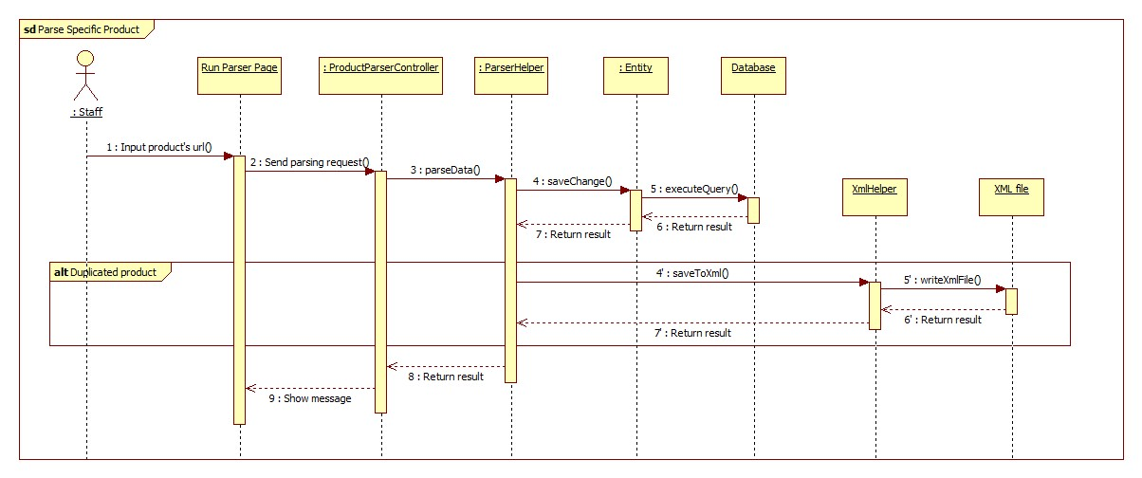

Figure 57: Parse Specific Product Sequence Diagram

#### Import Excel File

**Summary:** This diagram shows how to add new word(s) into the system by excel file.

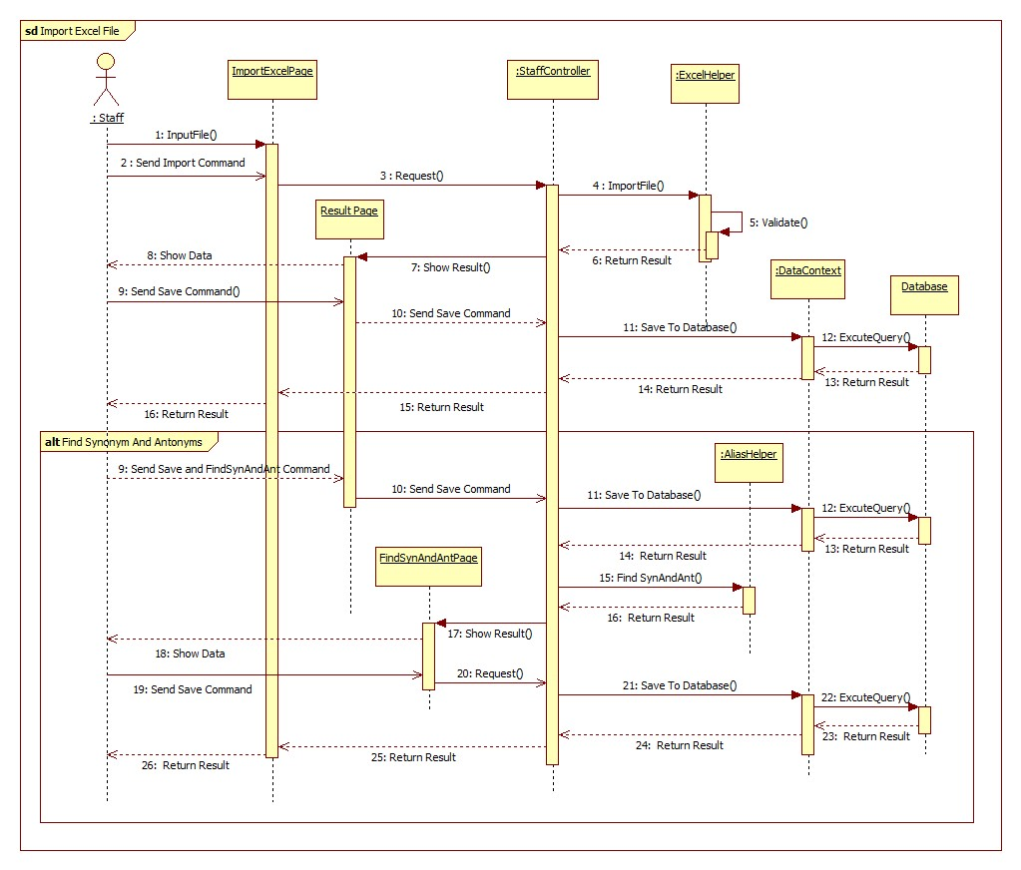

Figure 58: Import Excel File Sequence Diagram

#### Import Dictionary File

**Summary:** This diagram shows how to import Dictionary into the system by text file.

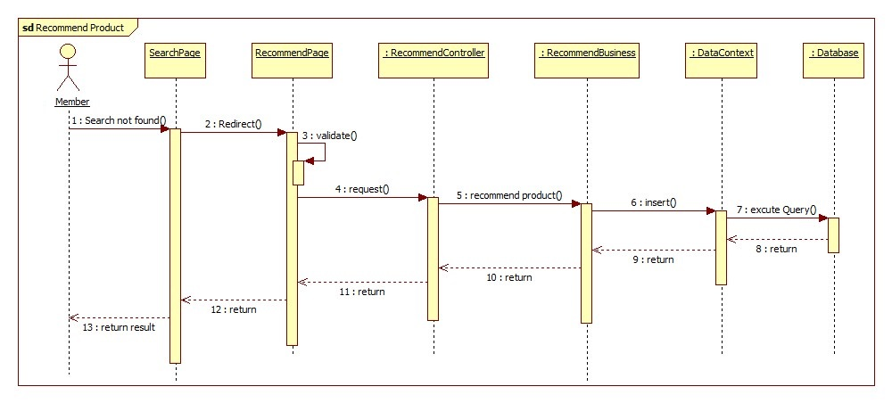

**Figure 59: Recommend Sequence Diagram**

#### Add Word

**Summary:** This diagram shows how to add new word

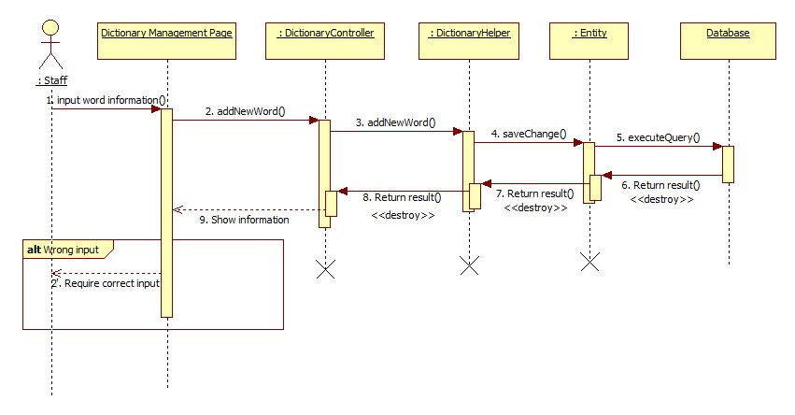

Figure 60: Add Word

#### Edit Word

**Summary:** This diagram shows how to edit available word

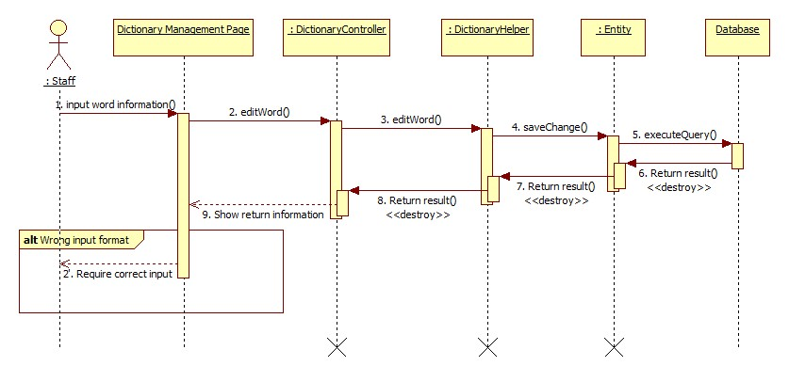

Figure 61: Edit Word

#### Search Laptop

**Summary:** This diagram shows how to search specific laptop

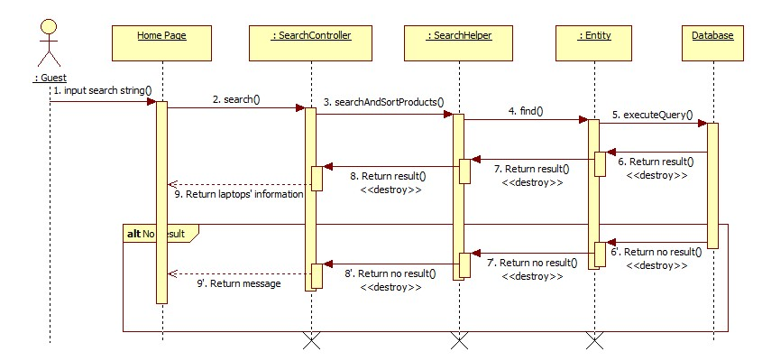

Figure 62: Search Laptop

#### Create New Site

**Summary:** This diagram shows how to create new site for parser.

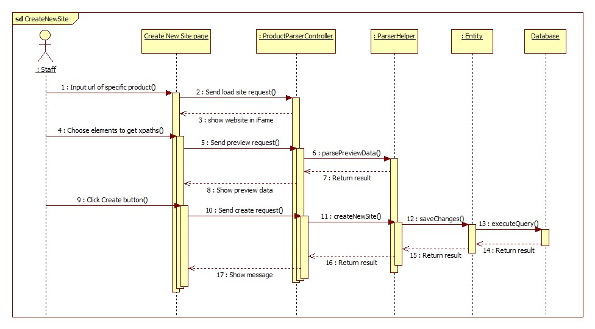

Figure 63: Create New Site Sequence Diagram

#### Configure System

**Summary:** This diagram shows how to update system configuration’s parameters.

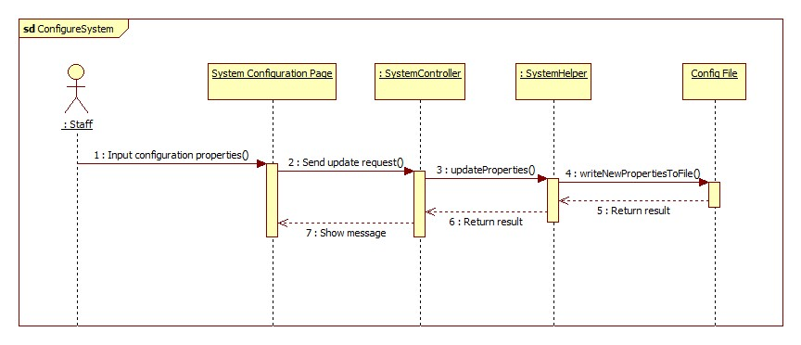

Figure 64: Configure System Sequence Diagram

#### Handle Duplicated Laptops

**Summary:** This diagram shows how to handle duplicated laptops

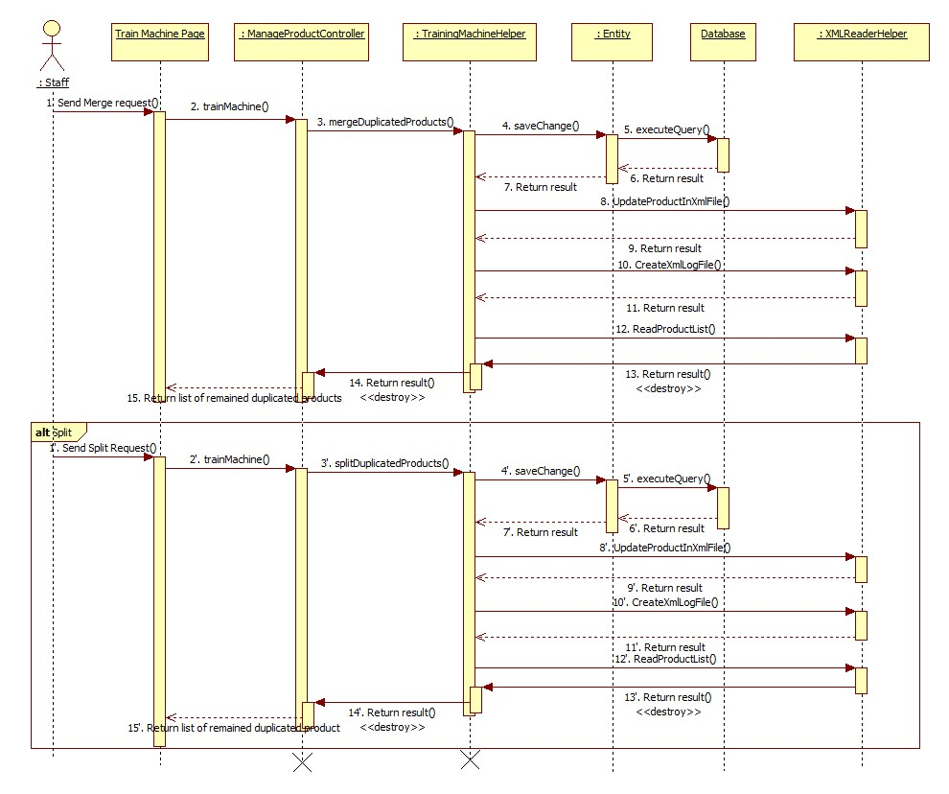

Figure 65: Training Machine

## User Interface Design

### Component Interface

#### Web Service Interface

|  |  |  |  |  |  |
| --- | --- | --- | --- | --- | --- |
| **Signature** | **Description** | **Input** | **Output** | **Output format** | **Exception** |
| **public ResponseObject AddProductComment(R r)** | Add new comment to product | Request object r contains:  Product Id: integer  Comment: string | Json Boolean result of adding new comment | Boolean | JsonProcessingException |
| **public ResponseObject SearchProduct(R r)** | Search product by product name | Request object r contains:  productName: string | Json string List of ProductSearchResult | ProductInfoModel | JsonProcessingException |
| **public ResponseObject SaveEmailForRecommendProduct(R r)** | Save customer email for recommend product | Request object r contains:  email: string  productName: string | Json string noticed message | String | JsonProcessingException |
| **public ResponseObject SearchComment(R r)** | Search comment by product id | Request object r contains:  productId: integer | Json string List of suitable comment | CommentEntity | JsonProcessingException |

Table 59: Web Service Interface

|  |  |
| --- | --- |
| **Entity/Model** | **Description** |
| ProductInfoModel | id  name  brand  description  images  comments  pros |
| CommentEntity | id  content  cmtTypeId  productId  isActive  isReported  reportedDate  cmtDate |

Table 60: Entity/Model description

|  |  |
| --- | --- |
| **Exception** | **Description** |
| JsonProcessingException | appear when processing (parsing, generating) JSON content |

**Table 61: Exception Descriptio**

### Web Application Design

#### Guest Interface Design

##### Guest Home Page



2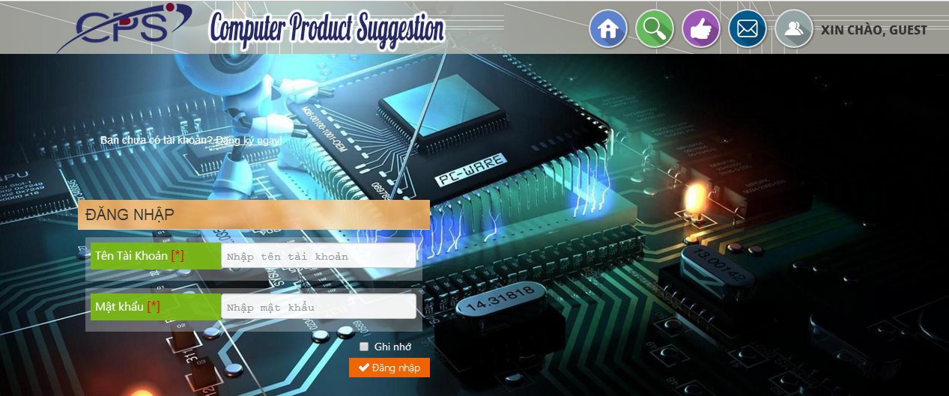

1

3

Figure 66: Guest Home Page

**Fields**

|  |  |  |  |  |  |  |  |
| --- | --- | --- | --- | --- | --- | --- | --- |
| **No** | **Field Name** | **Description** | **Read only** | **Mandatory** | **Control Type** | **Data Type** | **Length** |
| 2 | Slide | Slide about website | No | No | Slide | N/A | N/A |
| 1 | Search Product | Search product by name | No | No | Textbox | String | N/A |

**Buttons/ Hyperlinks**

|  |  |  |  |  |
| --- | --- | --- | --- | --- |
| **No** | **Function** | **Description** | **Validation** | **Outcome** |
| 3 | Home page | Click to transfer to home page | No | Transfer to Home page |

##### Result Page

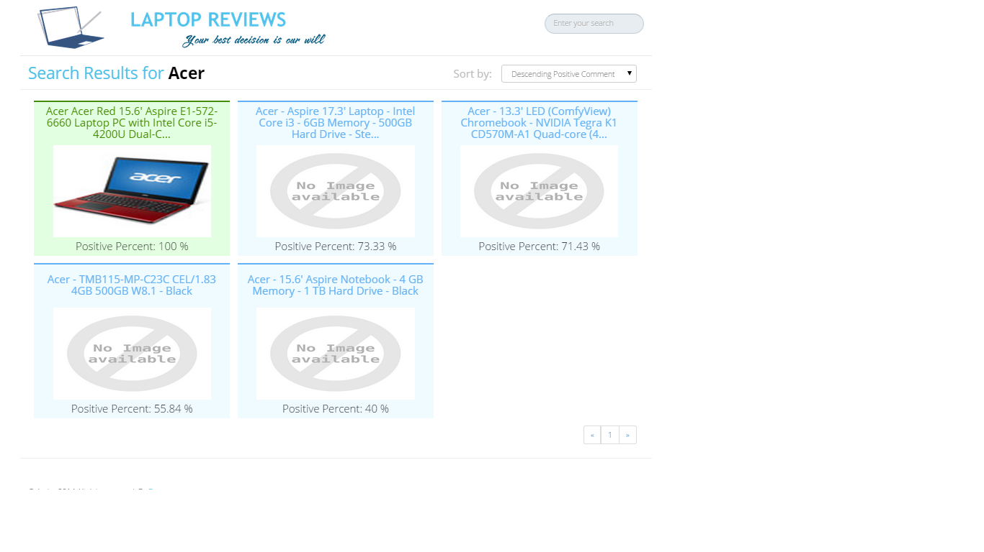

3

5

4

2

1

Figure 67: Result Page

**Fields**

|  |  |  |  |  |  |  |  |
| --- | --- | --- | --- | --- | --- | --- | --- |
| **No** | **Field Name** | **Description** | **Read only** | **Mandatory** | **Control Type** | **Data Type** | **Length** |
| 1 | Search | Search laptops by Name | No | No | Textbox | String | N/A |
| 2 | Sort By | Sort laptop by Positive comment or by Name | No | No | Dropdown List | N/A | N/A |
| 3 | Product brief Information | Product short information with name, avatar and positive percent | Yes | No | N/A | N/A | N/A |

**Buttons/Hyperlinks**

|  |  |  |  |  |
| --- | --- | --- | --- | --- |
| **No** | **Function** | **Description** | **Validation** | **Outcome** |
| 4 | Home | Click to go to home page | N/A | Navigate to home page |
| 5 | Product Detail | Click to go to guest product detail page | N/A | Transfer to guest product detal page |

##### No Reulst Page

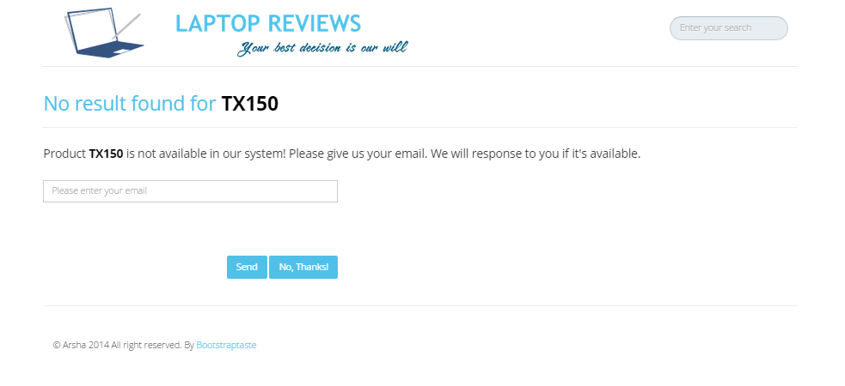

1

6

5

4

3

2

Figure 68: Register Page

**Fields**

|  |  |  |  |  |  |  |  |
| --- | --- | --- | --- | --- | --- | --- | --- |
| **No** | **Field Name** | **Description** | **Read only** | **Mandatory** | **Control Type** | **Data Type** | **Length** |
| 1 | Search | Search for laptop by name | No | No | Textbox | String | N/A |
| 3 | Email | Fill guest email | No | Yes | Textbox | String | N/A |
| 6 | Information message | Message to require guest to input their email for their wanted product | Yes | N/A | Text | String | N/A |

**Buttons/Hyperlinks**

|  |  |  |  |  |
| --- | --- | --- | --- | --- |
| **No** | **Function** | **Description** | **Validation** | **Outcome** |
| 2 | Home | Click to go to home page | N/A | Transfer to home page |
| 4 | Send | Click to send email | Yes | Transfer to home page |
| 5 | No, Thanks! | Click to cancel request | No | Transfer to home page |

##### Laptop Detail Page

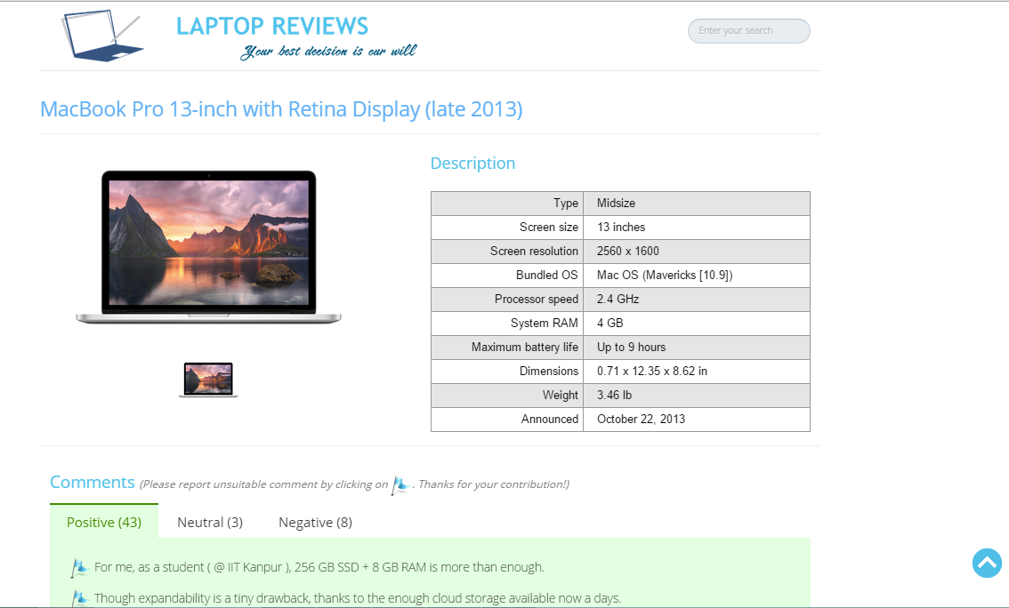

5

10

8

9

7

6

4

3

1

2

Figure 69: Member Home Page

**Fields**

|  |  |  |  |  |  |  |  |
| --- | --- | --- | --- | --- | --- | --- | --- |
| **No** | **Field Name** | **Description** | **Read only** | **Mandatory** | **Control Type** | **Data Type** | **Length** |
| 2 | Search | Search for laptop by name | No | No | Textbox | String | N/A |
| 3 | Laptop’s Name | Name of Laptop | Yes | N/A | Label | String | N/A |
| 4 | Product Image | Show big image of product | Yes | N/A | Image | Image | N/A |
| 6 | Product Description | Show product description | Yes | N/A | Table/Text | String | N/A |
| 7 | Product Comments | Show comments of product | Yes | N/A | Text | String | N/A |

**Buttons/ Hyperlinks**

|  |  |  |  |  |
| --- | --- | --- | --- | --- |
| **No** | **Function** | **Description** | **Validation** | **Outcome** |
| 1 | Home page | Click to transfer to home page | No | Transfer to Home page |
| 5 | View Product Image | Click to view product image in full size | No | Show full-size product image |
| 8 | Switch between Positive/Negative/Neutral comments | Click to view Positive/Negative or Neutral comments | No | Show appropriate comments |
| 9 | Report comment | Click to report insufficient comment | No | Reported comment is highlighted |
| 10 | Go to top | Click to go to top of current page | No | Go to top of current page |

#### Member Interface Design

##### Login Page

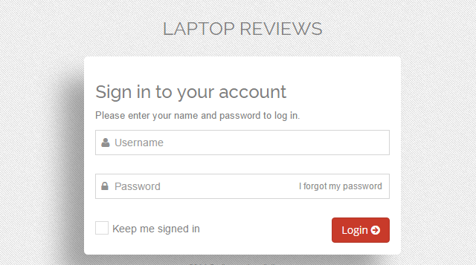

5

4



3

1

2

Figure 70: Admin/Staff Login Page

**Fields**

|  |  |  |  |  |  |  |  |
| --- | --- | --- | --- | --- | --- | --- | --- |
| **No** | **Field name** | **Description** | **Read only** | **Mandatory** | **Control type** | **Data type** | **Length** |
| 1 | Username | Fill username | No | Yes | Textbox | String | [6-20] |
| 2 | Password | Fill password | No | Yes | Password | String | [6-20]] |
| 3 | Keep me signed in | Keep account signed in | NO | N/A | checkbox | Bool | N/A |

**Button/Hyperlink**

|  |  |  |  |  |
| --- | --- | --- | --- | --- |
| **No** | **Function** | **Description** | **Validation** | **Outcome** |
| 4 | Retrieve password | Click to retrieve password by email | Yes | Transfer to Forgot password page |
| 5 | Login | Click to login into the system | Yes | Transfer to Admin/Staff Home page |

##### Account Management Page

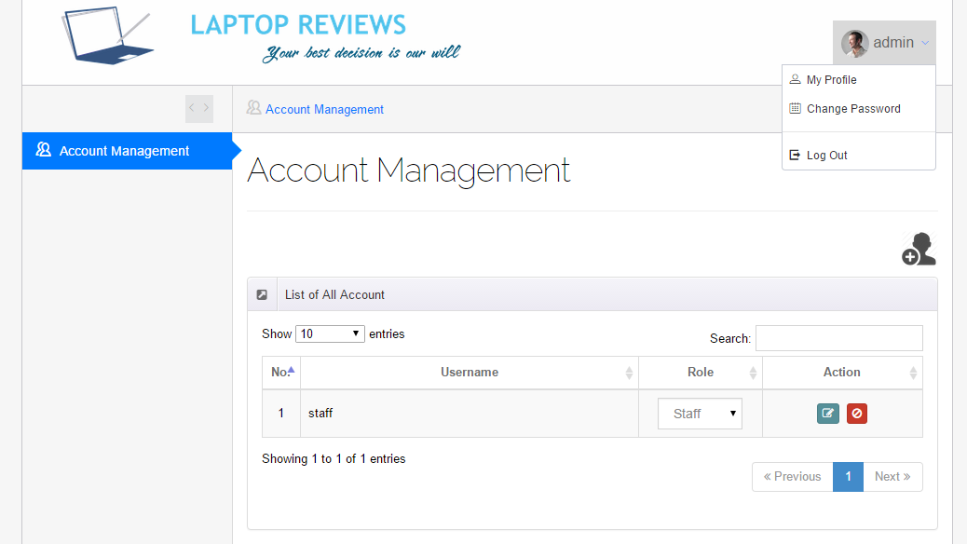

Figure 71: User List Page - 1



2

3

5

4

8

7

6

1

Figure 72: User List Page - 2

**Fields**

|  |  |  |  |  |  |  |  |
| --- | --- | --- | --- | --- | --- | --- | --- |
| **No** | **Field name** | **Description** | **Read only** | **Mandatory** | **Control type** | **Data type** | **Length** |
| 1 | Account info | Username of admin | N/A | N/A | Label | N/A | N/A |
| 2 | List of all account | Table showing | Yes | Yes | Table | N/A | N/A |

**Button/ Hyperlink**

|  |  |  |  |  |
| --- | --- | --- | --- | --- |
| **No** | **Function** | **Description** | **Validation** | **Outcome** |
| 3 | Logout | Click to logout account | No | Transfer to Admin/Staff Login page |
| 4 | Change password | Click to go to manage user page | No | Transfer to Admin/Staff Change password page |
| 5 | User profile | Click to go to manage user page | No | Transfer to Manage user page |
| 6 | Number entries | Click to select number entries will be showed | No | Show a dropdown list |
| 7 | Active/Deactive account | Click to Enable/Disable the user | No | Message completed |
| 8 | Edit Account | Click to edit account | No | Transfer to edit user page |

**Table User List includes**

|  |  |  |  |  |  |
| --- | --- | --- | --- | --- | --- |
| **Field name** | **Description** | **Read only** | **Control type** | **Data type** | **Length** |
| Email | Email | N/A | Label | String | N/A |
| Username | Username | N/A | Label | String | N/A |
| Role | Select role of user | N/A | Drop down list | N/A | N/A |
| Action | Enable/Disable account | No | Button | N/A | N/A |

##### Change Password Page

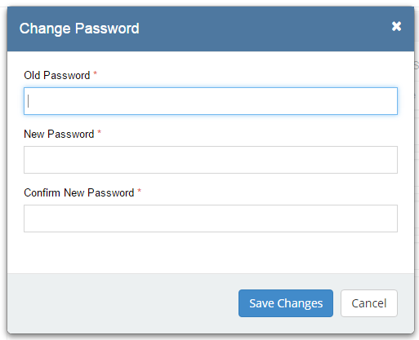

5

4

3

2

1

Figure 73: Create New User Page

**Fields**

|  |  |  |  |  |  |  |  |
| --- | --- | --- | --- | --- | --- | --- | --- |
| **No** | **Field name** | **Description** | **Read only** | **Mandatory** | **Control type** | **Data type** | **Length** |
| 1 | Old Password | Fill old password of user | No | Yes | Textbox | String | [6-20] |
| 2 | New Password | Fill password | No | Yes | Password | String | [6-20] |
| 3 | Confrm New Password | Fill password | No | Yes | Password | String | [6-20] |

**Button/ Hyperlink**

|  |  |  |  |  |
| --- | --- | --- | --- | --- |
| **No** | **Function** | **Description** | **Validation** | **Outcome** |
| 7 | Save changes | Save changes | Yes | Transfer to Account Managent page |
| 6 | Cancel | Cancel | No | Transfer to Account Managent page |

#### Staff Interface Design

##### System Configuration Page

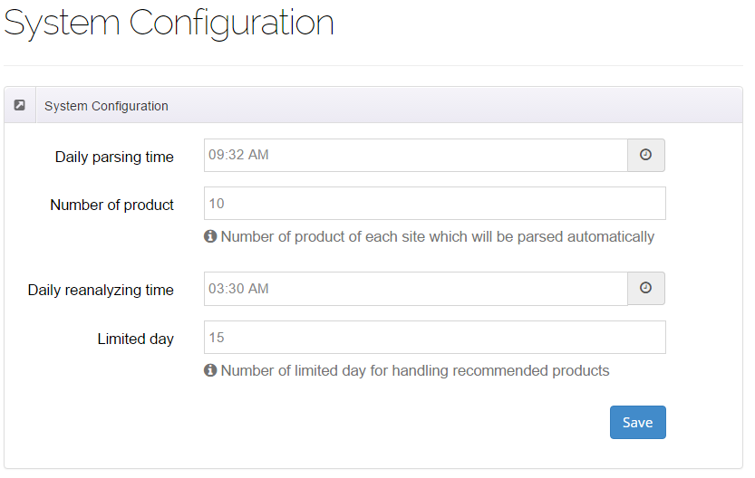

2

3

4

5

6

7

1

Figure 74: System Configuration Page

**Fields**

|  |  |  |  |  |  |  |  |
| --- | --- | --- | --- | --- | --- | --- | --- |
| **No** | **Field name** | **Description** | **Read only** | **Mandatory** | **Control type** | **Data type** | **Length** |
| 1 | System Configuration | Page’s name | Yes | N/A | Label | N/A | N/A |
| 2 | System Configuration | Area’s name | Yes | N/A | Label | N/A | N/A |
| 3 | Daily parsing time | Fill time parse product automatically | No | Yes | Time picker | Date Time | N/A |
| 4 | Number of product | Number of product of each site which will be parsed automatically | No | Yes | Textbox | Integer | 2 |
| 5 | Daily reanalyzing time | Fill time reanalyze comment automatically | No | Yes | Time picker | Date Time | N/A |
| 6 | Limited day | Number of limited day for handling recommended products | No | Yes | Textbox | Integer | N/A |

**Button/ Hyperlink**

|  |  |  |  |  |
| --- | --- | --- | --- | --- |
| **No** | **Function** | **Description** | **Validation** | **Outcome** |
| 7 | Update configuration | Click to update configuration system | Yes | Message completed |

##### Dictionary Management Page

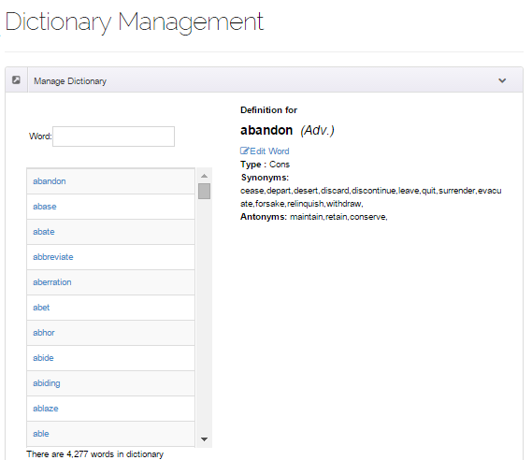

10

8

6

3

4

7

5

2

9

1

Figure 75: <Staff> Dictionary Management

**Fields**

|  |  |  |  |  |  |  |  |
| --- | --- | --- | --- | --- | --- | --- | --- |
| **No** | **Field Name** | **Description** | **Read only** | **Mandatory** | **Control Type** | **Data Type** | **Length** |
| 2 | Word | Show word character | Yes | Yes | Label | String | N/A |
| 3 | Word class | Show word class | Yes | Yes | Label | String | N/A |
| 5 | Word type | Show word type | Yes | Yes | Label | String | N/A |
| 6 | Word’s synonyms | Show word’s synonyms | Yes | Yes | Label | String | N/A |
| 7 | Word’s antonyms | Show word’s antonyms | Yes | Yes | Label | String | N/A |
| 8 | List of words | Show list of words | No | Yes | Scrollable List | String | N/A |
| 9 | Total words | Show total words inforamtion | Yes | Yes | Label | String | N/A |

**Button/ Hyperlink**

|  |  |  |  |  |
| --- | --- | --- | --- | --- |
| **No** | **Function** | **Description** | **Validation** | **Outcome** |
| 1 | Search word | Input search string to find specific word | N/A | Specific word is shown |
| 4 | Edit word | Click to show edit word field | Yes | Edit word field is shown |
| 10 | Show word definition | Click to show word definition | Yes | Word definition is shown |

###### Add new word

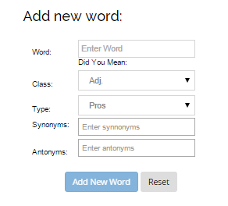

7

6

8

5

4

3

2

1

Figure 76: <Staff> Add new word

**Fields**

|  |  |  |  |  |  |  |  |
| --- | --- | --- | --- | --- | --- | --- | --- |
| **No** | **Field Name** | **Description** | **Read only** | **Mandatory** | **Control Type** | **Data Type** | **Length** |
| 1 | Word | Input word character | No | Yes | Textbox | String | N/A |
| 2 | Validation for word input | Show validate information for word input | No | No | Label | String | N/A |
| 3 | Word class | Choose word class | No | Yes | Drop down list | String | N/A |
| 4 | Word type | Choose word type | No | Yes | Drop down list | String | N/A |
| 5 | Word’s synonyms | Input word synonyms | No | No | Textbox | String | N/A |
| 6 | Word’s antonyms | Input word antonyms | No | No | Textbox | String | N/A |

**Button/ Hyperlink**

|  |  |  |  |  |
| --- | --- | --- | --- | --- |
| **No** | **Function** | **Description** | **Validation** | **Outcome** |
| 7 | Reset | Click to clear all input fields | N/A | All fields are cleared |
| 8 | Add new word | Click to submit add new word field | Yes | New word is added. Show new word definition |

###### Edit Word

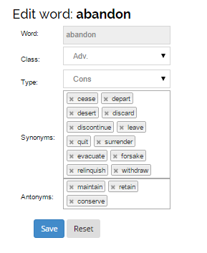

7

6

5

4

3

2

1

Figure 77: <Staff> Add new word

**Fields**

|  |  |  |  |  |  |  |  |
| --- | --- | --- | --- | --- | --- | --- | --- |
| **No** | **Field Name** | **Description** | **Read only** | **Mandatory** | **Control Type** | **Data Type** | **Length** |
| 1 | Word | Show word characters | Yes | Yes | Label | String | N/A |
| 2 | Word class | Edit word class | No | Yes | Drop down list | String | N/A |
| 3 | Word type | Edit word type | No | Yes | Drop down list | String | N/A |
| 4 | Word’s synonyms | Edit word synonyms | No | No | Textbox | String | N/A |
| 5 | Word’s antonyms | Edit word antonyms | No | No | Textbox | String | N/A |

**Button/ Hyperlink**

|  |  |  |  |  |
| --- | --- | --- | --- | --- |
| **No** | **Function** | **Description** | **Validation** | **Outcome** |
| 6 | Reset | Click to clear all input fields | N/A | All fields are cleared |
| 7 | Edit word | Click to submit edit word field | Yes | New information of word is saved and shown to current page. |

##### Import Excel File

###### Import Excel Page

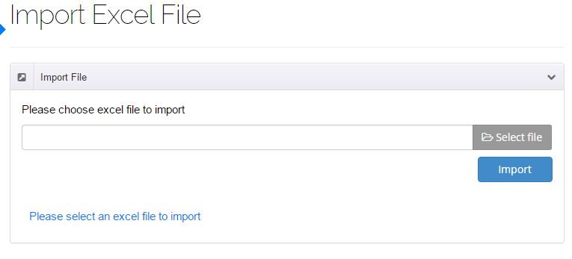

3



2

1

Figure 78: Import Excel Page

**Fields**

|  |  |  |  |  |  |  |  |
| --- | --- | --- | --- | --- | --- | --- | --- |
| **No** | **Field Name** | **Description** | **Read only** | **Mandatory** | **Control Type** | **Data Type** | **Length** |
| 3 | Message | Message | Yes | N/A | Label | N/A | N/A |

**Button/ Hyperlink**

|  |  |  |  |  |
| --- | --- | --- | --- | --- |
| **No** | **Function** | **Description** | **Validation** | **Outcome** |
| 1 | Select excel file | Click to select excel file | N/A | N/A |
| 2 | Import excel file | Get data in excel file | N/A | N/A |

###### Result Page

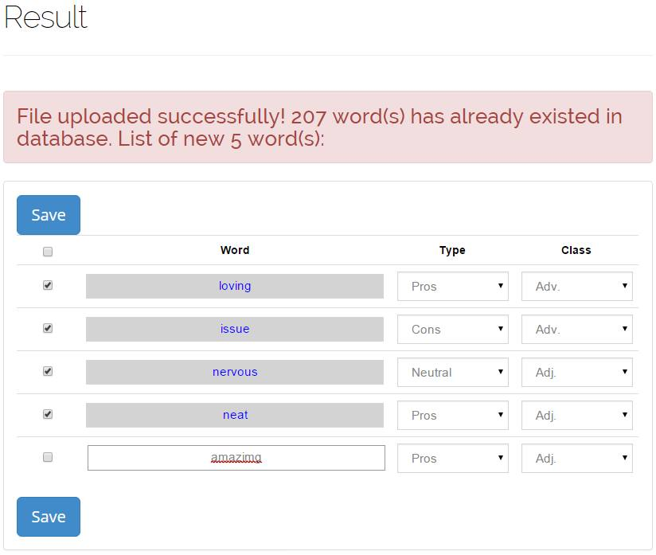

6



5

4

3

2

1

Figure 79: Result Page

**Fields**

|  |  |  |  |  |  |  |  |
| --- | --- | --- | --- | --- | --- | --- | --- |
| **No** | **Field Name** | **Description** | **Read only** | **Mandatory** | **Control Type** | **Data Type** | **Length** |
| 2 | Select | Select | No | N/A | Checkbox | Boolean | N/A |
| 3 | Word name | Word name | No | N/A | Textbox | String | N/A |
| 4 | Word Type | Type word | No | N/A | Textbox | String | N/A |
| 5 | Word Class | Word class | No | N/A | Textbox | String | N/A |
| 6 | Message | Message | No | N/A | Textbox | String | N/A |

**Button/ Hyperlink**

|  |  |  |  |  |
| --- | --- | --- | --- | --- |
| **No** | **Function** | **Description** | **Validation** | **Outcome** |
| 1 | Save | Click to save select word(s) | N/A | N/A |

###### Find Synonyms and Antonyms Page

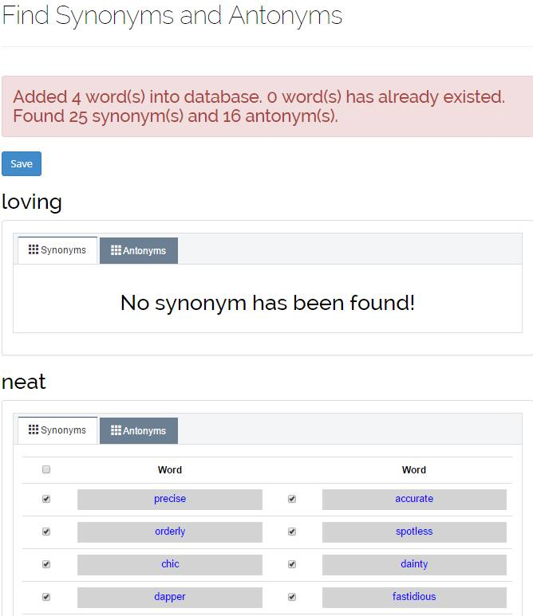

2



7

6

5

4

3

1

**Fields**

|  |  |  |  |  |  |  |  |
| --- | --- | --- | --- | --- | --- | --- | --- |
| **No** | **Field Name** | **Description** | **Read only** | **Mandatory** | **Control Type** | **Data Type** | **Length** |
| 2 | Message | Message | No | N/A | Textbox | String | N/A |
| 3 | Word name | Word name | No | N/A | Label | String | N/A |
| 4 | Synonym | Synonym table | No | N/A | TabTable | N/A | N/A |
| 5 | Antonyms | Antonyms table | No | N/A | TabTable | N/A | N/A |

**Button/ Hyperlink**

|  |  |  |  |  |
| --- | --- | --- | --- | --- |
| **No** | **Function** | **Description** | **Validation** | **Outcome** |
| 1 | Save | Click to save select word(s) | N/A | N/A |

**Table Recommend List includes**

|  |  |  |  |  |  |
| --- | --- | --- | --- | --- | --- |
| **Field name** | **Description** | **Read only** | **Control type** | **Data type** | **Length** |
| Select | Select | No | Checkbox | Boolean | N/A |
| Word name | Word name | No | Textbox | String | N/A |

##### Import Dictionary File Page

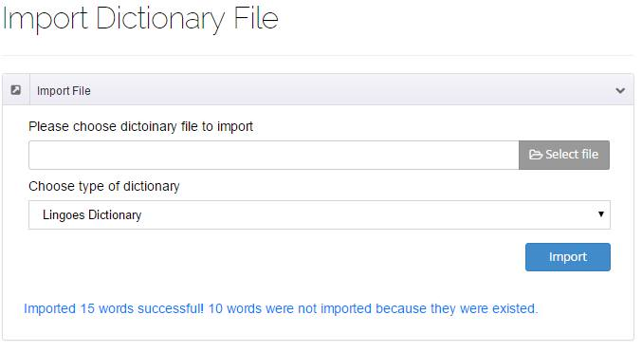

4

3

2

1

Figure 80: Import Dictionary File

**Fields**

|  |  |  |  |  |  |  |  |
| --- | --- | --- | --- | --- | --- | --- | --- |
| **No** | **Field name** | **Description** | **Read only** | **Mandatory** | **Control type** | **Data type** | **Length** |
| 10 | User price list | Table showing | No | Yes | Table | N/A | N/A |
| 4 | Select product | Select recommend product to auto list | No | N/A | Check box | N/A | N/A |
| 5 | Select product | Select recommend product to Ignore list | No | N/A | Check box | N/A | N/A |
|  |  |  |  |  |  |  |  |

**Button/ Hyperlink**

|  |  |  |  |  |
| --- | --- | --- | --- | --- |
| **No** | **Function** | **Description** | **Validation** | **Outcome** |
| 1 | Select excel file | Click to select excel file | N/A | N/A |
| 2 | Import excel file | Get data in excel file | N/A | N/A |

**Table Recommend List includes**

|  |  |  |  |  |  |
| --- | --- | --- | --- | --- | --- |
| **Field name** | **Description** | **Read only** | **Control type** | **Data type** | **Length** |
| Username | Username | N/A | Label | String | N/A |
| URL | URL of product | N/A | Label | String | N/A |
| RecommendTime | Recommend time | N/A | Label | Datetime | N/A |
| Action | Action of staff | No | Button, Checkbox | N/A | N/A |

##### Product Management

###### Product Management Page

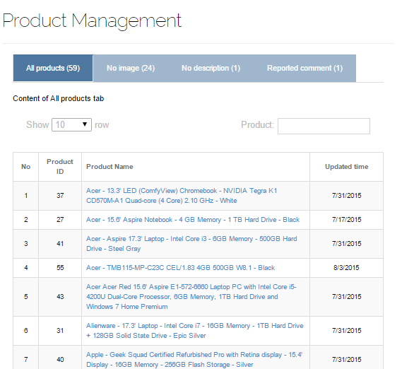

7

6

4

3

1

2

Figure 81: Product Management - All Product Page

**Fields**

|  |  |  |  |  |  |  |  |
| --- | --- | --- | --- | --- | --- | --- | --- |
| **No** | **Field name** | **Description** | **Read only** | **Mandatory** | **Control type** | **Data type** | **Length** |
| 1 | Page name | Name of current page | Yes | Yes | Label | String | N/A |
| 3 | Search Product | Search for product by name | No | No | Textbox | String | N/A |
| 4 | Filter product | Filter number of displayed product | No | Yes | Dropdown List | String | N/A |
| 6 | Table of Products | Show list of products | Yes | Yes | Table | N/A | N/A |

**Button/ Hyperlink**

|  |  |  |  |  |
| --- | --- | --- | --- | --- |
| **No** | **Function** | **Description** | **Validation** | **Outcome** |
| 2 | Change Table | Click to switch displayed table between: All Product, No Description Product, No Image Product and Reported Comments | No | Reload table and its contains |
| 7 | Go to Edit Product Page | Click to go to Edit Product Page | No | Navigate to appropriate edit product page |

**Table of Product includes**

|  |  |  |  |  |  |
| --- | --- | --- | --- | --- | --- |
| **Field name** | **Description** | **Read only** | **Control type** | **Data type** | **Length** |
| No | No of product in table | Yes | Label | String | N/A |
| Product ID | ID of products | Yes | Label | String | N/A |
| Product Name | Name of Product | Yes | Hyperlink | String | N/A |
| Updated Time | The date the product was updated | Yes | Label | String | N/A |

###### Edit Product Page

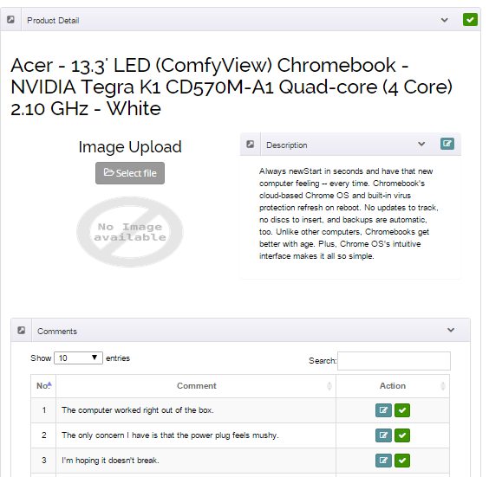

11

10

9

8

7

6

5

4

3

2

1

Figure 82: Product Edit Page

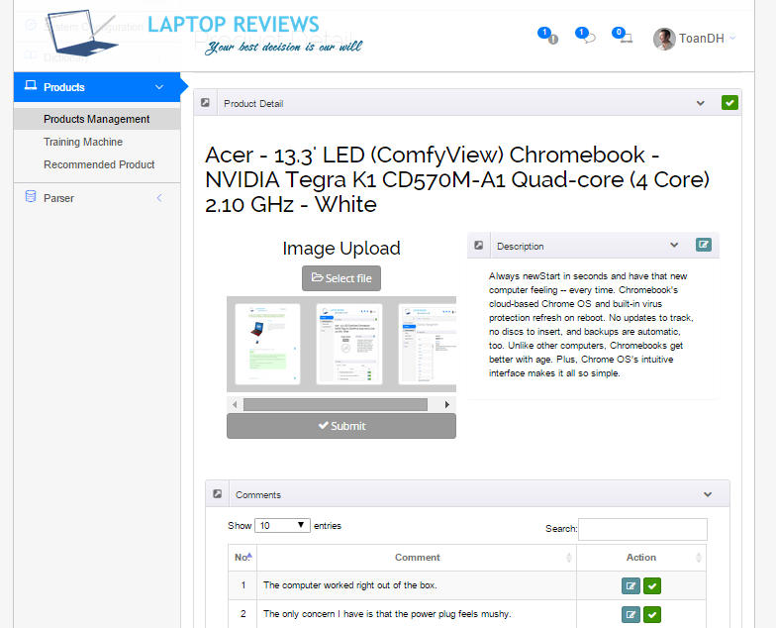

12

Figure 83: Product Edit Page - Upload Image

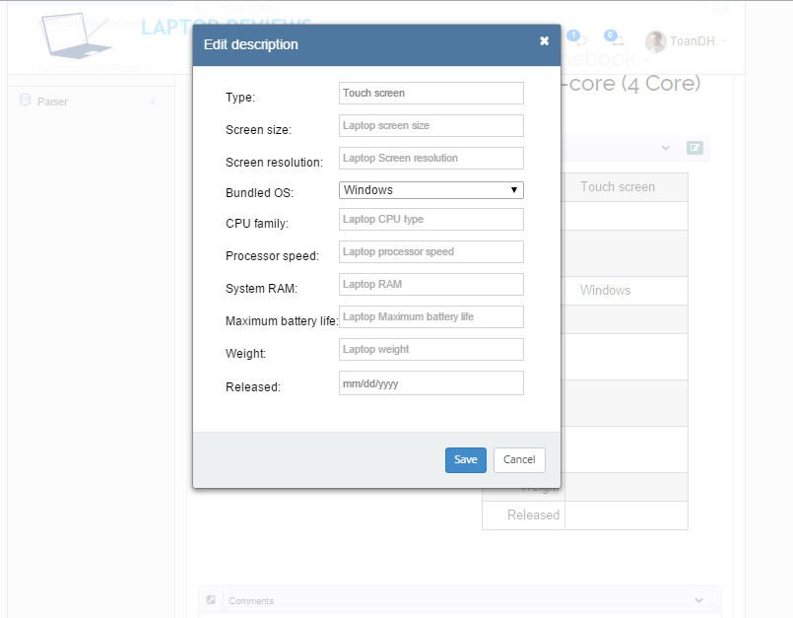

24

23 

22

21

20

19

18

17

16

15

14

13

Figure 84: Edit Product Page - Edit Description

**Fields**

|  |  |  |  |  |  |  |  |
| --- | --- | --- | --- | --- | --- | --- | --- |
| **No** | **Field name** | **Description** | **Read only** | **Mandatory** | **Control type** | **Data type** | **Length** |
| 2 | Product Name | Name of Product | Yes | Yes | Label | String | N/A |
| 4 | Product Description | Description of product | Yes | Yes | Text | String | N/A |
| 6 | Images area | Show product images | Yes | Yes | N/A | N/A | N/A |
| 9 | Comment Table | Table contains produc comments | Yes | Yes | Table | N/A | N/A |
| 12 | Image preview | Show selected images for reviewing | Yes | No | N/A | N/A | N/A |
| 13 | Laptop Type | Input type of laptop | No | No | Textbox | String | N/A |
| 14 | Laptop Screen Size | Input screen size of laptop | No | No | Textbox | String | N/A |
| 15 | Laptop Screen Resolution | Input screen resolution of laptop | No | No | Textbox | String | N/A |
| 16 | Laptop Operation System | Input laptop operation system | No | No | Dropdown List | String | N/A |
| 17 | Laptop CPU type | Input laptop CPU type | No | No | Textbox | String | N/A |
| 18 | Laptop Processor Speed | Input laptop processor speed | No | No | Textbox | String | N/A |
| 19 | Laptop Ram | Input Laptop Ram | No | Yes | Textbox | Int | N/A |
| 20 | Laptop maximum battery life | Input laptop maximum battery life | No | No | Textbox | String | N/A |
| 21 | Laptop weight | Input laptop weight | No | Yes | Textbox | Double | N/A |
| 22 | Laptop released day | Input laptop released date | No | Yes | Datetime Input | Datetime | N/A |

**Button/Hyperlink**

|  |  |  |  |  |
| --- | --- | --- | --- | --- |
| **No** | **Function** | **Description** | **Validation** | **Outcome** |
| 3 | Edit description | Click to show edit description form | No | Edit description form appears |
| 5 | Choose Images | Click to show “Choose Image” form | No | Choose image form appears |
| 7 | Filter comment | Filter maximum of comments showing in each page in table | No | Maximum of comments in each page is correctly set |
| 8 | Search comment | Search for comment by its content | No | Appropriate comments are searched |
| 10 | Enable/Disable comment | Enable/Disable a comment | No | Selected comment is enabled/disabled |
| 11 | Edit comment | Show edit comment form | No | Edit comment form is shown |
| 23 | Save description | Click to save new description and load it to page | No | New descripton is saved and loaded to page |
| 24 | Cancel update description | Click to cancel all update | No | Close Edit Description form |

**Comment table includes:**

|  |  |  |  |  |  |
| --- | --- | --- | --- | --- | --- |
| **Field Name** | **Description** | **Read only** | **Control Type** | **Data Type** | **Length** |
| No | No of comment in table | Yes | Label | String | N/A |
| Comment | Comment content | Yes | Text | String | N/A |
| Action | Action to handle comment | No | Button | N/A | N/A |

###### Reported Comment Page

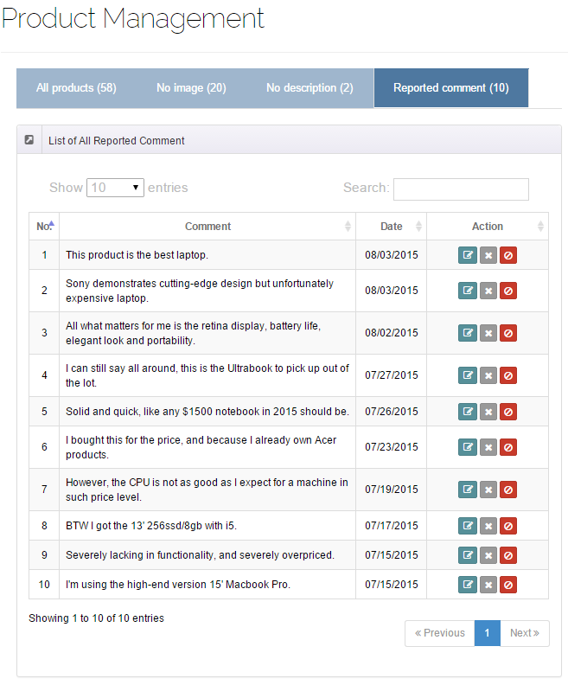

9

10

8

7

6

5

4

3

2

1

Figure 85: Reported Comment Page

**Fields**

|  |  |  |  |  |  |  |  |
| --- | --- | --- | --- | --- | --- | --- | --- |
| **No** | **Field Name** | **Description** | **Read only** | **Mandatory** | **Control Type** | **Data Type** | **Length** |
| 1 | Product management | Page’s name | Yes | N/A | Label | N/A | N/A |
| 5 | Reported comment | Selected tab’s name | Yes | N/A | Label | N/A | N/A |
| 6 | List of all reported comment | Area’s name | Yes | N/A | Label | N/A | N/A |
| 7 | Reported comment table | Show reported comment | No | N/A | Table list view | N/A | N/A |

**Button/ Hyperlink**

|  |  |  |  |  |
| --- | --- | --- | --- | --- |
| **No** | **Function** | **Description** | **Validation** | **Outcome** |
| 2 | Show content of “All products” tab | Click to change to “All products” tab | No | Show all product |
| 3 | Show content of “No image” tab | Click to change to “No image” tab | No | Show all products that have no image |
| 4 | Show content of “No description” tab | Click to change to “No description” tab | No | Show all products that have no description |
| 8 | Edit comment | Click to edit this comment | No | Show this comment’s detail |
| 9 | Deny report | Click to deny this report | No | Remove this report from this list |
| 10 | Deactivate comment | Click to deactivate this comment | No | Remove this report from this list |

**List of Reported Comment includes**

|  |  |  |  |  |  |
| --- | --- | --- | --- | --- | --- |
| **Field Name** | **Description** | **Read only** | **Control Type** | **Data Type** | **Length** |
| Number row | Number of row | N/A | Label | String | N/A |
| Comment | Comment’s content | N/A | Label | String | N/A |
| Date | Report’s date | N/A | Label | String | N/A |
| Action | Action for this comment | No | Button | N/A | N/A |

###### Edit Comment Page

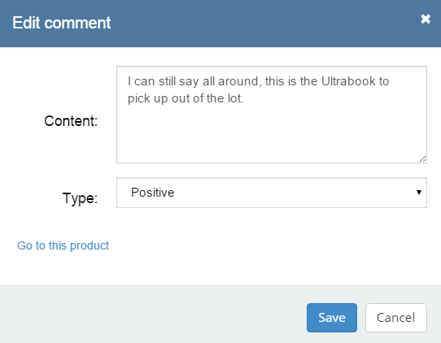

5

4

3

2

1

Figure 86: Edit Comment Page

**Fields**

|  |  |  |  |  |  |  |  |
| --- | --- | --- | --- | --- | --- | --- | --- |
| **No** | **Field Name** | **Description** | **Read only** | **Mandatory** | **Control Type** | **Data Type** | **Length** |
| 1 | Content | Fill content of comment | No | Yes | Textarea | String | N/A |
| 2 | Type | Fill type of comment | No | Yes | Dropdown list | String | N/A |

**Button/ Hyperlink**

|  |  |  |  |  |
| --- | --- | --- | --- | --- |
| **No** | **Function** | **Description** | **Validation** | **Outcome** |
| 3 | Go to this product | Click to go to the product which has this comment | No | Transfer to product’s detail page. |
| 4 | Save comment | Click to save changes | No | Back to report comment page and remove this comment from the list |
| 5 | Cancel | Click to back to report comment page | No | Back to report comment page |

##### Train Machine

###### Train Machine Page

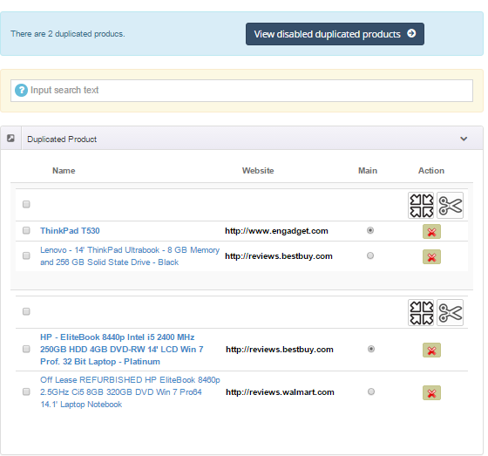

3

108

6

7

8

9

5

4

2

1

Figure 87: Train Machine

**Fields**

|  |  |  |  |  |  |  |  |
| --- | --- | --- | --- | --- | --- | --- | --- |
| **No** | **Field name** | **Description** | **Read only** | **Mandatory** | **Control type** | **Data type** | **Length** |
| 1 | Total duplicate products | Show total number of duplicate products | Yes | Yes | Label | String | N/A |
| 3 | Search duplicated product | Search duplicated products by name | No | No | Textbox | String | N/A |
| 7 | Product Website | Show website which product is parsed from | Yes | Yes | Label | String | N/A |

**Button/Hyperlink**

|  |  |  |  |  |
| --- | --- | --- | --- | --- |
| **No** | **Function** | **Description** | **Validation** | **Outcome** |
| 2 | Show disabled duplicated product | Click to go to disabled duplicated products | No | Transfer to Disabled duplicated product page |
| 4 | Split | Click to split selected products | Yes | Selected products are split |
| 5 | Merge | Click to merge selected products | Yes | Selected producs are merged |
| 6 | Disable | Click to disable selected product | Yes | Selected product is disabled |
| 8 | Product Description | Click to show product description | Yes | Selected product’s description is shown |
| 9 | Check products | Check to select products that need to handle | Yes | After checking, product is selected and ready to process next step |
| 10 | Check main product | Check to select main product | Yes | After checking, selected product is selected as main product |

###### Product Log File

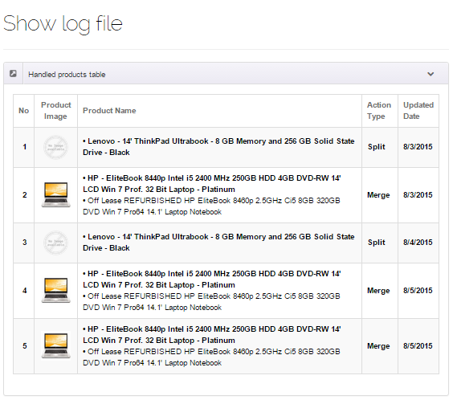

1

Figure 88: Edit Alias Product

**Fields**

|  |  |  |  |  |  |  |  |
| --- | --- | --- | --- | --- | --- | --- | --- |
| **No** | **Field name** | **Description** | **Read only** | **Mandatory** | **Control type** | **Data type** | **Length** |
| 1 | Proccessed product table | Show processed products information | Yes | Yes | Table | N/A | N/A |

**Proccessed table includes:**

|  |  |  |  |  |  |
| --- | --- | --- | --- | --- | --- |
| **Field Name** | **Description** | **Read only** | **Control Type** | **Data Type** | **Length** |
| No | No of product in table | Yes | Label | String | N/A |
| Product Image | Avatar of product (with split products) or group of products (wit merged product) | Yes | Image | N/A | N/A |
| Product Name | Show processed product names | Yes | Text | String | N/A |
| Action type | Show how products were processed | Yes | Text | String | N/A |
| Updated date | Show the date the products were processed | Yes | Label | String | N/A |

##### Recommended Product

###### Recommended Product Page

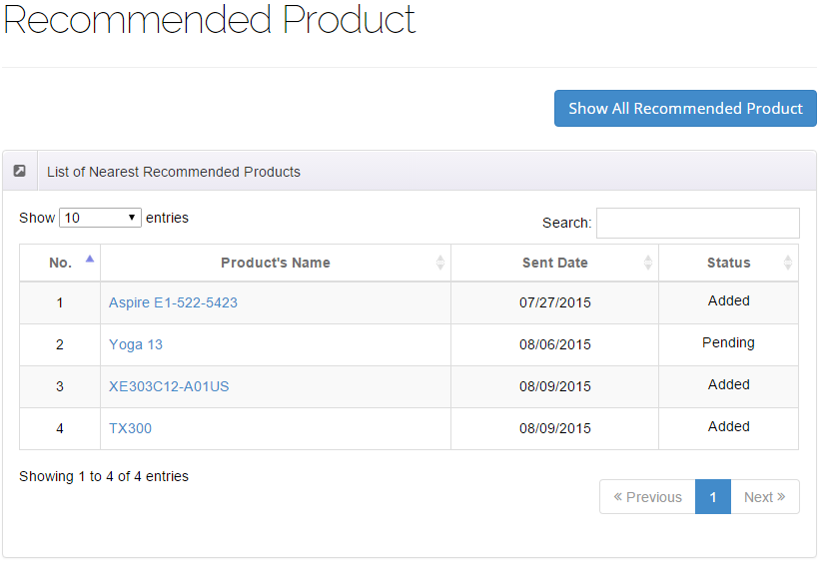

2

1

3

4

5

Figure 89: Recommended Product Page

**Fields**

|  |  |  |  |  |  |  |  |
| --- | --- | --- | --- | --- | --- | --- | --- |
| **No** | **Field name** | **Description** | **Read only** | **Mandatory** | **Control type** | **Data type** | **Length** |
| 1 | Recommended product | Page’s name | Yes | N/A | Label | N/A | N/A |
| 2 | List of nearest recommended products | Area’s name | Yes | N/A | Label | N/A | N/A |
| 4 | Recommended product table | Show recommended product | No | N/A | Table list view | N/A | N/A |

**Button/Hyperlink**

|  |  |  |  |  |
| --- | --- | --- | --- | --- |
| **No** | **Function** | **Description** | **Validation** | **Outcome** |
| 3 | Show all recommended product | Show all recommended product in database | No | Reload table with all recommended products |
| 5 | Show product’s detail | Show selected product’s detail | No | Show selected product’s detail in |

**List of Nearest Recommended Products includes**

|  |  |  |  |  |  |
| --- | --- | --- | --- | --- | --- |
| **Field Name** | **Description** | **Read only** | **Control Type** | **Data Type** | **Length** |
| Number row | Number of row | N/A | Label | String | N/A |
| Product’s name | Recommended product’s name | No | Hyperlink | String | N/A |
| Sent date | Recommend’s sent date | N/A | Label | String | N/A |
| Status | Product’s status | N/A | Label | boolean | N/A |

###### Recommended Product Detail Page

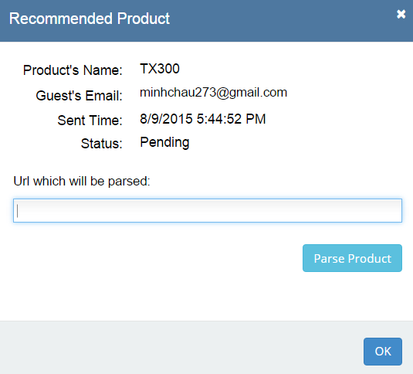

7

1

2

3

4

5

6

Figure 90: Recommended Product Detail Page

**Fields**

|  |  |  |  |  |  |  |  |
| --- | --- | --- | --- | --- | --- | --- | --- |
| **No** | **Field name** | **Description** | **Read only** | **Mandatory** | **Control type** | **Data type** | **Length** |
| 1 | Product’s name | Recommended product’s name | Yes | N/A | Label | N/A | N/A |
| 2 | Guest’s email | Emails of people who sent recommend | Yes | N/A | Label | N/A | N/A |
| 3 | Sent time | Recommend’s sent date | Yes | N/A | Label | N/A | N/A |
| 4 | Status | Product’s status | Yes | N/A | Label | N/A | N/A |
| 5 | Url which will be parse | Url of this recommended product which will be parse | No | Yes | Textbox | String | N/A |

**Button/Hyperlink**

|  |  |  |  |  |
| --- | --- | --- | --- | --- |
| **No** | **Function** | **Description** | **Validation** | **Outcome** |
| 6 | Parse product | Parse this product and send email to guest | Yes | Message completed |
| 7 | Cancel | Turn off this popup | No | Back to Recommended Product page |

##### Site Management Page

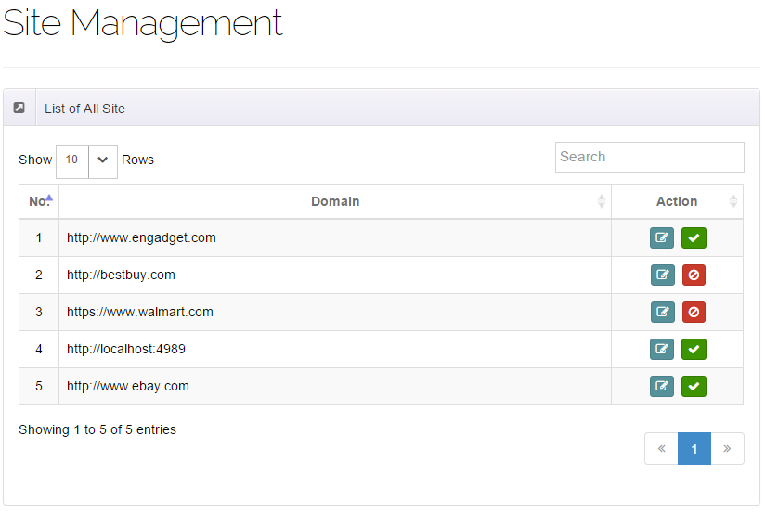

4

5

3

2

1

Figure 91: Site Management Page

**Fields**

|  |  |  |  |  |  |  |  |
| --- | --- | --- | --- | --- | --- | --- | --- |
| **No** | **Field name** | **Description** | **Read only** | **Mandatory** | **Control type** | **Data type** | **Length** |
| 1 | Site management | Page’s name | Yes | N/A | Label | N/A | N/A |
| 2 | List of all site | Area’s name | Yes | N/A | Label | N/A | N/A |
| 3 | List of all site table | Show all sites | No | N/A | Table list view | N/A | N/A |

**Button/Hyperlink**

|  |  |  |  |  |
| --- | --- | --- | --- | --- |
| **No** | **Function** | **Description** | **Validation** | **Outcome** |
| 1 | Edit site | Click to edit site | No | Show site’s detail |
| 2 | Enable/Disable site | Click to Enable/Disable site | N/A | Change icon of action |

**List of all site includes**

|  |  |  |  |  |  |
| --- | --- | --- | --- | --- | --- |
| **Field name** | **Description** | **Read only** | **Control type** | **Data type** | **Length** |
| No. | Number | N/A | Label | Integer | N/A |
| Domain | Website name | N/A | Label | String | N/A |
| Action | Action for this site | No | Button | N/A | N/A |

##### Create New Site Page

###### View Site

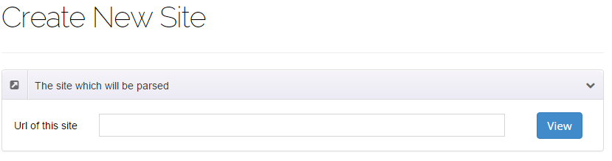

3

2

1

Figure 92: View Site

**Fields**

|  |  |  |  |  |  |  |  |
| --- | --- | --- | --- | --- | --- | --- | --- |
| **No** | **Field name** | **Description** | **Read only** | **Mandatory** | **Control type** | **Data type** | **Length** |
| 1 | Create new site | Page’s name | Yes | N/A | Label | N/A | N/A |
| 2 | Url of this site | Url of this site which will be created parser | No | Yes | Textbox | String | N/A |

**Button/Hyperlink**

|  |  |  |  |  |
| --- | --- | --- | --- | --- |
| **No** | **Function** | **Description** | **Validation** | **Outcome** |
| 2 | View site | Click to view site | No | Display site’s view |

###### Step 1

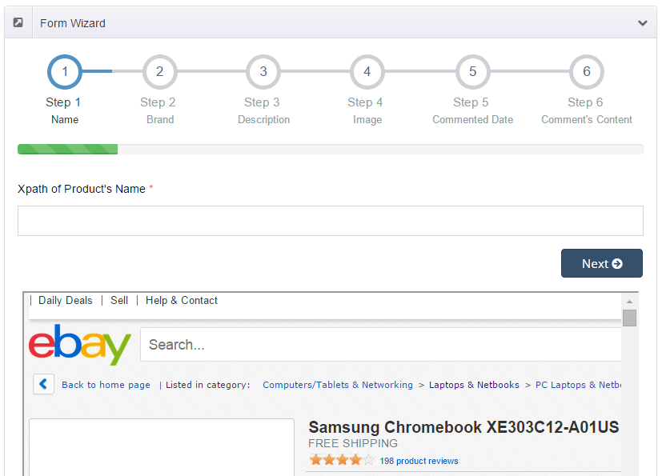

9

6

5

8

7

3

1

4

2

Figure 93: Create New Site - Step 1

**Fields**

|  |  |  |  |  |  |  |  |
| --- | --- | --- | --- | --- | --- | --- | --- |
| **No** | **Field name** | **Description** | **Read only** | **Mandatory** | **Control type** | **Data type** | **Length** |
| 7 | Xpath of product’s name | Xpath of product’s name | No | Yes | Textbox | String | N/A |
| 9 | Web view | Web view | No | N/A | Web view | N/A | N/A |

**Button/Hyperlink**

|  |  |  |  |  |
| --- | --- | --- | --- | --- |
| **No** | **Function** | **Description** | **Validation** | **Outcome** |
| 1 | Name xpath | Click to go to step 1 | No | Transfer to step 1 |
| 2 | Brand xpath | Click to go to step 2 | Yes | Transfer to step 2 |
| 3 | Description xpath | Click to go to step 3 | Yes | Transfer to step 3 |
| 4 | Image xpath | Click to go to step 4 | Yes | Transfer to step 4 |
| 5 | Date xpath | Click to go to step 5 | Yes | Transfer to step 5 |
| 6 | Content xpath | Click to go to step 6 | Yes | Transfer to step 6 |
| 8 | Next step | Click to go to next step | Yes | Transfer to step 2 |

###### Step 2

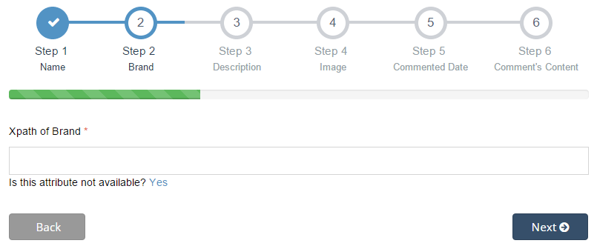

3

2

1

4

Figure 94: Create New Site - Step 2

**Fields**

|  |  |  |  |  |  |  |  |
| --- | --- | --- | --- | --- | --- | --- | --- |
| **No** | **Field name** | **Description** | **Read only** | **Mandatory** | **Control type** | **Data type** | **Length** |
| 1 | Xpath of brand | Xpath of brand | No | Yes | Textbox | String | N/A |

**Button/Hyperlink**

|  |  |  |  |  |
| --- | --- | --- | --- | --- |
| **No** | **Function** | **Description** | **Validation** | **Outcome** |
| 2 | Set N/A | Set not available for this field | No | This field is “N/A” |
| 3 | Previous step | Click to go to previous step | Yes | Transfer to step 1 |
| 4 | Next step | Click to go to next step | Yes | Transfer to step 3 |

###### Step 3

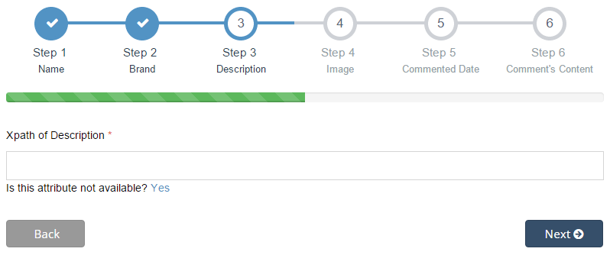

3

1

4

2

Figure 95: Create New Site - Step 3

**Fields**

|  |  |  |  |  |  |  |  |
| --- | --- | --- | --- | --- | --- | --- | --- |
| **No** | **Field name** | **Description** | **Read only** | **Mandatory** | **Control type** | **Data type** | **Length** |
| 1 | Xpath of description | Xpath of description | No | Yes | Textbox | String | N/A |

**Button/Hyperlink**

|  |  |  |  |  |
| --- | --- | --- | --- | --- |
| **No** | **Function** | **Description** | **Validation** | **Outcome** |
| 2 | Set N/A | Set not available for this field | No | This field is “N/A” |
| 3 | Previous step | Click to go to previous step | Yes | Transfer to step 2 |
| 4 | Next step | Click to go to next step | Yes | Transfer to step 4 |

###### Step 4

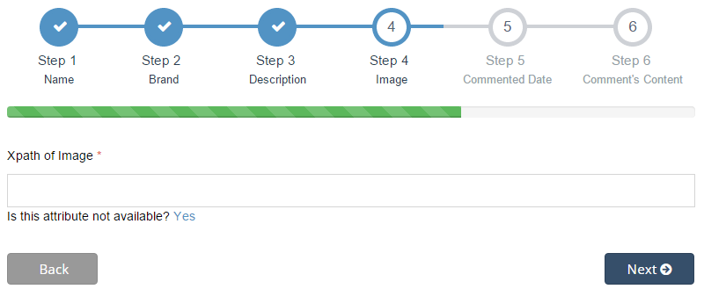

3

1

4

2

Figure 96: Create New Site - Step 4

**Fields**

|  |  |  |  |  |  |  |  |
| --- | --- | --- | --- | --- | --- | --- | --- |
| **No** | **Field name** | **Description** | **Read only** | **Mandatory** | **Control type** | **Data type** | **Length** |
| 1 | Xpath of image | Xpath of image | No | Yes | Textbox | String | N/A |

**Button/Hyperlink**

|  |  |  |  |  |
| --- | --- | --- | --- | --- |
| **No** | **Function** | **Description** | **Validation** | **Outcome** |
| 2 | Set N/A | Set not available for this field | No | This field is “N/A” |
| 3 | Previous step | Click to go to previous step | Yes | Transfer to step 3 |
| 4 | Next step | Click to go to next step | Yes | Transfer to step 5 |

###### Step 5

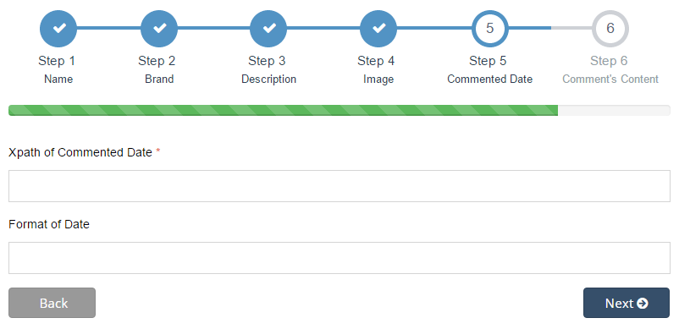

1

2

3

4

Figure 97: Create New Site - Step 5

**Fields**

|  |  |  |  |  |  |  |  |
| --- | --- | --- | --- | --- | --- | --- | --- |
| **No** | **Field name** | **Description** | **Read only** | **Mandatory** | **Control type** | **Data type** | **Length** |
| 1 | Xpath of commented date | Xpath of commented date | No | Yes | Textbox | String | N/A |
| 2 | Format of date | Format of date | No | No | Textbox | String | N/A |

**Button/Hyperlink**

|  |  |  |  |  |
| --- | --- | --- | --- | --- |
| **No** | **Function** | **Description** | **Validation** | **Outcome** |
| 3 | Previous step | Click to go to previous step | Yes | Transfer to step 4 |
| 4 | Next step | Click to go to next step | Yes | Transfer to step 5 |

###### Step 6

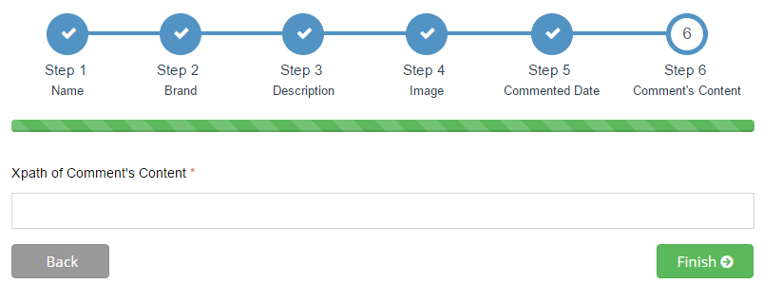

1

3

2

Figure 98: Create New Site - Step 6

**Fields**

|  |  |  |  |  |  |  |  |
| --- | --- | --- | --- | --- | --- | --- | --- |
| **No** | **Field name** | **Description** | **Read only** | **Mandatory** | **Control type** | **Data type** | **Length** |
| 1 | Xpath of comment’s content | Xpath of comment’s content | No | Yes | Textbox | String | N/A |

**Button/Hyperlink**

|  |  |  |  |  |
| --- | --- | --- | --- | --- |
| **No** | **Function** | **Description** | **Validation** | **Outcome** |
| 2 | Previous step | Click to go to previous step | Yes | Transfer to step 5 |
| 3 | Finish process | Click to go to finish process | Yes | Transfer to preview product’s infomation |

###### Preview Product’s Information

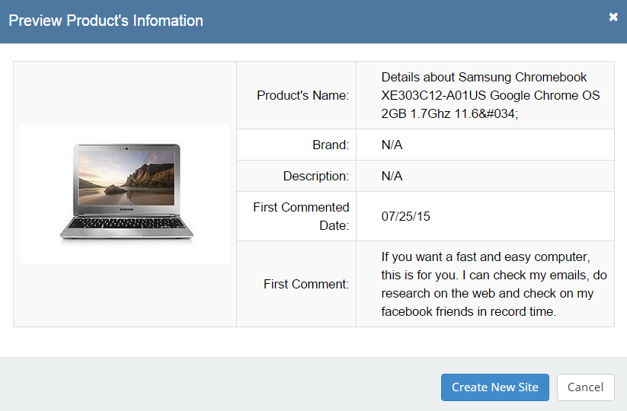

7

6

2

3

1

4

5

Figure 99: Create New Site – Preview Product’s Information

**Fields**

|  |  |  |  |  |  |  |  |
| --- | --- | --- | --- | --- | --- | --- | --- |
| **No** | **Field name** | **Description** | **Read only** | **Mandatory** | **Control type** | **Data type** | **Length** |
| 1 | Product’s name | Product’s name | Yes | N/A | Label | String | N/A |
| 2 | Brand | Product’s brand | Yes | N/A | Label | String | N/A |
| 3 | Description | Product’s description | Yes | N/A | Label | String | N/A |
| 4 | First commented date | Product’s first commented date | Yes | N/A | Label | String | N/A |
| 5 | First comment | Product’s first comment | Yes | N/A | Label | String | N/A |

**Button/Hyperlink**

|  |  |  |  |  |
| --- | --- | --- | --- | --- |
| **No** | **Function** | **Description** | **Validation** | **Outcome** |
| 6 | Create new site | Click to create new site | Yes | Transfer to step 5 |
| 7 | Cancel | Click to cancel process | Yes | Back to create new site page |

##### Log File Page

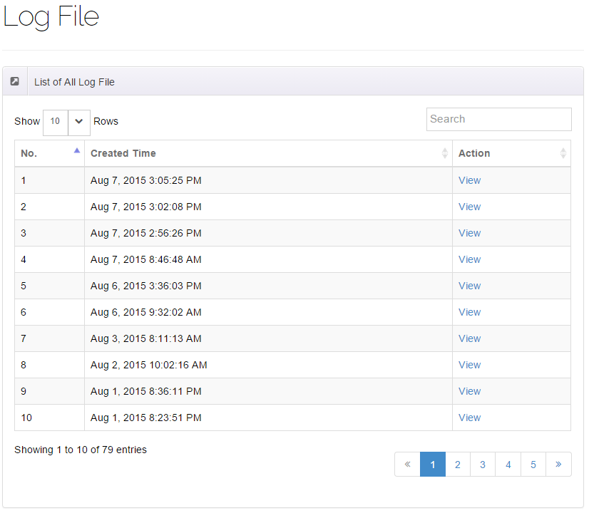

4

3

2

1

Figure 100: Manage Log File

**Fields**

|  |  |  |  |  |  |  |  |
| --- | --- | --- | --- | --- | --- | --- | --- |
| **No** | **Field name** | **Description** | **Read only** | **Mandatory** | **Control type** | **Data type** | **Length** |
| 1 | Log file | Page’s name | Yes | N/A | Label | N/A | N/A |
| 2 | List of all log file | Area’s name | Yes | N/A | Label | N/A | N/A |
| 3 | List of all log file table | Show all log files | No | N/A | Table list view | N/A | N/A |

**Button/Hyperlink**

|  |  |  |  |  |
| --- | --- | --- | --- | --- |
| **No** | **Function** | **Description** | **Validation** | **Outcome** |
| 2 | View log file | Click to view log file | No | Transfer to log file detail |

**List of all log file includes**

|  |  |  |  |  |  |
| --- | --- | --- | --- | --- | --- |
| **Field name** | **Description** | **Read only** | **Control type** | **Data type** | **Length** |
| No. | Number | N/A | Label | Integer | N/A |
| Created time | Created time of this file | N/A | Label | String | N/A |
| Action | Action of staff | No | Link | N/A | N/A |

##### Run Parser Page

###### Parser Specific Page

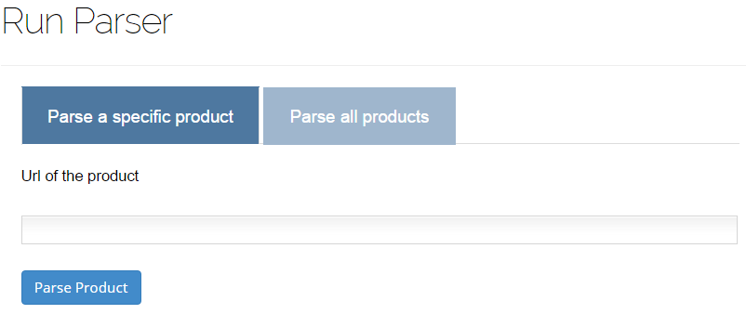

5

4

3

2

1

Figure 101: Parser Specific Product Page

**Fields**

|  |  |  |  |  |  |  |  |
| --- | --- | --- | --- | --- | --- | --- | --- |
| **No** | **Field name** | **Description** | **Read only** | **Mandatory** | **Control type** | **Data type** | **Length** |
| 1 | Run parser | Page’s name | Yes | N/A | Label | N/A | N/A |
| 2 | Parse a specific product | Selected tab’s name | Yes | N/A | Label | N/A | N/A |
| 4 | Url of the product | Url of the product which will be parsed | No | Yes | Textbox | String | N/A |

**Button/Hyperlink**

|  |  |  |  |  |
| --- | --- | --- | --- | --- |
| **No** | **Function** | **Description** | **Validation** | **Outcome** |
| 3 | Show content of “Parse all products” tab | Click to change to “Parse all products” tab | No | Show “Parse all products” tab |
| 5 | Parse product | Click to parse this product | Yes | Message completed |

###### Run Parser

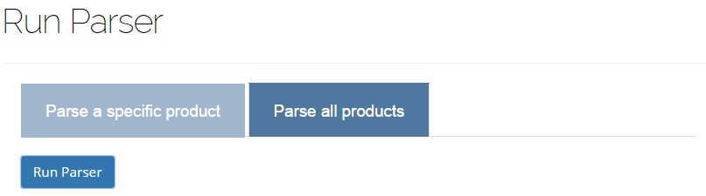

4

1

2

3

Figure 102: Run Parser

**Fields**

|  |  |  |  |  |  |  |  |
| --- | --- | --- | --- | --- | --- | --- | --- |
| **No** | **Field name** | **Description** | **Read only** | **Mandatory** | **Control type** | **Data type** | **Length** |
| 1 | Run parser | Page’s name | Yes | N/A | Label | N/A | N/A |
| 3 | Parse all products | Selected tab’s name | Yes | N/A | Label | N/A | N/A |

**Button/Hyperlink**

|  |  |  |  |  |
| --- | --- | --- | --- | --- |
| **No** | **Function** | **Description** | **Validation** | **Outcome** |
| 2 | Show content of “Parse a specific products” tab | Click to change to “Parse a specific product” tab | No | Show “Parse a specific product” tab |
| 4 | Run parser | Click to run parser | Yes | Show progress bar and progress table during this process |

## Database Design

### Web Application

#### Logical Diagram

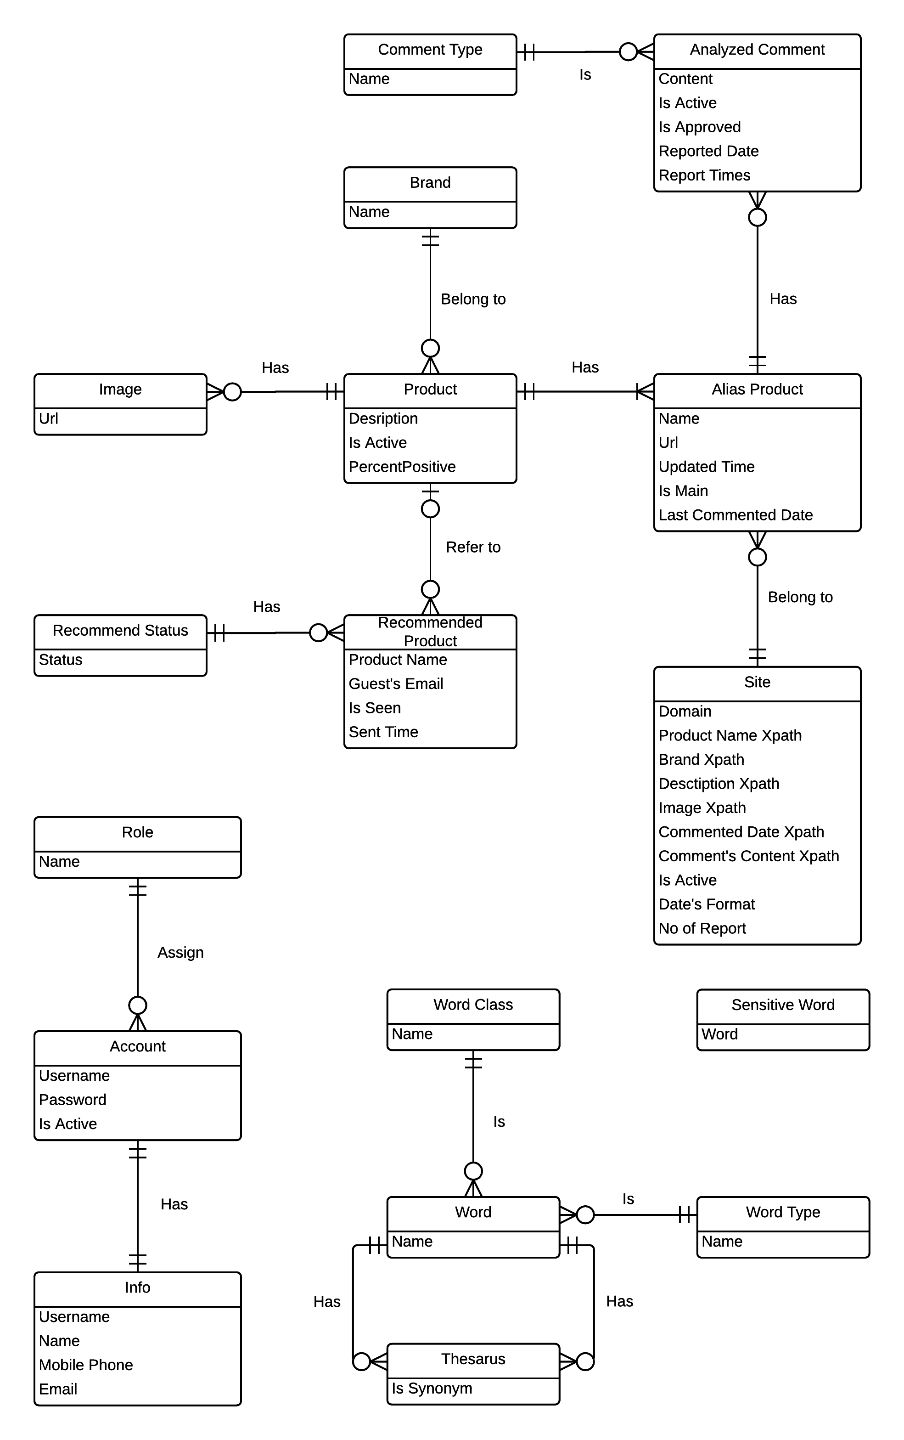

Figure 103: Entity Relationship Diagram

#### Data Dictionary

|  |  |
| --- | --- |
| **Entity Data dictionary: describe contents of all entities** | |
| **Entity Name** | **Description** |
| Image | Describe all image links that product is included. |
| Product | Describe all products in the system. |
| Alias Product | Describe all alias names of product in the system. |
| Recommend Product | Describe all products that recommend by user. |
| Brand | Describe all brands that product is included. |
| Analyzed Comment | Describe all comments of products. |
| Comment Type | Describe all types of comments. |
| Site | Describe all site parse data. |
| Word | Describe all words in the system |
| Word Class | Describe all classes of words |
| Sensitive Word | Describe all sensitive words |
| Word Type | Describe all types of words |
| Thesaurus | Describe all words’ synonyms/antonyms |
| Account | Describe all user accounts |
| Role | Describe all accounts’ roles |
| Info | Describe all accounts’ information |

Table 62: Entity Data Dictionary

|  |  |  |  |  |
| --- | --- | --- | --- | --- |
| **Entity name** | **Attributes** | **Description** | **Domain** | **Null** |
| Image | Url | Describe all image link that product is included. | nvarchar(255) | No |
| Product | Description | Describe all descriptions of all products | nvarchar(max) | Yes |
| Is Active | Describe whether products are active or not | bit | No |
| Is Reported | Describe whether products are reported or not | int | Yes |
| Alias Product | Name | Describe names of alias products | nvarchar(200) | No |
| Url | Describe links to websites contain alias products | nvarchar(max) | No |
| Updated Time | Describe time alias products are updated | datetime | Yes |
| Is Main | Describe whether alias products are main products or not | bit | No |
| Last Commented Date | Describe the date the last comment was added to one alias product | datetime | No |
| Recommend Product | Product’s Name | Describe names of recommended products | nvarchar(200) | No |
| Guest’s Email | Describe emails of guests who suggest the products | nvarchar(50) | No |
| Is Seen | Describe whether staff have seen the guests’ requests or not | bit | No |
| Is Added | Describe whether staff have collected the recommend products information or not | bit | No |
| Sent Time | Describe the time the guests’ requests were sent | datetime | No |
| Brand | Name | Describe names of brands | nvarchar(50) | No |
| Analyzed Comment | Content | Describe contents of comments | nvarchar(max) | No |
| isReported | Describe whether the comment is reported or not | bit | No |
| isApproved | Describe whether the comment is approved or not | bit | No |
| Reported Date | Describe the date the comment is reported | datetime | Yes |
| Report Times | Describe number of times this comment be reported | int | No |
| Comment Type | Name | Describe name of types of comments. | nvarchar(15) | No |
| Site | Domain | Describe sites’ domain information | nvarchar(200) | No |
| Product Name Xpath | Describe Xpath that define products names in the websites | nvarchar(255) | No |
| Brand Xpath | Describe Xpath that define products brands in the websites | nvarchar(255) | No |
| Description Xpath | Describe Xpath that define products descriptions in the websites | nvarchar(255) | No |
| Image Xpath | Describe Xpath that define products images in the websites | nvarchar(255) | No |
| Commented Date Xpath | Describe Xpath that define products commented date in the website | nvarchar(255) | No |
| Comment’s Content Xpath | Describe Xpath that define products comments content in the website | nvarchar(255) | No |
| Is Active | Describe whether sites are active or not | bit | No |
| Date’s Format | Describe date’s format in sites. | nvarchar(30) | No |
| Word | Name | Describe names of words | nvarchar(20) | No |
| Word Type | Name | Describe names of word type. | nvarchar(20) | No |
| Word Class | Name | Describe names of word class. | nvarchar(20) | No |
| Sensitive Word | Word | Describe sensitive words. | nvarchar(20) | No |
| Thesaurus | Is Synonyms | Describe whether words in Dictionary are synonyms or not | bit | No |
| Account | Username | Describe username information | varchar(35) | No |
| Password | Describe password information | varchar(35) | No |
| Is Active | Describe whether account owner is active or not | bit | No |
| Role | Name | Describe name of roles of account | varchar(10) | No |
| Info | Username | Describe username information | varchar(35) | No |
| Name | Describe name information of Info | varchar(35) | No |
| Email | Describe email information | nvarchar(50) | No |
| Mobile Phone | Describe mobile phone information | varchar(15) | No |

Table 63: Attribute Data Dictionary

## Algorithms

### Parse Data

#### Define Problem

Given a laptop website then parse laptops’ specification and comments.

#### Requirement

This website must have users’ comments.

#### Solution

Our system will parse data from 3 websites: <http://www.engadget.com/>, <http://www.bestbuy.com/> and <http://www.walmart.com/>. With each product, we need to collect name and all its comments. However, to make the source more diversity, we collect these extra information, such as: brand, description and images. We also save the last comment’s date of in order to get only new comment for the next parsing time of this product. After researching from many websites, we realise that a laptop can appear in many websites with different names. We have these entities:

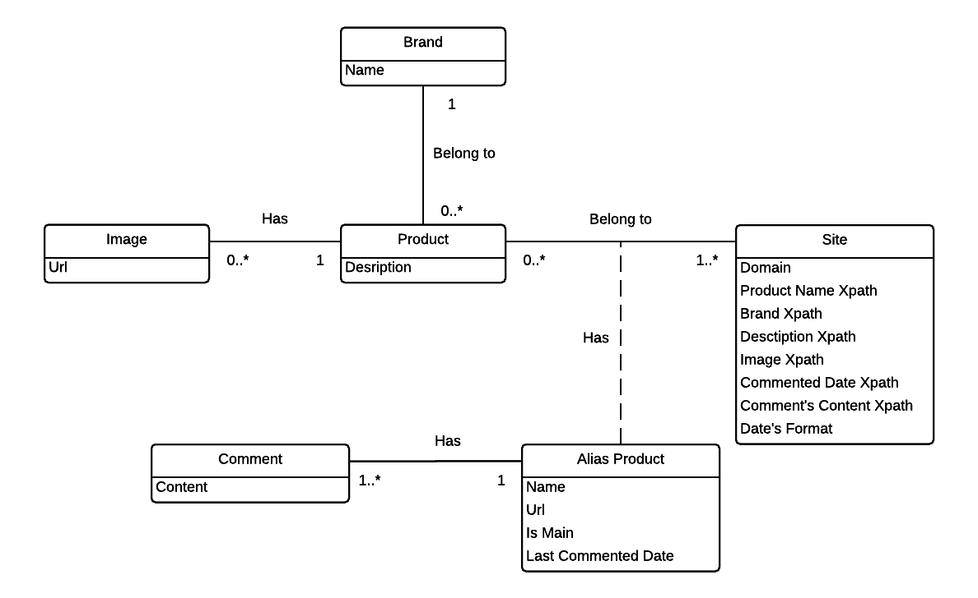

There are many libraries supporting parsing data and the 2 most popular are HtmlAgilityPack and Selenium. After researching 2 libraries, we decide to choose HtmlAgilityPack because during parsing process, Selenium have to create a simulator web browser to load the website’s content but HtmlAgilityPack do not have. This make improve parsing speed too much.

We intend that our system will be served to people who do not need to know what xPath is, so we develop a wizard supporting user to get xPath of anything they want. The solution is:

Step 1: From clicked node

Step 2: Get parent node

Step 3: Stop when meeting “HTML” or “ID” node

Step 4: Take xPath

Step 5: Get data

After parsing 1 product, we analyse all comments and classify them into 3 types: positive, neutral and negative comments (refer algorithm 7.2). After getting all information of this product, we compare it with existed product in database to detect if this is a duplicated product (refer algorithm 7.4). With new product, it will be inserted to database. Otherwise, duplicated product will be added to xml file and staff will handle it.

### Analyze Comment

#### Define Problem

Given a sentence then the system will check whether that sentence has positive or negative or neutral meaning

#### Requirement

All sentence must have correct grammar. They must also have sufficient length. Moreover, all sentences that contains impolite or meaningless words will not be counted.

#### Solution

* Manually prepare 10 lists of lower-cased words by reading first 100 comments:
* A list contains all words which meanings are totally Pros
* A list contains all adjectives and adverbs which meanings are Pros (these words’ positive meaning is not as strong as words in “Totally Pros” list)
* A list contains all adjectives and adverbs which meanings are Neutral
* A list contains all adjectives and adverbs which meanings are Cons
* A list contains all adjectives and adverbs which meanings are totally Cons (these words’ negative meaning is not as strong as words in “Totally Cons” list)
* A list contains all nouns and verbs which meanings are Pros (these words’ positive meaning is not as strong as words in “Totally Pros” list)
* A list contains all nouns and verbs which meanings are Neutral
* A list contains all nouns and verbs which meanings are Cons (these words’ negative meaning is not as strong as words in “Totally Cons” list)
* A list contains all nouns and verbs which meanings are totally Cons
* A list of negative words such as not, no, do not, does not …
* Lower case the whole sentence and break it into a list of words, then lower case all the words.
* With a list of words, we will check how many words of that list belong to the 10 lists above, then we divide into these cases:
* Case 1: List of words contains word(s) which belong to “Totally Pros” word list: In this case, the sentence will be Positive sentence.
* Case 2: List of words contains word(s) which belong to “Totally Pros” word list but it also contains word(s) which belong to “Negative” word list: In this case, the sentence will be Negative sentence.
* Case 3: We will check the adjectives and adverbs fist. So if list of words contains adjectives, adverbs and belongs to adjectives/adverbs’ “Pros”, “Cons” or “Neutral” lists, we will have these sub-cases:
* If there are more “Pros” words than “Cons” words 🡪 The sentence is positive (1)
* If there are more “Cons” words than “Pros” words 🡪 The sentence is negative (2)
* With those 2 above sub-cases, if there are words belong to “Negative” list, then the sentence will be negative with sub-case (1) and positive with sub-case (2)
* If the sentence contains no adjectives/adverbs that belongs to “Pros”, “Cons” and has words belong to “Neutral”, that sentence is neutral. If the sentence has same number of “Pros” and “Cons” adjectives/adverbs and has no “Neutral” adjectives/adverbs, we will check in Case 4.
* If there is no “Pros”, “Cons” and “Neutral” adjectives/adverbs in that sentence, we will check in Case 4.
* Case 4: After checking for adjectives, adverbs, we will check verbs and nouns in that sentence. We have these sub-cases
* If there are more “Pros” words than “Cons” words 🡪 The sentence is positive (1)
* If there are more “Cons” words than “Pros” words 🡪 The sentence is negative (2)
* With those 2 above sub-cases, if there are words belong to “Negative” list, then the sentence will be negative with sub-case (1) and positive with sub-case (2)
* If the sentence contains no verbs/nouns that belongs to “Pros”, “Cons” and has words belong to “Neutral”, that sentence is neutral. Similarly, if the numbers of verbs/nouns belongs to “Pros” and “Cons” are the same, that sentence is Neutral
* If there is no “Pros”, “Cons” and “Neutral” verbs in that sentence, it will be unidentified and will be decided later by staff

#### Example

Giving the sentence: “*This Mac is fast, and combined with Mavericks I am now getting some great battery life.”*

* Assume that we already have “Totally Pros” words list which contains “great”.
* Lower case the whole sentence:

+ This Mac is fast, and combined with Mavericks I am now getting some great battery life.🡪 this mac is fast, and combined with mavericks i am now getting some great battery life.

* Split sentence into list words:

+ this mac is fast, and combined with mavericks i am now getting some great battery life 🡪 {this, mac, is, fast, and, combined, with, mavericks, i, am, now, getting, some, great, battery, life}

* We will check for “Totally Pros” words first. In this case, we have word “great”. This word belongs to “Totally Pro” list, so this sentence is Positive.

### String Comparison

#### Define Problem

Give two strings. Calculate their matching percent.

#### Requirement

* A robustness to changes of word order: two strings which contain the same words, but in a different order, should be recognized as being similar.
* Language independence: the algorithm should work not only in English, but in many different languages.

#### Solution

* If a string contains many words, break it into a list of words.
* For each word, we find out how many adjacent character pairs are contained in it.
* Create a function *pairs(s)* which returns a list of adjacent character pairs of string *s*.
* Then, we use below formula to calculate matching percent.

$$similarity\left(s1,s2\right)=\frac{\left|pairs(s1)∩pairs(s2)\right|}{\left|pairs(s2)\right|}$$

$$similarity\left(s2,s1\right)=\frac{\left|pairs(s1)∩pairs(s2)\right|}{\left|pairs(s1)\right|}$$

#### Example

Calculate the matching percent of 2 strings: MacBook Air 2015 and MacBook Air 2015 Retina.

* Upper case 2 strings:
  + MacBook Air 2015 $→$ MACBOOK AIR 2015.
  + MacBook Air 2015 Retina $→$ MACBOOK AIR 2015 RETINA
* Break string into list of adjacent character pairs:
  + MACBOOK AIR 2015 $→\left\{MA,AC,CB,BO,OO,OK,AI,IR,20,01,15\right\}$
  + MACBOOK AIR 2015 RETINA $→\left\{MA,AC,CB,BO,OO,OK,AI,IR,20,01,15,RE,ET,TI,IN,NA\right\}$
* Calculate its matching percent.

$$similarity\left(MACBOOK AIR 2015,MACBOOK AIR 2015 RETINA\right)=\frac{\left|\left\{MA,AC,CB,BO,OO,OK,AI,IR,20,01,15\right\}\right|}{|\{MA,AC,CB,BO,OO,OK,AI,IR,20,01,15,RE,ET,TI,IN,NA\}| }$$

$$=\frac{11}{16}=\frac{22}{27}≈0.69$$

$$similarity\left(MACBOOK AIR 2015,MACBOOK AIR 2015 RETINA\right)=\frac{\left|\left\{MA,AC,CB,BO,OO,OK,AI,IR,20,01,15\right\}\right|}{|\{MA,AC,CB,BO,OO,OK,AI,IR,20,01,15\}|}=1$$

### Detect Duplicated Product

#### Define Problem

Give new product. Detect if it is a duplicated product.

#### Requirement

The product has been defined brand.

#### Solution

During implementation process, we discussed and improved the algorithm more times in order to improve the exactness. Here is our solution.

* First solution:
* Step 1: Using the String comparison in 7.3 to compare the new product’s name with each existed product’s name in the database. But the current formula to calculate matching percent has a little difference to the one in 7.3. The formula is:

$$similarity\left(s1,s2\right)=\frac{2×\left|pairs(s1)∩pairs(s2)\right|}{\left|pairs\left(s1\right)\right|+\left|pairs(s2)\right|}$$

If the result is above 40%, add these existed product to a list.

* Step 2: If the list is empty, this new product is not a duplicated product. Otherwise, choose the existed product which has the biggest comparison result in the list and the new product is duplicated product with it.

With this solution, we found 9 duplicated products when parsing 50 products.

* Second solution:
* Be improved from the 1st solution.
* At step 1, only compare the new product’s name with each existed product’s name in the database which has the same brand with new product.
* With this solution, we found 7 duplicated products when parsing 50 products – less 22% duplicated products than the 1st solution.
* Third solution:
  + - Be improved from the 2nd solution.
    - Use the different formula to compare 2 products’ names.

$$similarity\left(s1,s2\right)=\frac{\left|pairs(s1)∩pairs(s2)\right|}{\left|pairs(s2)\right|}$$

$$similarity\left(s2,s1\right)=\frac{\left|pairs(s1)∩pairs(s2)\right|}{\left|pairs(s1)\right|}$$

And the comparison result is the minimum of 2 results from above formulas.

* With this solution, we found 2 duplicated products when parsing 50 products – less 71% duplicated products than the 2nd solution.

Finally, we decided to choose the 3rd solution to detect duplicated product.

# System Implementation & Test

## Introduction

### System Overview

This section provides in detail all necessary information about test plans, test cases, test result, test environments, pass/fail criteria and risks estimations as well as a checklist to cover all possible cases of LRA.

### Test Approach

- Goal: To test the whole system based on the core workflow.

- Method: System Testing, Black-box Testing.

## Database Relationship Diagram

### Physical Diagram



Figure 104: Physical Diagram

### Data Dictionary

|  |  |
| --- | --- |
| **Entity Data dictionary: describe content of all entities** | |
| Entity Name | Description |
| Image | Describe all image links that product is included. |
| Product | Describe all products in the system. |
| Alias Product | Describe all alias names of product in the system. |
| Recommend Product | Describe all products that recommend by user. |
| Recommend Status | Describe all recommends by user. |
| Brand | Describe all brands that product is included. |
| Analyzed Comment | Describe all analyzed comments of products. |
| Comment Type | Describe all types of comments. |
| Site | Describe all site parse data. |
| Word | Describe all words in the system |
| Word Class | Describe all classes of words |
| Sensitive Word | Describe all sensitive words |
| Word Type | Describe all types of words |
| Thesaurus | Describe all word’s synonyms/antonyms |
| Account | Describe all user accounts |
| Role | Describe all accounts’ roles |
| Info | Describe all accounts’ information |

Table 64: Data Dictionary

|  |  |  |  |  |
| --- | --- | --- | --- | --- |
| **Entity name** | **Attributes** | **Description** | **Domain** | **Null** |
| Image | Id {PK} | Unique identifier of a image, auto increment. | int | No |
| Url | Describe all image link that product is included. | nvarchar(255) | No |
| ProductId{FK} | Foreign key, product identifier. | int | No |
| Product | Id {PK} | Unique identifier of a product, auto increment. | int | No |
| BrandId{FK} | Foreign key, brand identifier. | int | No |
| Description | Describe all descriptions of all products | nvarchar(max) | Yes |
| Is Active | Describe whether products are active or not | bit | No |
| PercentPositive | Describe percent of positive comments | float | Yes |
| Alias Product | Id {PK} | Unique identifier of a alias product, auto increment. | int | No |
| ProductId{FK} | Foreign key, product identifier. | int | No |
| Name | Describe names of alias products | nvarchar(200) | No |
| Url | Describe links to websites contain alias products | nvarchar(max) | No |
| SiteId { FK } | Foreign key, site identifier. | int | No |
| Updated Time | Describe time alias products are updated | datetime | Yes |
| Is Main | Describe whether alias products are main products or not | bit | No |
| Last Commented Date | Describe the date the last comment was added to one alias product | datetime | No |
| Recommend Product | Id {PK} | Unique identifier of a recommend product, auto increment. | int | No |
| Product’s Name | Describe names of recommended products | nvarchar(200) | No |
| Guest’s Email | Describe emails of guests who suggest the products | nvarchar(50) | No |
| Is Seen | Describe whether staff have seen the guests’ requests or not | bit | No |
| Is Added | Describe whether staff have collected the recommend products information or not | bit | No |
| Sent Time | Describe the time the guests’ requests were sent | datetime | No |
| ProductId{FK} | Foreign key, product identifier. | int | No |
| StatusId{FK} | Foreign key, recommend identifier. | int | No |
| Recommend Status | Id {PK} | Unique identifier of a brand, auto increment. | int | No |
| Status | Describe status of Recommend | bit | No |
| Brand | Id {PK} | Unique identifier of a brand, auto increment. | int | No |
| Name | Describe names of brands | nvarchar(50) | No |
| Analyzed Comment | Id {PK} | Unique identifier of a comment, auto increment. | int | No |
| Content | Describe contents of comments | nvarchar(max) | No |
| isApproved | Describe whether the comment is approved or not | bit | No |
| isActive | Describe whether the comment is active or not | bit | No |
| Reported Date | Describe the date the comment is reported | datetime | Yes |
| ReportTimes | Describe no of times this comment be reported | int | No |
| ProductId{FK} | Foreign key, product identifier. | int | No |
| Comment Type | Id {PK} | Unique identifier of a comment type, auto increment. | int | No |
| Name | Describe name of types of comments. | nvarchar(15) | No |
| Site | Id {PK} | Unique identifier of a site, auto increment. | int | No |
| Domain | Describe sites’ domain information | nvarchar(200) | No |
| Product Name Xpath | Describe Xpath that define products names in the websites | nvarchar(255) | No |
| Brand Xpath | Describe Xpath that define products brands in the websites | nvarchar(255) | No |
| Description Xpath | Describe Xpath that define products descriptions in the websites | nvarchar(255) | No |
| Image Xpath | Describe Xpath that define products images in the websites | nvarchar(255) | No |
| Commented Date Xpath | Describe Xpath that define products commented date in the website | nvarchar(255) | No |
| Comment’s Content Xpath | Describe Xpath that define products comments content in the website | nvarchar(255) | No |
| Is Active | Describe whether sites are active or not | bit | No |
| Date’s Format | Describe date’s format in sites. | nvarchar(30) | No |
| Word | Name | Describe names of words | nvarchar(20) | No |
| WordTypeId{FK} | Foreign key, word type identifier. | int | No |
| WordClassId{FK} | Foreign key, word class identifier. | int | No |
| Word Type | Id {PK} | Unique identifier of a word type, auto increment. | int | No |
| Name | Describe names of word type. | nvarchar(20) | No |
| Word Class | Id {PK} | Unique identifier of a word class, auto increment. | int | No |
| Name | Describe names of word class. | nvarchar(20) | No |
| Sensitive Word | Word | Describe sensitive words. | nvarchar(20) | No |
| Thesaurus | FirstWord {PK} | Unique identifier of a thesaurus, auto increment. | int | No |
| SecondWord{FK} | Foreign key, thesaurus identifier. | int | No |
| Is Synonyms | Describe whether words in Dictionary are synonyms or not | bit | No |
| Account | Username {FK} | Describe username information | varchar(35) | No |
| Password | Describe password information | varchar(35) | No |
| RoleId{FK} | Foreign key, word class identifier. | int | No |
| Is Active | Describe whether account owner is active or not | bit | No |
| Role | Id {PK} | Unique identifier of a role, auto increment. | int | No |
| Name | Describe name of roles of account | varchar(10) | No |
| Profile | Username {FK} | Describe username information | varchar(35) | No |
| Name | Describe name information of Info | varchar(35) | No |
| Email | Describe email information | nvarchar(50) | No |
| Mobile Phone | Describe mobile phone information | varchar(15) | No |
| LogFile | Id {PK} | Unique identifier of a log, auto increment. | int | No |
| Name | Describe names of log | nvarchar(200) | No |
| CreatedDate | Describe create date of log | nvarchar(50) | No |
| Is Seen | Describe whether log have seen or not | bit | No |

Table 65: Attribute Data Dictionary

## Performance Measures

### Parser Performance

* Parsing speed is 5ms per product.

### Analyzing Comment Algorithm Performance

* The test is ran 10 times. In each time, we calculate the executed time of one comment. The average time for one comment to be analysed is about 0.5 ms. Here is the chart reflects our results:

Figure 105: Analyze comment test result

* The average correct result giving by the algorithm is about 78 comments over 100 comments.

## Test Plan

The purpose of this section is to verify and ensure that LRA meets its design specification and other requirements from user. The following part will describe which features to be tested and which will not.

### Features to be tested

We will test the entire system based on the following core workflow (Reference: **Figure 99, 100, 101: Core Workflow**).

Based on the workflow, all following features will be tested, which can include one or more functions. These features will be focused and tested thoroughly during the test phase.

* Guest: search product, add to cart, and view compare.
* Member: recommend, view compare details, ask for suggestion, and save product history.
* System: run parsers.
* Staff: create parser, run parser, train system, and import excel.

### Features not to be tested

* Login, Logout.
* Change Password.
* Manage hardware.
* Manage product.
* Manage user.
* Configure System.

## System Testing Test Case

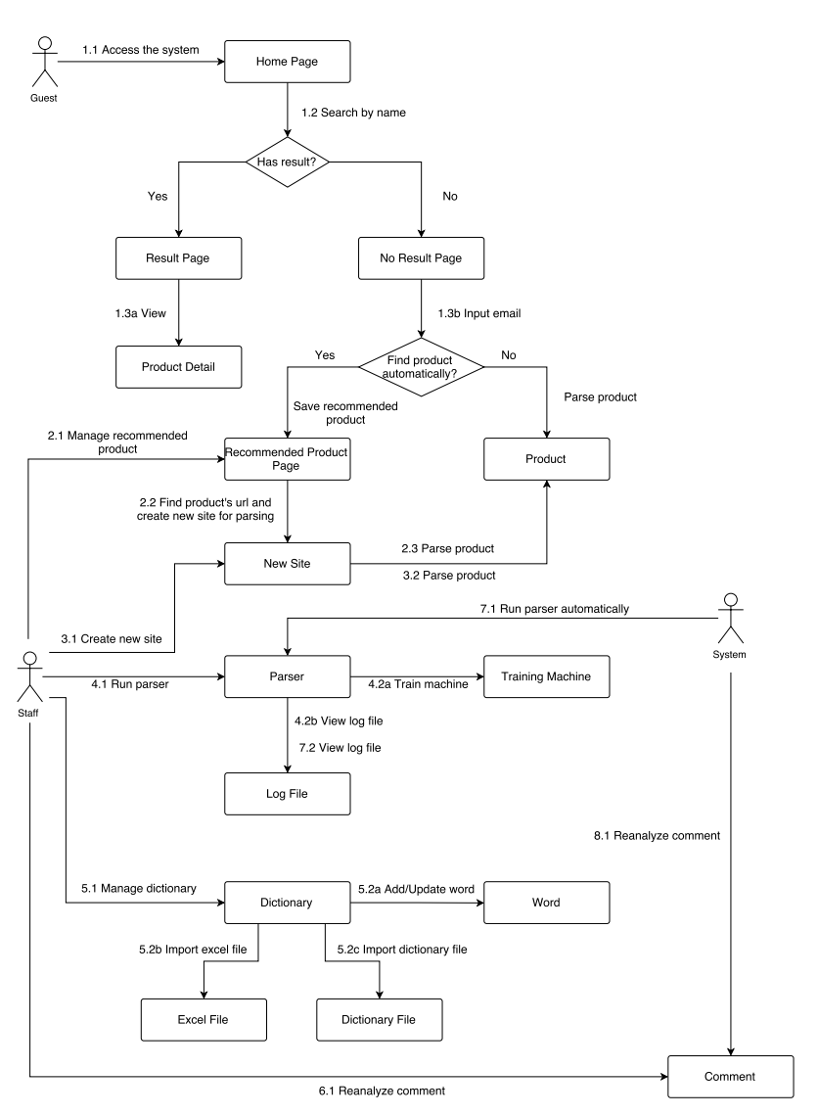

Figure 106: Core Flow

Test cases summary:

|  |  |  |  |  |
| --- | --- | --- | --- | --- |
| **ID** | **Description** | **Test start date** | **Test passed date** | **Number of test times** |
| SPN01 | Guest searches laptop by name. | 05/07/2015 | 06/07/2015 | 7 |
| SPN02 | Guest searches unavailable product by name | 10/07/2015 | 17/07/2015 | 4 |
| VD01 | Guest view detail. | 16/06/2015 | 06/07/2015 | 6 |
| RP01 | Guest input email to receive recommend product information | 17/07/2015 | 12/08/2015 | 11 |
| RP02 | Guest input wrong email format | 17/07/2015 | 17/07/2015 | 2 |
| RP03 | Guest don’t want to receive recommend product information | 17/07/2015 | 17/07/2015 | 1 |
| RP01 | Run parser automatically | 16/06/2015 | 08/08/2015 | 23 |
| RC01 | Staff force Reanalyze comment | 20/07/2015 | 10/08/2015 | 9 |
| RC02 | Automatically reanalyse comment | 10/08/2015 | 10/08/2015 | 2 |
| MRP01 | Staff view list of recommended product | 13/08/2015 | 13/08/2015 | 3 |
| MRP02 | Create new site and parse recommended product | 02/08/2015 | 13/08/2015 | 8 |
| CNS01 | Staff creates new site | 02/08/2015 | 13/08/2015 | 8 |
| CNS02 | Staff parse a specific product | 01/08/2015 | 13/08/2015 | 8 |
| TM01 | Staff uses training machine function | 18/07/2015 | 20/07/2015 | 4 |
| TM02 | Staffs merge products. | 20/07/2015 | 07/08/2015 | 7 |
| TM03 | Staffs split products. | 20/07/2015 | 07/08/2015 | 5 |
| TM04 | Staffs disable products | 20/7/2015 | 06/08/2015 | 3 |
| TM05 | Staffs enable products | 20/7/2015 | 06/08/2015 | 1 |
| TM06 | Staffs search duplicated products | 20/07/2015 | 20/07/2015 | 2 |
| TM07 | Staffs view log file | 18/07/2015 | 20/07/2015 | 2 |
| UW01 | Staffs use Dictionary Management function | 16/06/2015 | 23/07/2015 | 10 |
| UW02 | Staffs view word’s definition | 16/06/2015 | 23/07/2015 | 8 |
| UW03 | Staffs update word | 18/06/2015 | 23/07/2015 | 10 |
| UW04 | Staffs add word | 18/06/2015 | 23/07/2015 | 7 |
| UW05 | Staffs search for specific word | 16/06/2015 | 18/06/2015 | 3 |
| UW06 | Staffs re-analyse comment | 10/08/2015 | 10/08/2015 | 1 |
| IEF01 | Staffs use Import Excel File function | 23/07/2015 | 23/07/2015 | 2 |
| IEF02 | Staffs import file | 17/07/2015 | 23/07/2015 | 5 |
| IEF03 | Staffs add word | 16/07/2015 | 23/07/2015 | 7 |
| IEF04 | Staffs add synonyms and antonyms | 16/07/2015 | 23/07/2015 | 6 |
| IDF01 | Staffs use Import Excel File function | 13/08/2014 | 13/08/2014 | 2 |
| IDF02 | Staffs import file | 13/08/2014 | 13/08/2014 | 3 |

Table 66: Test cases summary

### Guest Test Case

#### Search Product by name

|  |  |  |  |  |  |  |  |
| --- | --- | --- | --- | --- | --- | --- | --- |
| **ID** | **Test Case Description** | **Test Case Procedure** | **Expected output** | **Inter-test Case Dependence** | **Result** | **Test Date** | **Note** |
| SPN01 | Guest searches laptop by name. | 1 – On the home page, input name of laptop on search textbox.  2 – Click “**Search**” button or press enter key. | - After step 2, show search result. Products are shown with products’ name, avatars of products, products’ positive comments percent and are surrounded with colors based on positive comments percent:  + If product has positive comments percent > 80%, then the color is green  + If product has positive comments percent places between 80% and 40% then the color is light blue  + If product has positive comments percent < 40%, then the color is red | N/A | Passed | 06/07/2015 |  |
| SPN02 | Guest searches unavailable product by name | After step 2 in SPN01, no available result is found | - Show No Result page | SPN01 | Passed | 17/07/2015 |  |

Table 67: Search Product by name Test Case

#### View Detail

|  |  |  |  |  |  |  |  |
| --- | --- | --- | --- | --- | --- | --- | --- |
| **ID** | **Test Case Description** | **Test Case Procedure** | **Expected output** | **Inter-test Case Dependence** | **Result** | **Test Date** | **Note** |
| VD01 | Guest view detail. | 1 – On Search Result page, click on name of product | - After step 1, go to detail page which contains:  + Name of product  + Images of product  +Description of product  + Classified comments of product | SPN01 | Passed | 17/06/2015 |  |

Table 68: View Detail Test Case

#### Recommend Product

|  |  |  |  |  |  |  |  |
| --- | --- | --- | --- | --- | --- | --- | --- |
| **ID** | **Test Case Description** | **Test Case Procedure** | **Expected output** | **Inter-test Case Dependence** | **Result** | **Test Date** | **Note** |
| RP01 | Guest input email to receive recommend product information | 1 – On No Result page, input email address to textbox and click “Send” | - After step 1, guest email is saved and show message:” Your request has been sent! We will keep in touch with you!” and go back to home page | SPN02 | Passed | 12/08/2015 |  |
| RP03 | Guest input wrong email format | 1 – On No Result page, input wrong email address format to textbox and click “Send” | - After step 1, show message :”Your email address must be in the format of name@domain.com” | SPN02 | Passed | 06/07/2015 |  |
| RP03 | Guest don’t want to receive recommend product information | 1 – On No Result page, click “No, Thanks!” | - After step 1, go back to home page | SPN02 | Passed | 07/07/2015 |  |

Table 69: Recommend Product Test Case

### System Test Case

#### Run Parser

|  |  |  |  |  |  |  |  |
| --- | --- | --- | --- | --- | --- | --- | --- |
| **ID** | **Test Case Description** | **Test Case Procedure** | **Expected output** | **Inter-test Case Dependence** | **Result** | **Test Date** | **Note** |
| RP01 | Run parser automatically | 1 – Set 03:00 am for daily parsing time.  2 – Change the system time to 03:00 am | - After step 2, parser is running and the button “Run parser” in “Run parser” page changes to “Parser is running”. | N/A | Passed | 08/08/2015 | N/A |

Table 70: Run Parser Test Case

#### Reanalyze Comment

|  |  |  |  |  |  |  |  |
| --- | --- | --- | --- | --- | --- | --- | --- |
| **ID** | **Test Case Description** | **Test Case Procedure** | **Expected output** | **Inter-test Case Dependence** | **Result** | **Test Date** | **Note** |
| RC01 | Staff force Reanalyze comment | 1 – On the menu bar, click on “Reanalyze comment” | - After step 1, show loading screen to indicate that comments are reanalysed | N/A | Passed | 10/08/2015 |  |
| RC02 | Automatically reanalyse comment | 1 – On the menu bar, click on “System configuration”  2 – In “System Configuration” page, set Daily reanalyse time | - After step 2, system will automatically reanalyse comments at set time | N/A | Passed | 10/08/2015 |  |

Table 71: History compares Test Case

### Staff Test Case

#### Manage Recommended Product

|  |  |  |  |  |  |  |  |
| --- | --- | --- | --- | --- | --- | --- | --- |
| **ID** | **Test Case Description** | **Test Case Procedure** | **Expected output** | **Inter-test Case Dependence** | **Result** | **Test Date** | **Note** |
| MRP01 | Staff view list of recommended product | 1 – Login into the system using a staff account  2 – On the staff home page, click “Product Management”, and then click “Recommended Product”.  3 – Click name of any product.  4 – Input url of new product in the text box.  5 – Click “Parse product” button.  6 – Click “Yes” button. | - After step 2, a list of recommended product will be shown.  - After step 3, a pop-up with this recommendation will be shown.  - After step 5, if the site which this product belongs to was not existed, a pop-up with a yes/no question will be shown.  - After step 6, the system will redirect to “Create New Site” page with this url will be filled in the “Url of site” text box. | N/A | Passed | 13/08/2015 | N/A |
| MRP02 | Create new site and parse recommended product | After step 6 in MRP01:  1 – Click “View” button.  2 – Fill in site’s detail   1. “Name” step 2. “Brand” step 3. “Description” step 4. “Image” step 5. “Date” step 6. “Content” step   3 – Click “Finish” button  4 – Click “Create New Site” button | - After step 1, a wizard form for creating new site with 6 steps will be show.  - After step 3, a pop-up with site’s detail will be shown.  - After step 4, new site will be inserted into database. The system will auto parse this product and inserted it into database. After that, the system will redirect to “Recommended Product” page and the message with the status of parsing product will be shown. | MRP01 | Passed | 13/08/2015 | N/A |

Table 72: Manage Recommended Product Test Case

#### Create New Site

|  |  |  |  |  |  |  |  |
| --- | --- | --- | --- | --- | --- | --- | --- |
| **ID** | **Test Case Description** | **Test Case Procedure** | **Expected output** | **Inter-test Case Dependence** | **Result** | **Test Date** | **Note** |
| CNS01 | Staff creates new site | 1 – Login into the system using a staff account  2 – On the staff home page, click “Parser”, and then click “Create New Site”.  3 – Click “View” button.  4 – Fill in site’s detail   1. “Name” step 2. “Brand” step 3. “Description” step 4. “Image” step 5. “Date” step 6. “Content” step   5 – Click “Finish” button  6 – Click “Create New Site” button | - After step 2, a textbox for inputting url of site will be shown.  - After step 3, a wizard form for creating new site with 6 steps will be show.  - After step 5, a pop-up with site’s detail will be shown.  - After step 6, new site will be inserted into database. | N/A | Passed | 13/08/2015 | N/A |
| CNS02 | Staff parse a specific product | 1 – Login into the system using a staff account  2 – On the staff home page, click “Parser”, and then click “Run parser”  3 – Input url to “Product’s url” textbox and click “Parse product”. | - After step 2, the page with 2 tab will be shown and the “Parse specific product” will be selected.  - After step 3, product will be inserted to database and the message with the status of parsing product will be shown. | N/A | Passed | 13/08/2015 | N/A |

Table 73: Create New Site Test Case

#### Train Machine

|  |  |  |  |  |  |  |  |
| --- | --- | --- | --- | --- | --- | --- | --- |
| **ID** | **Test Case Description** | **Test Case Procedure** | **Expected output** | **Inter-test Case Dependence** | **Result** | **Test Date** | **Note** |
| TM01 | Staff uses training machine function | 1 – Login into the system using a staff account.  2 – On the staff home page, click “Products” on navigation bar, and then click “Training Machine”. | - After step 2, duplicated products list in log file will be shown with related commands | N/A | Passed | 20/07/2015 |  |
| TM02 | Staffs merge products. | After step 2 in test case TM01.  1 – Click checkbox to selected duplicated products  2 – Select “Main” product by clicking “Main” radio button.  3 – Click “Merge” button | - After step 3, system will check whether main product belongs to selected products in step 1:  + If main product belongs, selected duplicated products are added into database.  + Else, return a pop-up requires staffs to choose appropriate main product. | TM01 | Passed | 07/08/2015 |  |
| TM03 | Staffs split products. | After step 2 in test case TM01.  1 – Click checkbox to selected duplicated products.  2 – Click “Split” button. | - After step 2, system will check whether staffs have selected any products or not in step 1:  If yes, duplicated products will be split and saved into database.  Else, return a pop-up requires staffs to choose at least 1 product to process. | TM01 | Passed | 07/08/2015 |  |
| TM04 | Staffs disable products | After step 2 in test case TM01.  1 – Click “Disable” button of each duplicated product | - After step 1, the product which disable button is clicked will be disabled and disappeared from the list. | TM01 | Passed | 06/08/2015 |  |
| TM05 | Staffs enable products | After step 1 in test case TM04.  1 – Click “View disabled duplicated products”  2 – Click “Enable” button of each disabled products | - After step 1, the list of disabled products is shown with related command.  - After step 2, disabled product is enabled. | TM04 | Passed | 06/08/2015 |  |
| TM06 | Staffs search duplicated products | After step 2 in test case TM01  1 – Input search string into “Input text search” textbox | - After step 1, appropriate products are shown | TM01 | Passed | 20/07/2015 |  |
| TM07 | Staffs view log file | After step 2 in test case TM01.  1 – Staff choose “Show log file” in navigation bar | After step 1, a list of managed products are shown with following information:  - Main Product Image  - Product name  - Action Type (Merge or Split)  - Updated Date | TM01 | Passed | 20/07/2015 |  |

Table 74: Train Machine Test Case

#### Update Word

|  |  |  |  |  |  |  |  |
| --- | --- | --- | --- | --- | --- | --- | --- |
| **ID** | **Test Case Description** | **Test Case Procedure** | **Expected output** | **Inter-test Case Dependence** | **Result** | **Test Date** | **Note** |
| UW01 | Staffs use Dictionary Management function | 1 – Login into the system using a staff account.  2 – On the staff home page, click “Dictionary” on navigation bar, and then click “Dictionary Management”. | - After step 2, dictionary words will be shown with first word in the list’s meaning | N/A | Passed | 23/7/2015 |  |
| UW02 | Staffs view word’s definition | After step 2 in UW01.  1 – Staffs click on word in the word list | - After step 1, word’s definition is shown | UW01 | Passed | 23/7/2015 |  |
| UW03 | Staffs update word | After step 1 in UW03.  1 – Staff click “Update word”  2 – Edit form appears, staffs can update:  - Class  - Type  - Synonyms  - Antonyms  3 – Staff click “Save” | - After step 3, Updated information is saved to database | UW03 | Passed | 23/7/2015 |  |
| UW04 | Staffs add word | After step 2 in UW01.  1 – Staff click “Add New” on navigation bar  2 – Staffs input new word information includes:  - Word  - Class  - Type  - Synonyms  - Antonyms  3 – Staffs click “Add new word” | - After step 2, system will check whether staffs have inputted Word field:  + If yes, staff can process step 3 and new word is added to database  + Else, “Save” button is disabled | UW01 | Passed | 23/7/2015 |  |
| UW05 | Staffs search for specific word | After step 2 in UW01.  1 – Staffs input search string into Search text box | - After step 2, list word will automatically filters words base on staffs input | UW01 | Passed | 23/7/2015 |  |
| UW06 | Staffs re-analyse comment | After step 2 in UW01.  1 – Staffs click “Re-analyze comments” button | - After step 1, comments will be re-analyzed. System will check whether comments are re-analyzed successfully or not:  + If yes, a pop-up appears to indicate process is successfully done  + Else, a pop-up appears to show error message | UW01 | Passed | 23/7/2015 |  |

Table 75: Update Word Test Case

#### Import Excel File

|  |  |  |  |  |  |  |  |
| --- | --- | --- | --- | --- | --- | --- | --- |
| **ID** | **Test Case Description** | **Test Case Procedure** | **Expected output** | **Inter-test Case Dependence** | **Result** | **Test Date** | **Note** |
| IEF01 | Staffs use Import Excel File function | 1 – Login into the system using a staff account.  2 – On the staff home page, click “Dictionary” on navigation bar, and then click “Import Excel File” | - After step 2, an import file box will be shown | N/A | Passed | 23/7/2015 |  |
| IEF02 | Staffs import file | After step 2 in IEF01.  1 – Staff choose an excel file.  2 – Staff click “Import” button. | - After step 2, words in excel file will be shown | IEF01 | Passed | 23/7/2015 |  |
| IEF03 | Staffs add word | After step 2 in IEF02.  1 – Staff choose word(s) from list  2 – Staff click “Save” button | - After step 2, selected word(s) will be save to the system. | IEF02 | Passed | 23/7/2015 |  |
| IEF04 | Staffs add synonyms and antonyms | After step 2 in IEF03.  1 – Staffs choose word(s) from Synonyms and Antonyms list and click “Save” button | - After step 2, selected word(s) will be save to the system. | IEF03 | Passed | 23/7/2015 |  |

Table 76: Import Excel File Test Case

#### Import Dictionary File

|  |  |  |  |  |  |  |  |
| --- | --- | --- | --- | --- | --- | --- | --- |
| **ID** | **Test Case Description** | **Test Case Procedure** | **Expected output** | **Inter-test Case Dependence** | **Result** | **Test Date** | **Note** |
| IDF01 | Staffs use Import Excel File function | 1 – Login into the system using a staff account.  2 – On the staff home page, click “Dictionary” on navigation bar, and then click “Import Dictionary File” | - After step 2, an import file box will be shown | N/A | Passed | 13/08/2014 |  |
| IDF02 | Staffs import file | After step 2 in IEF01.  1 – Staff choose a file.  2 – Staff click “Import” button. | - After step 2, words in file will be save to the system | IDF01 | Passed | 13/08/2014 |  |

Table 77: Import Dictionary File Test Case

# Software User’s Manual

## Installation Guide

### Setting up environment at server side

The following software must be installed into the server machine:

#### Hardware requirements

Personal computers for developing with the minimum configuration:

* CPU Core 2 Duo 2.0GHz.
* 1GB of RAM.
* 30GB of hard disk.
* Wifi Internet (> 2Mbps).

#### Software requirements

* Web Server: Internet Information System – IIS 8.0.
* Microsoft Windows Server 2008: operating system.
* SQL Server 2008 R2: use to create and manage the database for web application.
* Other library:
* Microsoft Visual C++ 2010 SP1 Redistributable Package (x86)

(<http://www.microsoft.com/en-us/download/details.aspx?id=8328>)

### Deployment at server side

#### Prepare deployment package

* Extract the deployment package to a folder on the server.
* For example: E:\LRA

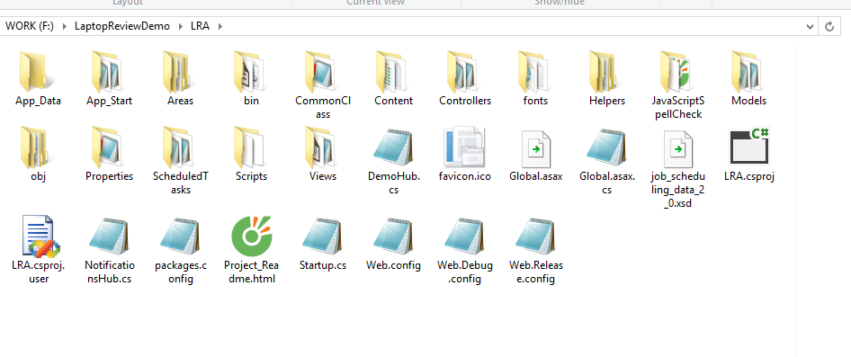

Figure 107: Prepare deployment package

#### Deploy database

* Open Microsoft SQL Server Management Studio.

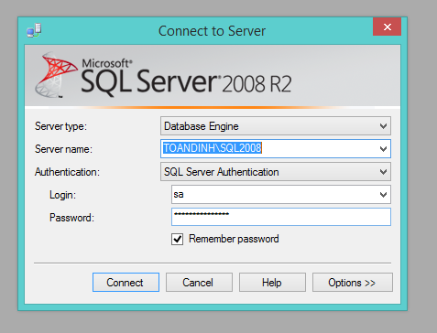

Figure 108: Deploy database – Step 1

* Open and excute the script.sql file

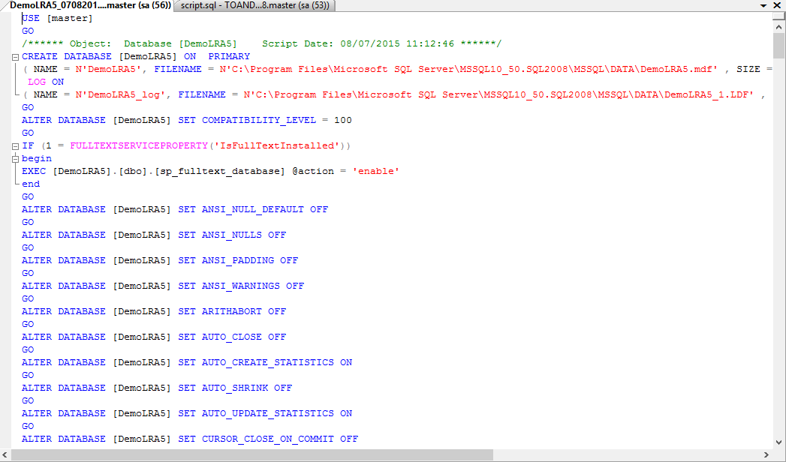

Figure 109: Deploy database – Step 2

#### Configure Server before deploy

* Open the Internet Information System Manager.
* Right click as Sites. Choose “Add Web Site”.

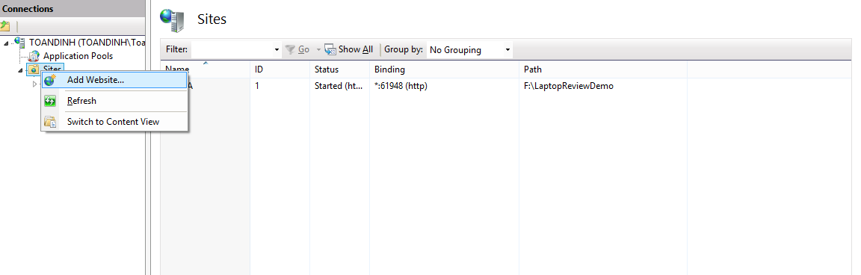

Figure 110: Deploy web application on server – Step 1

* Enter site name. Choose Application Pool as ASP.NET 4.0
* Select the path as the folder in step 1. Enter port other than 80.

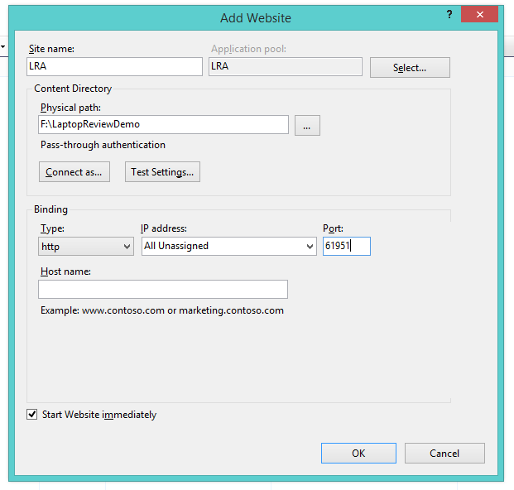

Figure 111: Deploy web application on server – Step 2

* Press OK to finish the process

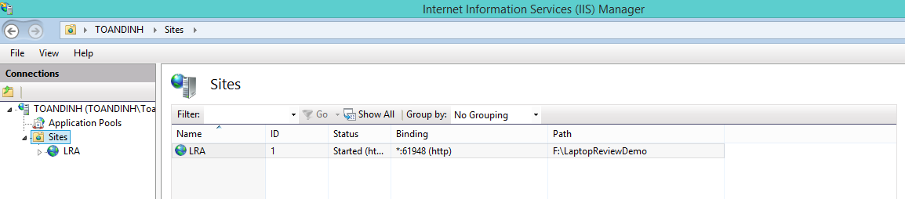

Figure 112: Deploy web application on server – Step 3

### Setting up the environment at client side

#### Setting up for computer

* The client devices need to have one of the following browsers to access the website:
* Google Chrome.
* Firefox.
* Coc coc

## User Guide

The user guide is based on the normal workflow of the system

### Guest/Member Guide

#### Search Product



1

Figure 113: Search Product Page

|  |  |
| --- | --- |
| **Step** | **Description** |
| 1 | Input search content and press “Enter” |

Table 78: Search Product Steps

#### Report Comment

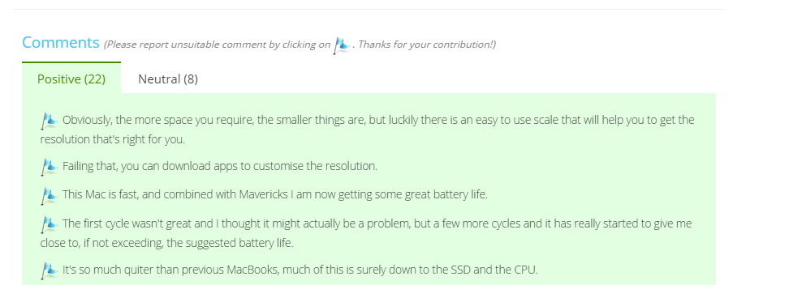

1

Figure 114: Report comment

|  |  |
| --- | --- |
| **Step** | **Description** |
| 1 | Click report icon to report comment |

Table 79: Report comment

#### Recommend Product



3

2

1

Figure 115: Recommend Product

|  |  |
| --- | --- |
| **Step** | **Description** |
| 1 | Fill “Email” |
| 2 | Click “Send” to submit Email |
| 3 | Click “No, Thanks!” to cancel submission |

Table 80: Recommend Product

### Staff Guide

#### Login



4

3

2

1

Figure 116: Staff Login

|  |  |
| --- | --- |
| **Step** | **Description** |
| 1 | Fill in user’s name |
| 2 | Fill in user’s password |
| 3 | Click button “Keep me signed in” to save user name and password |
| 4 | Click button “Login” to log in the system |

Table 81: Staff Login Steps

#### Import Excel File



2

1

Figure 117: Imported Excel File

|  |  |
| --- | --- |
| **Step** | **Description** |
| 1 | Click to select file excel. |
| 2 | Click button “Import” to upload file excel. |

Table 82: Import Excel File Steps

#### Import Dictionary File



3

2

1

Figure 118: Import Dictionary File

|  |  |
| --- | --- |
| **Step** | **Description** |
| 1 | Click to select name. |
| 2 | Click for pick type of Dictionary |
| 3 | Click on “Import” to upload |

Table 83: Import Dictionary File Steps

#### Create New Site



1

2

Figure 119: Create New Site Page – 1

|  |  |
| --- | --- |
| **Step** | **Description** |
| 1 | Fill url to parse. |
| 2 | Click “View” button to view website parse. |

Table 84: Create New Site Steps – 1



2

1

Figure 120: Create New Site Page – 2



3

4

Figure 121: Create New Site Page – 3



6

5

Figure 122: Create New Site Page – 4



7

8

Figure 123: Create New Site Page – 5



10

9

11

Figure 124: Create New Site Page – 6



12

13

Figure 125: Create New Site Page – 7



14

Figure 126: Create New Site Page – 8

|  |  |
| --- | --- |
| **Step** | **Description** |
| 1 | Select product’s name |
| 2 | Click “Next” |
| 3 | Select brand |
| 4 | Click “Next” |
| 5 | Select description |
| 6 | Click “Next” |
| 7 | Select image |
| 8 | Click “Next” |
| 9 | Select commented date |
| 10 | Fill in date’s format |
| 11 | Click “Next” |
| 12 | Select comment’s content |
| 13 | Click “Finish” |
| 14 | Click “Create new site” |

Table 85: Create New Site Steps – 2

#### Run Parser



1

Figure 127: Run Parser

|  |  |
| --- | --- |
| **Step** | **Description** |
| 1 | Click “Run Parser” button force parse data |

Table 86: Run Parser

#### Manage Recommend Product



1

Figure 128: Manage Recommended Product – 1



3

2

Figure 129: Manage Recommended Product – 2

|  |  |
| --- | --- |
| **Step** | **Description** |
| 1 | Click name of any product which has “pending” status |
| 2 | Input “Url which will be parsed” |
| 3 | Click “Parse Product” |

Table 87: Manage Recommended Product

#### Train Machine



1

2

3

4

Figure 130: Confirm new laptop

|  |  |
| --- | --- |
| **Step** | **Description** |
| 1 | Click to choose duplicated products |
| 2 | Click to choose main product (For Merge) |
| 3 | Click to process “Merge” |
| 4 | Click to process “Split” |

Table 88: Train Machine

#### Manage Product



4

3

2

1

Figure 131: Manage Product – Step 1

|  |  |
| --- | --- |
| **Step** | **Description** |
| 1 | Click to choose All product tab |
| 2 | Input search string to search product |
| 3 | Choose to show maximum row |
| 4 | Click to go to detail page |

Table 89: Manage Product - Step 1



3

4

2

1

Figure 132: Manage Product – Step 2

|  |  |
| --- | --- |
| **No** | **Description** |
| 1 | Click to edit description |
| 2 | Click to add images |
| 3 | Click to enable/disable comment |
| 4 | Click to edit comment |

Table 90: Manage Product - Step 2



2

1

Figure 133: Manage Product – Edit Description

|  |  |
| --- | --- |
| **No** | **Description** |
| 1 | Fill in information |
| 2 | Click Save to save description |

Table 91: Manage Product – Edit Description



2

1

Figure 134: Manage Product – Upload Image

|  |  |
| --- | --- |
| **No** | **Description** |
| 1 | Click to choose images |
| 2 | Click to save images to system |

Table 92: Manage Product – Upload Image

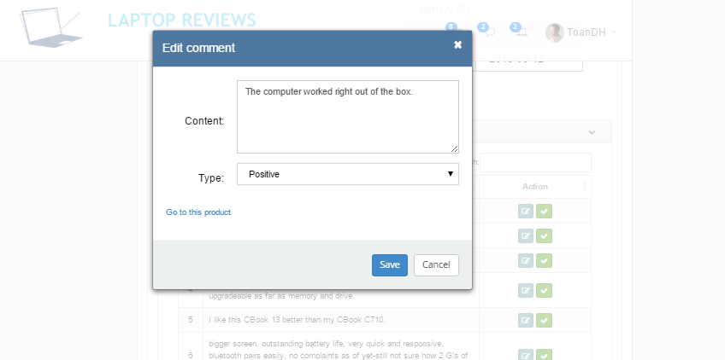

2

1

Figure 135: Manage Product – Edit Comment

|  |  |
| --- | --- |
| **No** | **Description** |
| 1 | Fill in information |
| 2 | Click to save edited information |

Table 93: Manage Product – Edit Comment

# Appendix

1. String Comparison: <http://www.catalysoft.com/articles/StrikeAMatch.html>